**Riding the Tide: Student Mobility in Cross Border Education**

Djoko Santoso

Director General of Higher Education, Ministry of Education and Culture, Indonesia

Nowadays we are witnessing the rise of cross border education, where more and more students study and obtain degrees from foreign univer­sities, professors teach outside of their home countries, and universities open branch cam­puses abroad. The development of cross border education has reflected the expansion of tertiary education systems worldwide and the globalization of economies and societies, which inevitably demands countries as well as individual higher education institution (HEI) to reform their education system into new direction. It is through cross border education, coherences among various education systems can be built via exchanges of goods and services, and facilitation of human and non-human mobility. Student mobility has been one of the strategic elements of cross border education as promoted by APEC.

**Student Mobility**

The increasing number of student mobility places higher education in APEC region a pivotal role in developing human resources capable of creating and sustaining globalized knowledge-based societies. Student mobility can be interpreted into several kinds. Taking into consideration the rapid development of online learning, student mobility is taking a different perspective at present. In addition to the inner country and intra country mobility, there is also a perspective of physical mobility versus virtual mobility, as depicted in the following picture.

|  |  |  |
| --- | --- | --- |
|  | **Physical mobility** | **Virtual mobility** |
| **Inner country**  **(local mobility)** | Student moves from one geographical area to another area within a country to pursue education | Student stays in his/her hometown to study via online learning scenario offered by local higher education institution |
| **Intra country**  **Cross border education** | Student moves from one country to another country to pursue education | Student stays in his/her country to study via online learning scenario offered by foreign higher education institution |

The conventional student mobility involves students physically moving from one geographical area to another to pursue higher education, whether it is in his/her own country or across the border to other countries . This practice has a long history. OECD’ research reveals that global students’ mobility is increasing rapidly, covering more than 4.3 million students in 2011 worldwide. While the US, UK, China, France, Germany, Australia, Canada, and Japan are the top host destination for international students to study (Project Atlas, Trends and Global Data 2012), Asia Pacific region has been considered as the biggest supplier of international students – especially from China and India. In OECD countries, Asian students make up to 45%, and up to 52% in non OECD countries.

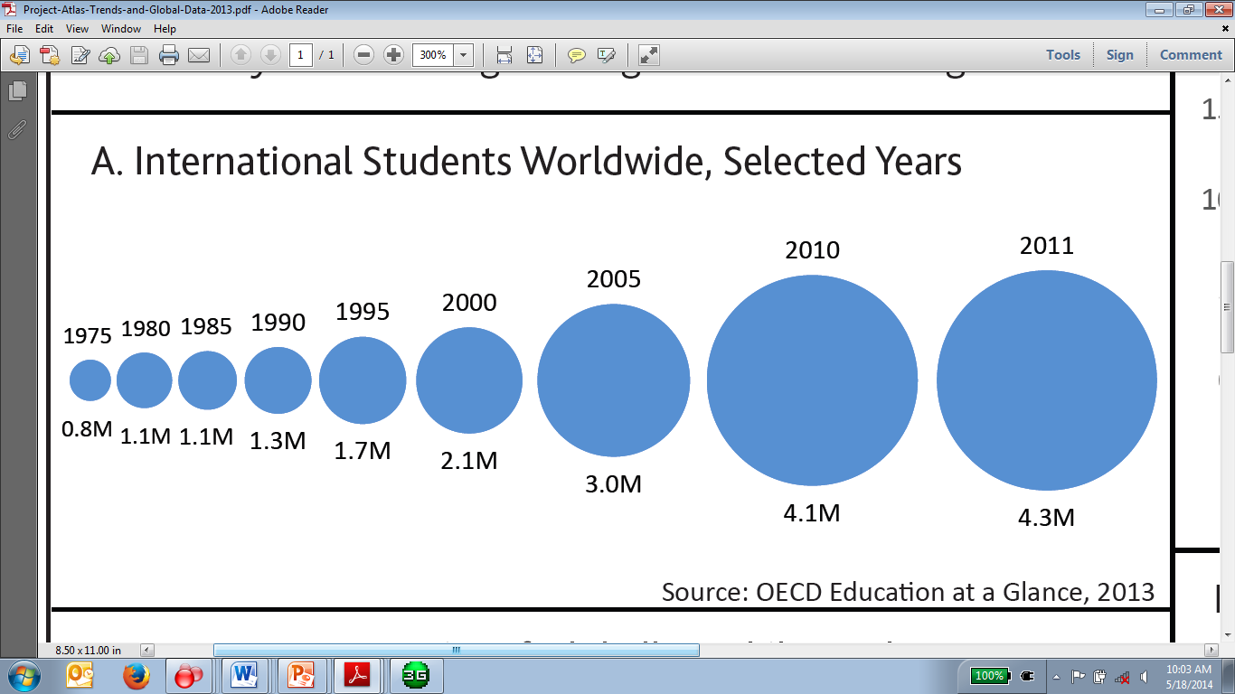

(Project Atlas, 2013)

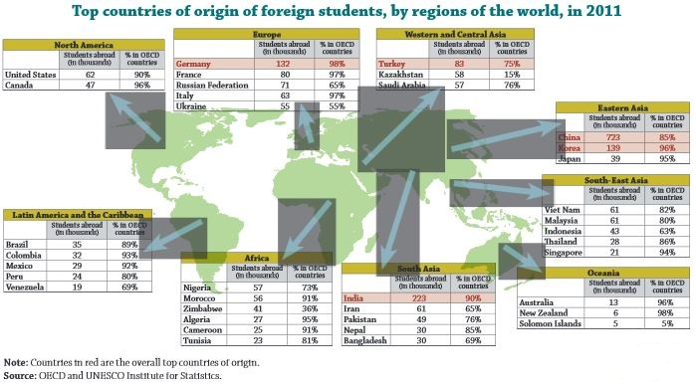

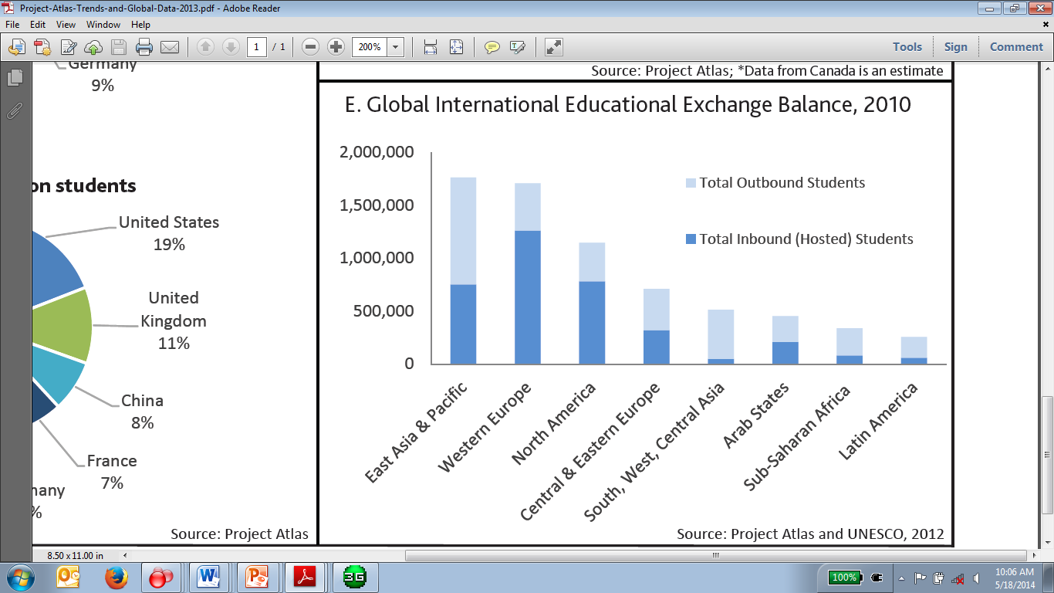Meanwhile, according to UNESCO (2012) the rise students mobility reflects growing enrolment of higher education around the world. In 2012, the 4 million students studying abroad represents 1.8% of all tertiary enrolments or 2 in 10 students globally.  There is a steady rise in the number of students studying abroad coming from Central Asia. This group grew from 67,300 in 2003 to 156,600 in 2012, with the outbound mobility ratio more than doubling from 3.5% to 7.5%. UNESCO claims that the figures suggest that domestic tertiary enrolment that has not kept pace with the growing demand for higher education. In contrast, students from sub-Saharan Africa, who are considered the second most mobile after Central Asia, are staying closer to home. According to the latest data, 288,200 students from sub-Saharan Africa studied abroad in 2012, up from 204,900 in 2003. Nevertheless, in this period the outbound mobility ratio in the region dropped from 6% in to 4.5%. The shift, according to UNESCO, suggests that domestic higher education systems in sub-Saharan Africa are expanding steadily. There are three regions have relatively low outbound mobility ratios: South and West Asia, where only 1.0% of tertiary students studied abroad, Latin America and the Caribbean (0.9%), and North America (1.4%).

The conventional student mobility is enriched at this present moment by the virtual mobility triggered by the rapid development of online learning. The virtual mobility is the form of education to help students acquire international education without having to leave the country or even their hometown. The development of Open Educational Resources and Massive Open Online Courses initiated by Massachusetts Institute of Technology in the late 1990s and UNESCO in early 2000s has provided a wide array of flexible education for students anywhere at any time. While the students may not be moving physically from their hometown, they are travelling virtually to pursue higher education, i.e., through online learning provision made available by various higher educations in countries around the world. There has been steady increase of students from around the world participating in online learning offered by a number of higher education consortium, such as Coursera, Udacity, MITx, 2tor, Academic Partnership, OpenUpEd, Schoo, Open2Study, Veduca, NPTEL, etc., although the initiatives is still at an early stage to be evaluated.

**APEC Education Space**

To enable students moving from one geographical area to other areas, both physically as well as virtually, it is required for the students to have “education space” as has been introduced in European Higher Education Area triggered by the Bologna Process in 1999, and ASEAN area of higher education that follows. As such, there should also be an establishment of APEC economies as APEC education space to allow student mobility across the APEC economies.

The APEC education space requires harmonization effort of education among APEC economies to take place. This harmonization effort reflects a process to recognize the significance of education cooperation and the importance of establishing an area of knowledge in which higher education operation, mobility, and employment opportunities can be easily facilitated and increased among the APEC economies. Through such process, APEC economies acknowledges diversity of higher education systems and cultures within its economies, while simultaneously seeking to create a common educational space. The process also fosters a higher level of understanding, a sense of shared purpose and common destiny in a highly globalized world. This harmonization could take place on the basis of a common, but not identical, practices and guidelines for collaboration in education.

APEC education space is not intended to create a uniform or standardized system of higher education across APEC economies. It is primarily to create common understanding in areas such as degree comparability through qualifications framework, quality assurance, lifelong learning, or credit transfer system and so on (Armstrong, 2009; Clark, 2007). As such, it will facilitate and smoothen student mobility and lifelong learning, which in the long run will strengthen regional economy. In this space, students, faculty members and higher education institutions are the key players promoting similar standards of higher education activities to allow for continuous interactions and mobility for students, faculty members and talents.

The establishment of APEC Education Space has political, economic, social and cultural dimensions to APEC economies. As a political lever, it provides opportunities for regions and individual economies to contribute to international quality assurance policy discussions. As an economic lever, regional integration provides smaller higher education systems entrance to possibilities of competition and cooperation on an international or regional scale. As a social or cultural lever, regional activities build solidarity among economies with diverse cultural and historical roots.

The success of establishment of APEC education space depends on various factors, such as the participation and consensus building at the level of national agencies, the public and also other stakeholders, as well as establishment of a commonly accepted roadmap that will consist of a vision of future goal, areas to develop common frameworks (such as credit transfer system, quality assurance guidelines, regional qualifications framework and so on), methods and the key players who will be responsible for framework development and information dissemination to the public. Harmonization of the highly diverse systems of higher education in the region is seen as an important step towards the regional integration objective. The most common measure is the step towards a greater degree of integration in higher education policies and practices through concerted regional efforts.

In recent years APEC economies have shown commitment towards deepening connections and interactions by looking at the rich regional diversity as important basis for regional cooperation and collaboration rather than as stumbling block. Taken into consideration the on-going movement and achievements in educational reform within each economy, APEC will find no difficulties in establishing this APEC education space to facilitate the greater student mobility among APEC economies, widening access and choices, academic and research collaborations, and enhanced collaboration on human capital investment.

**Indonesia Initiatives**

***a. Indonesian Qualification Framework***

Student mobility program has been endorsed by the Government of Indonesia as one strategic component in the the national education strategy. The four dimensions of students mobility are practiced with different degree, within the national higher education institution or with cross-national education institutions through academic collaboration. This practice has been in line with Indonesian Law No.12 year 2012 article 38, that student mobility can be performed through: (1) Study programs at the same education programs, (2) Type of higher education and/or, (3) Higher education institutions. The decree of Ministry of Education and Culture No. 14 Year 2014, Article 7 endorses that higher education institutions can establish cooperation with cross national higher education institutions in the field of teaching, researches, and community services. The above regulations have shown that the GoI’s appreciation of the increasing number of university graduates as a valuable asset for the national development. Sailah, et.al., (2004) indicates that it is therefore necessary to uphold the mobility program for university students, particularly for undergraduate students in regional or international areas. The mobility program will be beneficial in increasing the competence produced by the students upon completion of their bachelor program.

To facilitate such effort, the Indonesian Qualification Framework (IQF) has been launched in 2011 by the Ministry of National Education and the Ministry of Manpower and Transmigration. It reflects the learning outcomes gained by the undergraduate students during the study are for each level of education. It is also called as the reflection of the Indonesian human resource qualities. Sailah, et.al. (2014) claim that IQF is an independent tool to measure the learning outcomes gained through the formal, non-formal education, and job experience (internships). IQF is seen in the international stage to serve as a device that can recognize and translate international workforce or student qualifications to the Indonesian qualification system. The IQF is grouped into 9 levels from the level 1 to 9 (Figure 1). The bachelor graduates are on the level 6 reflecting the ability for bachelor graduates to take strategic decision based on the information and data analysis and provide directions in choosing several alternative solutions.



IQF is designed to provide reference for study programs offered by the higher education institutions. It is the framework which requires study programs to provide learning outcomes through their curriculum. Conventionally, learning outcomes are achieved through curriculum established by the study programs consisting of courses offered by and within a single university. As the globalization moves countries to become borderless, collaboration among and mobility of education providers, i.e., universities, are increasing. This establishment of IQF paves the way for further collaboration and integration among Indonesian universities and universities in the region, and enhances the overall reputation of Indonesian universities.

The availability of IQF facilitates greater students’ mobility – both physical as well as virtual mobility. As one of the learning outcomes include international exposure, which can be achieved via physical student mobility based on the IQF. In regard with virtual mobility, the IQF guides students as well as government to recognize the students’ learning experienced through various means and technology. The transfer of credits and credits earning can relatively be done at ease based on the IQF, for various student mobility program covering:

1. By region, i.e. national, regional, international
2. By length of program, i.e. short period (one semester or less) includes short visit/field trip, short course, summer course, student exchange; and long period (more than one semester) includes sandwich, Double Degree or Joint Degree Program
3. By financial source, i.e. university, government and private sponsorship
4. By activity, i.e. lecture, internship, research, field trip
5. Degree and non-degree

As such, it is necessary for all participating economies of APEC to establish its own qualification framework. There are some regional qualification frameworks introduced by regional bodies, such as ASEAN Qualifications Reference Framework chaired by Malaysia, ASEAN Quality Assurance Network (AQAN) by ASEAN; and also individual economies qualification frameworks.

Based on the available qualification framework, credit transfer system has also been established. For example, the University Credit Transfer System (UCTS), a mechanism to satisfy mobility for students seeking transfer of credits within the Asia Pacific region. Founded in 1994 with 35 countries and over 359 HEIs members, UMAP has developed a trial program to promote student mobility in Asia Pacific. UCTS aims at creating a more sustainable mobility program that enables students to earn credits during their studies in other universities in a cross border setting. Meanwhile the ASEAN University Network’s (AUN) credit transfer system known as ASEAN Credit Transfer System (ACTS) was developed by ASEAN University Network (by ASEAN in 1995). As of 2011, it had about 26 members. According to ACTS, credit transfer is the award of credit for a subject in a given program for learning that had taken place in another program completed by a learner prior to the program he/she is undertaking or about to undertake through cross border education scheme.

Nevertheless, there are also some economies who has not had comparable education system as well as learning outcomes, due to lack of the qualification framework. This situation, in general will hinder the student mobility, and in specific constraint to credit transfer as well as mutual recognition of learning outcomes. APEC needs a system that guarantee the quality of credits associated with education gained under any economies. Mutual trust and confidence between different systems are of high importance. Without transparency and knowledge about the quality of each other’s system, the development of credit transfer system within APEC economies will be very slow, thus student mobility will be constraint.

***b. AIMS (ASEAN International Mobility for Students)***

AIMS Program (formerly known as M-I-T Program) is coordinated by SEAMEO RIHED since 2009. Indonesia is one of the founders and actively participated in the program up to today. The program aims to make temporary student mobility as a regular feature of higher education in Southeast Asia, as dedicated academic and administrative measures for internationalization of students’ experiences are generally viewed as essential for dynamic institution of higher education.

AIMS program involves undergraduates at degree level of any year in the program from fields of study (disciplines) that were determined collectively by participating countries. They highlighted initiatives that remove institutional barriers and broaden the base of participation in international mobility programs.

[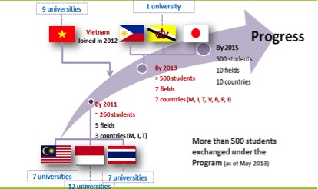](http://globalhighered.files.wordpress.com/2014/04/morshidiphotoblog.jpg)

(Source : *Student Mobility: focusing on the globally competent human resources*, Li Zhe (2013) Presented at the First Working group on Mobility of Higher education and Ensuring Quality Assurance of Higher education Among ASEAN plus Three Countries, 30 September 2013, Tokyo, Japan.

From the above projection, AIMS is open for new members and the decision to join AIMS must come from the ministry responsible for higher education.

To support AIMS program in Indonesia, DGHE (Directorate General of Higher Education), Ministry of Education and Culture established a taskforce responsible for planning, executing and monitoring the program. To ensure AIMS Program runs appropriately, a guidebook mainly dedicated for participating universities in Indonesia is created. In general, this guidebook provides information on overview of AIMS Program, procedure for inbound and outbound students, monitoring and evaluation, and reporting. The funding is provided through the Ministry of Education and Culture. Continuous support of the government is indicated by increasing number of scholarship provided by the government (Table.2).

As the number of students increases, the AIMs needs to move their focus on numbers and percentages of students involved in each country to the content and quality of the regional experience. After all, student mobility and internationalization of higher education as such is not a goal in itself but a means to enhance the quality of the educational experience and the international learning outcome of the students (Zhe, 2013).

**Moving forward**

To enable greater student mobility among the APEC economies, in addition to the availability of qualification frameworks and initiatives to collaborate for provision of innovative regional learning experience, there are some other intrinsic factors APEC should consider, i.e., regional accreditation, collaborative research for regional innovation, regional skills competition, and increase use of English Language.

Accreditation is very important in higher education. It is viewed as both a process and a result. It is a process by which a university/college or technical and vocational training institution evaluates its educational activities, and seeks an independent judgment to confirm that it substantially achieves its objectives, and is generally equal in quality to comparable institutions. As a result, it is a form of certification, or grant of formal status by a recognized and authorized accrediting agency to an educational institution as possessing certain standards of quality which are over and above those prescribed as minimum requirements by the government. APEC regional accreditation is important to establish mutual trust and confidence between different education systems of economies. APEC regional accreditation will provide knowledge about the quality of each other’s system to allow greater student mobility. This closer cooperation on accreditation and quality assurance among APEC economies will definitely enhance cross-border student mobility

Collaborative research and publication signify one key aspect of cross-border education cooperation and facilitation of exchange in education services within APEC, as mentioned specifically in the 2012 APEC Leaders' Declaration. The effort will nurture the development of regional innovation which will be available for wider good of APEC community. As higher education is contributing to the production and dissemination universal knowledge, collaborative research for regional innovation can be marked with universal and cross-border imparted content and knowledge for regional development. This collaborative research for innovation paves the way for regional skills competition, such as the ASEAN Skills Competition, to support workforce development and to achieve regional standards competency. Such regional skills competition will contribute towards the advancement of quality and skills of workers in APEC community, especially with increased focus on technical and vocational education and training. This research collaboration and regional skills competition will further open up possibilities for greater student mobility, especially in the area of STEM (science, technology, engineering, and mathematics) ([http://wenr.wes.org/2014/03/ international-student-mobility-trends-2014-the-upward-momentum-of-stem-fields/](http://wenr.wes.org/2014/03/%20international-student-mobility-trends-2014-the-upward-momentum-of-stem-fields/))

Student mobility is also influenced by the availability of scholarships/financial aid. More programs on scholarships grant on students from all the regions are now being practiced in most APEC economies. This provision will open to the young people of to develop their potential and equip them with skills that will enable them to confidently step into the enlarged community. Support for education of teachers, academics and other educational personnel to upgrade their professional competency is also important for increasing quality of education in any APEC economies which at the end allow greater student mobility.

Students involved in mobility program may be faced with adjustment problems particularly with respect to instructional practices, curriculum incomparability, and cultural diversity. Then there is the language problem: differences in languages post a great barrier for inward and outward mobility of students at the macro level. Mostly, the language barrier has always been a problem among the people of the member economies. Language is a key towards student mobility, as a means of communication that will allow students to physically or virtually mobile in their pursuance of education. The increase of usage of English language is one of the focal areas to be considered. Being able to communicate in English is required so that students will not face a handicap to benefit from the APEC education space as their education travel space.

The increasing number of student mobility among APEC economies places higher education in APEC region a pivotal role in developing human resources capable of creating and sustaining globalized knowledge-based societies. For all of these to take place, a clear guideline for student mobility is indeed important. Some present challenges are dispersed information for different procedures in various offices (no one-stop concept), alignment of qualification framework on each economies, regulation on students visa and study abroad procedures, mutual recognition for credit transfer and credit earning, legal aspect of the joint program. There have been several guidelines available under various regional collaboration, such as the AIMS Guideline for ASEAN countries, OECD Guideline for student mobility among OECD countries; or under individual countries regulation such as the UK guideline for student mobility, USA guideline for student mobility, etc. Acknowledging APEC’s leading role in developing cross-border student mobility in the Asia Pacific, it is important for APEC to provide a clear guideline on this students mobility, to guide reform and transparency, and drawing on case studies of domestic education providers. A concerted effort to develop APEC Guideline for Student Mobility – as proposed by Indonesia – will be of high importance. The guideline, in general, is not imposing uniformity, but providing transparent information to stakeholders, especially potential students from APEC communities, to get engaged in cross border education in the APEC region. Reciprocal activities can flourish among APEC economies based on the clear and transparent information provided in the guideline. Thus, the map of higher education supply and demand or host and home will be more balanced.

At present, we are anticipating the increasing demand of higher education, increasing recruitment of international students, and increasing out/inflow of cross borders students that will be targeting top universities in APEC economies. It is a momentum for APEC community. APEC economies are rich in culture, diverse in language and religion but have one common goal united as APEC community that will be benefitting from sending as well as receiving students in our APEC education space,. Regardless the differences, APEC community share a similar emphasis on human resource development as a key in developing the whole nation to enter the knowledge-based economy and global environment. While some factors can be best managed by each individual economy, there are some factors which can be established as collective effort under the umbrella of APEC community and contributing to the development of all economies under APEC community within the fast changing global higher education landscape. This requires strong and long-lasting commitment by all of us the APEC economies and entails strong collaborations within and across Ministries, and other stakeholders in the economies. This is the moment to ride the tide.

**References**

(n.n.) (2006). International Student Mobility in the Commonwealth. Presented in The Sixteenth Conference Of Commonwealth Education Ministers Cape Town, South Africa 2006. <http://www.cecomm.org.uk/publications/104-international-student-mobility-in-the-commonwealth>

Belyavina, R., Li, J. & Bhandari, R. (2013) *New Frontiers: U.S. Students Pursuing Degrees Abroad: A 2-year analysis of key destinations and fields of study*. Institute of International Education (IIE): Center for Academic Mobility Research.

Institute of International Education (2013). *Project Atlas: Trends and Global Data 2013*. IIE Center for Academic Mobility Research.

Lester, S. (2013) Liberalizing Cross-Border Trade in Higher Education: The Coming Revolution of Online Universities. *Policy Analysis*, no. 720, February 2013.

King, R., Findlay, A., & Ahrens, J. (2010). *International student mobility literature review.* Report to HEFCE, and co-funded by the British Council, UK National Agency for Erasmus. Higher Education Funding Council for England

Measuring UK student mobility – a review of the data collected related to outwardly mobile students. [http://www.hesa.ac.uk/dox/datacoll/studentStream/consultation_2011/ Mobility_report.pdf](http://www.hesa.ac.uk/dox/datacoll/studentStream/consultation_2011/%20Mobility_report.pdf)

OECD (2013) Education Indicators in Focus – 2013/05 (July). <http://www.oecd-ilibrary.org/education/how-is-international-student-mobility-shaping-up_5k43k8r4k821-en>

QS Quacquarelli Symonds (2014) *Trends in International Student Mobility: A Comparative Study of International Student Choices, Motivation, and Expectations 2009-2013*. [www.TopUniversities.com](http://www.TopUniversities.com)

Sailah, I., et.al. (2014) *International Student Mobility in Indonesia*. Paper is presented in 7th AIMS Review Meeting, 8 May 2014, Manila, Philippines

SEAMEO RIHED (2012) *ASEAN International Mobility for Students (AIMS) Programme: Operational Handbook.* Bangkok, SEAMEO RIHED.

Sirat, M., Azman, N. Abu Bakar, A. (2013) *Towards harmonization of higher education in Southeast Asia: Malaysia’s perspective*. [http://www.insidehighered.com/blogs/ globalhighered/ towards-harmonization-higher-education-southeast-asia#ixzz31ZAS6QoD](http://www.insidehighered.com/blogs/%20globalhighered/%20towards-harmonization-higher-education-southeast-asia#ixzz31ZAS6QoD)

UNESCO (2012). *As demand for education rises, mobile students explore new destinations* <http://www.uis.unesco.org/Education/Pages/international-student-flow-viz.aspx>

University World News (2014). Summing up international student mobility in 2014 <http://monitor.icef.com/2014/02/summing-up-international-student-mobility-in-2014/>

WES Research & Advisory Services( 2014) *International Student Mobility Trends 2014: The Upward Momentum of STEM Fields*. <http://wenr.wes.org/2014/03/international-student-mobility-trends-2014-the-upward-momentum-of-stem-fields/>

Zhe, L. (2013) *Student Mobility: focusing on the globally competent human resources*. Presented at the First Working group on Mobility of Higher education and Ensuring Quality Assurance of Higher education Among ASEAN plus Three Countries, 30 September 2013, Tokyo, Japan.