

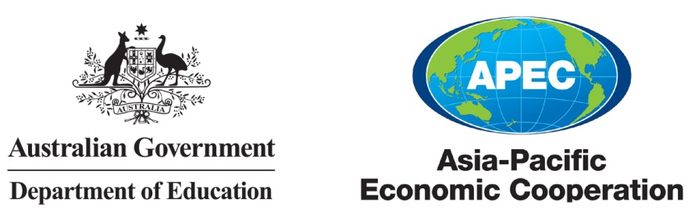

Promoting Regional Education Services Integration: APEC University Associations

Cross-Border Education Cooperation Workshop

20 – 22 May 2014

Prince Hotel & Residence

Kuala Lumpur, Malaysia

Workshop agenda

**Tuesday 20 May 2014**

08:30 – 10:00 Registration

Arrival tea and coffee

10:00 – 11:00 **Opening Plenary**

*Opening Address*

Mr Niclas Jönsson

Director, Multilateral Section, Department of Education

Australia

Project Overseer, APEC University Associations Cross-Border Education Cooperation Workshop

*University Association Collaboration in Cross-Border Education*

Professor Kent Anderson

Pro Vice Chancellor (International), University of Adelaide

Australia

Facilitator, APEC University Associations Cross-Border Education Cooperation Workshop

11:00 – 11:30 Morning tea

11:30 – 12:00 *Key Issues in Cross-Border Education*

Dr Sarah Richardson

Senior Research Fellow, Australian Council for Educational Research  
Australia

Project Manager, APEC University Associations Cross-Border Education Cooperation Workshop

12:00 – 13:00 **Enhancing the mobility of students**

*Global Capacity-building in Student Mobility Data Collection and Dissemination*

Ms Raisa Belyavina

Senior Research Officer, Institute for International Education

The United States

*Student Mobility: a Vietnamese perspective*

Dr Nguyen Thi Thanh Minh

Deputy Director General, Vietnam International Education Development

Ministry of Education and Training

Viet Nam

13:00 – 14:00 Lunch

14:00 – 15:00 *Sharing the University of Malaya perspective*

Ms Rozitah Md Amin

Director, International Student Centre

Chancellery, University of Malaya

Malaysia

*Revolutionary Student Mobility: A New Role for Credit Transfer Processes*

Mr Trevor Goddard

Associate Director, Global Programs

Office of the President and Vice-Chancellor, Monash University

Australia

15:00 – 16:00 *Student Mobility Panel Discussion*

16:00 – 16:30 Afternoon tea

16:30 – 17:00 **Day 1 summary**

Professor Kent Anderson

Pro Vice Chancellor (International), University of Adelaide

Australia

Facilitator, APEC University Associations Cross-Border Education Cooperation Workshop

18:00 – 20:00 **Welcome Reception**

**Wednesday 21 May 2014**

09:00 – 10:00 Arrival tea and coffee

10:00 – 11:00 **Enhancing the mobility of researchers**

*Student and Researcher Mobility: an Indonesian perspective*

Professor Paulina Pannen

Expert – Higher Education, Directorate General of Higher Education

Ministry of Education and Culture

Indonesia

*Mobility and Qualifications Frameworks*

Mr David Yu

Senior Manager, Hong Kong Qualifications Framework

Hong Kong, China

11:00 – 11:30 Morning tea

11:30 – 12:00 *Researcher Mobility Programmes*

Dr Chantavit Sujatanond

Interim Director, SEAMEO RIHED

Thailand

12:00 – 13:00 *Researcher Mobility Panel Discussion*

13:00 – 14:00 Lunch

14:00 – 15:00 **Enhancing the mobility of education providers**

*Cross-Border Mobility: Provider Perspectives*

Professor Christine Ennew

Provost and Chief Executive Officer

Malaysia Campus of the University of Nottingham

Malaysia

*Asia Pacific Regionalisation of Higher Education: Findings from JICA-RI Surveys for East Asian Leading Universities*

Professor Kazuo Kuroda

Professor of International Education

Graduate School of Asia-Pacific Studies, Waseda University

Japan

15:00 – 16:00 *Provider Mobility Panel Discussion*

16:00 – 16:30 Afternoon tea

16:30 – 17:00 **Day 2 summary**

Professor Kent Anderson

Pro Vice Chancellor (International), University of Adelaide

Australia

Facilitator, APEC University Associations Cross-Border Education Cooperation Workshop

**Thursday 22 May 2014**

09:00 – 10:00 Arrival tea and coffee

10:00 – 10:30 **Beyond mobility – enhancing cross-border education without movement**

*Open Educational Resources: Opportunities for Collaboration*

Professor Rory McGreal

UNESCO/Commonwealth of Learning/International Council for Open and Distance Education Chair in OER, Athabasca University

Canada

10:30 – 11:30 *Mobility without movement Panel Discussion*

11:30 – 12:00 **Closing Plenary**

Professor Kent Anderson

Pro Vice Chancellor (International), University of Adelaide

Australia

Facilitator, APEC University Associations Cross-Border Education Cooperation Workshop

Mr Niclas Jönsson

Director, Multilateral Section, Department of Education

Australia

Project Overseer, APEC University Associations Cross-Border Education Cooperation Workshop

12:00 – 13:00 (Optional) **Farewell Lunch**