

October 2016

Transnational education in the higher education sector

Transnational education is the provision of education to international students by Australian institutions offshore. For example, an Australian university may have campuses in one or more countries outside Australia, or offer courses via distance education, online learning or correspondence. International students may be enrolled in partnership programs managed by an Australian university and a foreign partner which may be delivered at that foreign university campus. This snapshot analyses the provision of transnational education in the higher education sector up to the year 2015.

A pie chart shows the transnational students by level of study:

Bachelors Degree, 66.9%
Master's by course work, 20.1%
Advanced Dipl/Dipl, 4.4%
Doctrate, 2.4%
Graduate Diploma & Certificate, 2.4%
Master's by Research, 0.3%
Other, 2.9%There were 363,298 international students studying in Australian higher education institutions in 2015. Just over a quarter of these were enrolled in offshore programs, and a further 13,537 were offshore distance education students (see table). In total, 109,541 transnational students represent 30.2% of all higher education international students in 2015.

**Level of study and field of education**

In 2015, the top levels of study for transnational students were Bachelors degree (66.9%) and Masters degree by coursework (20.1%) (Figure 1). Among transnational students the most popular fields of education were: Management and Commerce (58.5%), Engineering and Related Technologies (8.9%), Society and Culture (7.8%), Information Technology (6.4%) and Health (5.3%).

**Age**

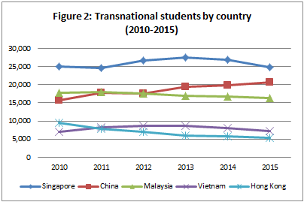The most common age range for transnational students in 2015 was between 19 and 22 years (46.7%). International students studying in Australia tended to be slightly older, with the half of them aged between 20 and 24 (53.7%).

**Nationality and Gender**

Figure 2 illustrates the changing patterns of transnational students in the top five countries in 2015. These countries reflect the nationality of students and not necessarily where they studied. In Australian university programs in Singapore for example, 67.7% of students were permanent residents of Singapore, the remaining students were residents of other countries.

Slightly more transnational students were females (50.7%) than male (49.3%). Conversely, more male international students were studying in Australia than females (53.1% and 46.9% respectively).

**Type of attendance**

Transnational students' type of attendance was more diverse than onshore international students, who are primarily full time students. In 2015, 73.9% of transnational students studied full time and 26.1% studied part-time.