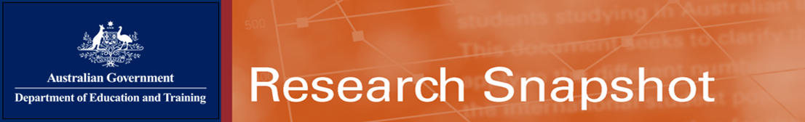
June 2016

Study Pathways of International Students in Australia, 2014–2015
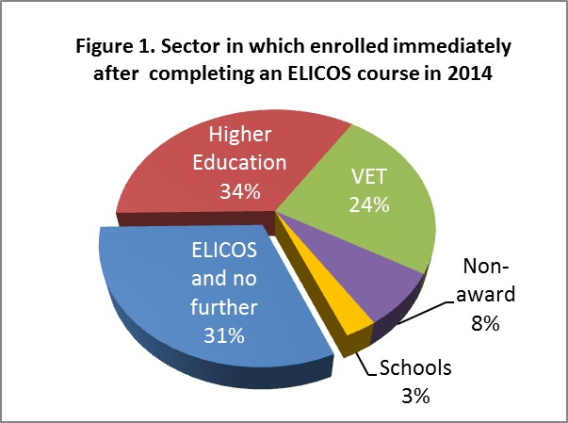
One of the strengths of Australia’s international education system is its flexible pathways between education sectors. Over half of international students undertake study in more than one educational sector during their Australian education experience.
For many students from non-English-speaking countries, English Language Intensive Courses for Overseas Students (ELICOS) are their first step towards further study in one of the tertiary sectors or in Australian schools. Many students also take advantage of the Australia’s non-award foundation courses to assist them in meeting the entry requirements for studying higher education in Australia. Many other study pathways are also available depending on students’ needs and interests.
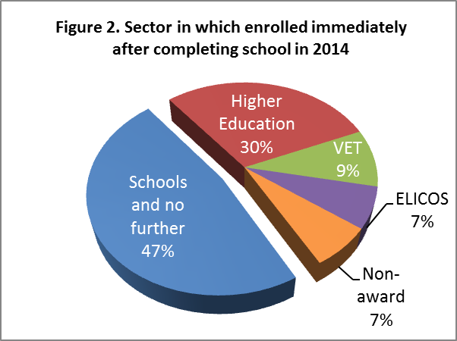
The next step after ELICOS and Schools
Almost two-thirds of international students on a student visa who completed an ELICOS course in 2014 undertook further study in Australia in another education sector (Figure 1). Of the major nationalities, 64 per cent of Chinese and 42 per cent of Indian ELICOS students progressed on to study in higher education. Two in five (42%) Thai ELICOS students progressed to VET. Students from Columbia (73%) and Japan (66%) more often enrolled in ELICOS without undertaking any further study.
For school students aged 17 or over who completed their school studies in 2014, more than half progressed on to another sector, incorporating almost a third who progressed to higher education (Figure 2). The majority (63%) of Malaysian school students and nearly half of students from Hong Kong (46%) and China (45%) progressed on to higher education. Just over a quarter (26%) of school students from Vietnam progressed on to VET. Most school students from Germany, Italy and Brazil did not progress on to another sector.

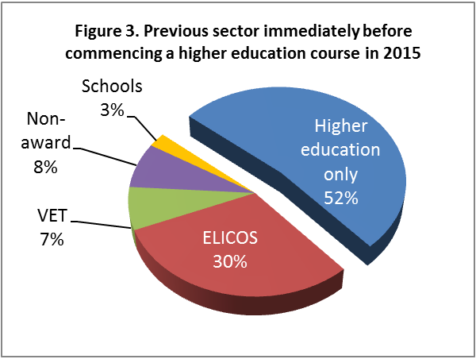
The previous step before higher education and VET
In 2015, nearly half of all international students who commenced a higher education course had followed a study pathway from a previous sector. Thirty per cent of students came from ELICOS into higher education. A further seven per cent came from VET and eight per cent from non-award study (Figure 3). Students from China and Vietnam most commonly progressed from ELICOS to higher education, while students from Malaysia, Indonesia, India and Nepal were most likely to enrol directly in higher education without any prior pathway study.
Non-award study (often involving foundation courses that enable students to meet higher education entry requirements) was a more important pathway for bachelor degree students, with nearly one third (30%) having studied a non-award course beforehand.
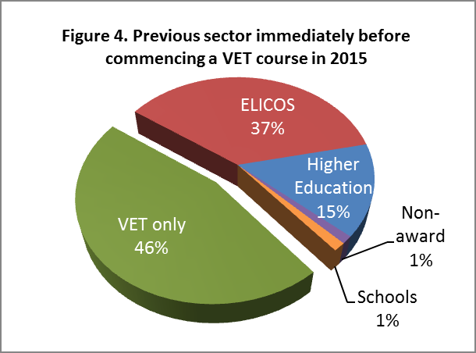
The majority (90%) of international postgraduate research students did not undertake any prior study in Australia. Of the small proportion who had undertaken prior study, 18 per cent had done non-award study, 11 per cent had studied a Masters degree by coursework and 10 per cent a Bachelor’s degree.
Of the international students who commenced a VET course in 2015, more than half did so through a pathway from another sector. Of those pathway students, 37 per cent had studied ELICOS beforehand (Figure 4).
More than half of students from Italy (69%), India (57%) and Malaysia (55%) most enrolled directly into VET with no prior study pathway. Most students from Thailand (89%), Vietnam (85%), Brazil (80%) and China (70%) have progressed to VET from ELICOS. More than half (57%) of students from India enrolled directly in a VET course with no prior study, while most others had followed a pathway from either higher education or ELICOS.

