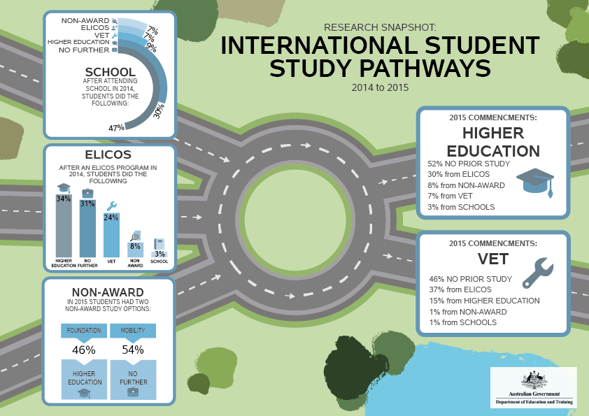
International student study pathways 2014 to 2015
This infographic provides data of international students’ study pathways between education sectors in the Australian education system.
Forward steps in study pathways:
SCHOOL
International students who commenced school in 2014, then did the following in 2015:
- 30 per cent moved to higher education
- 9 per cent moved to vocational education and training (VET)
- 7 per cent moved to English Language and Intensive Courses for Overseas Students (ELICOS)
- 7 per cent moved to non-award courses
- 47 per cent did not move to another sector.
English Language Intensive Courses for Overseas Students (ELICOS)
International students who commenced English language study in 2014, then did the following in 2015:
- 34 per cent moved to higher education
- 24 per cent moved to VET sector
- 8 per cent moved to non-award courses
- 3 per cent moved to schools
- 31 per cent did not move to another sector.
Non-award
Of the international students who commenced non-award study in 2015:
- 46 per cent studied Foundation courses which lead to study in higher education
- 54 per cent studied Mobility courses and generally returned home afterwards.
Previous steps in study pathways:
For international students who commenced studying higher education in 2015:
- 52 per cent had no prior study in Australia
- 30 per cent had studied a English language course
- 8 per cent had studied a non-award course
- 7 per cent had studied in an Australian school.
For international students who commenced studying VET in 2015:
- 46 per cent had no prior study in Australia
- 37 per cent had studied an English language course
- 15 per cent had studied a higher education course
- 1 per cent had studied a non-award course
- 1 per cent had studied in an Australian school.

