Research Snapshot:

STUDY LOCATIONS IN 2015

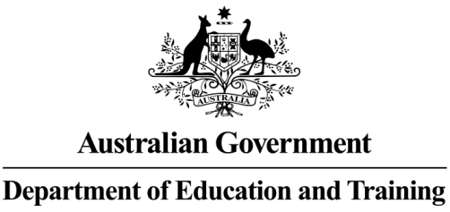

TOP FIVE SOURCE COUNTRIES

STUDY LOCATIONS OF INTERNATIONAL STUDENTS

5%

of international students are in regional areas

95%

of international students are in metropolitan areas



METROPOLITAN

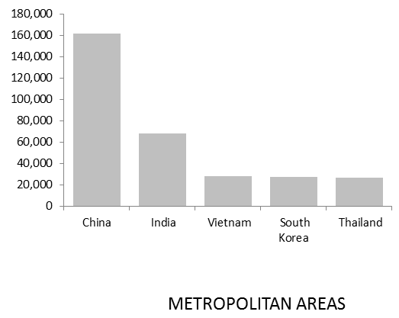

Regional areas are

99.9%

of Australia’s land mass

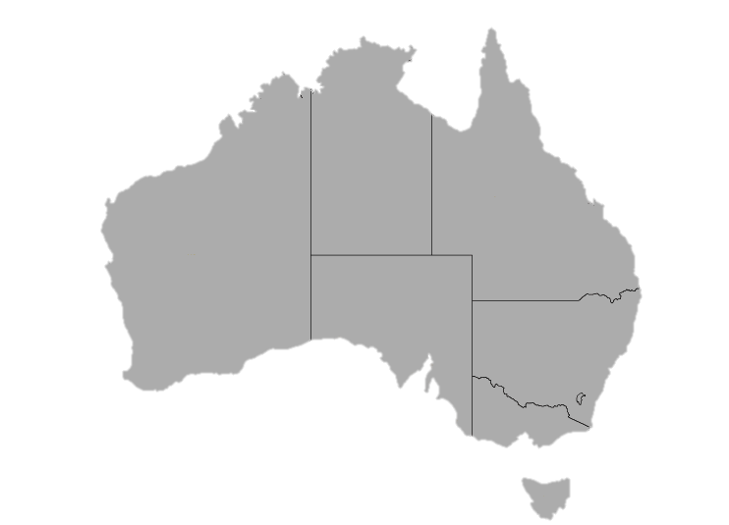

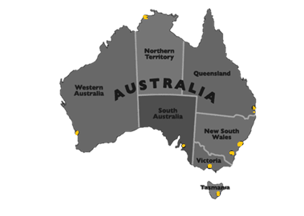



















CANBERRA

GOLD COAST

SYDNEY

DARWIN

BRISBANE

HOBART

ADELAIDE

PERTH

MELBOURNE

WHAT IS A REGIONAL AREA?

Metropolitan areas are

0.1%

of Australia’s land mass

