

Research  
Snapshot

October 2018

Offshore delivery of Australian VET courses in 2017

This snapshot provides an overview of vocational education and training (VET) delivered offshore by Australian training providers in 2017. This information is sourced from national data reported to the National Centre for Vocational Education Research (NCVER) by Australian training providers[1].

**Australian training provider type and offshore location**

Australian training providers delivering VET programs to offshore students reported 36,765 program enrolments in over 40 offshore locations in 2017[2]. The majority (92%) of VET program enrolments offshore were with public providers. China was the top offshore location for public training providers and Vietnam was the top offshore location for private training providers. Hong Kong was one of the top five offshore locations for both public and private training providers, but otherwise offshore delivery locations varied between public and private providers (Table 1). The total number of Australian training providers delivering VET programs offshore increased from 53 in 2015 to 68 in 2017.

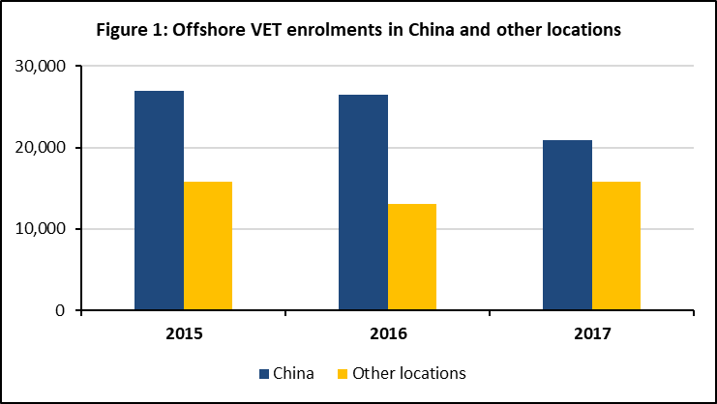The total number of program enrolments in VET training offshore declined by 7 per cent in 2017 (from 39,526 in 2016). As shown in figure 1, this decline was primarily related to decline in offshore program enrolments in China, which declined by 21 per cent (from 26,482 in 2016). VET enrolments across all other offshore locations grew by 21 per cent (from 13,044 in 2016).

**State**

More than half (58%) of VET program enrolments offshore were with providers in Victoria followed by providers in New South Wales (16%). Offshore VET enrolments with providers from New South Wales and Queensland grew by 11 and 16 per cent respectively since 2016. Offshore VET enrolments with providers in other states declined: Victoria by 9%; Western Australia by 29%; and other jurisdictions[3] by 36%.

**Field of education**

In 2017, Management & Commerce was the top broad field of education for offshore VET students (45% of all enrolments) followed by Engineering & Related Technologies (15% of enrolments), although enrolments in these fields did not grow in 2017. Offshore enrolments did grow in the fields of Education (by 41%), Health (by 25%) and Food, Hospitality & Personal Services (by 19%). Offshore enrolments in Natural & Physical Sciences field more than tripled from 70 in 2016 to 265 in 2017.

1. NCVER 2018, *Australian vocational education and training statistics: total VET students and courses 2017 — pivot tables*, NCVER, Adelaide*.* 
2. *Note that the numbers may contain duplicates*. More information on duplicated/de-duplicated student counts is available at*:* [*https://www.ncver.edu.au/__data/assets/pdf_file/0029/58079/TVA-fact-sheet.pdf*](https://www.ncver.edu.au/__data/assets/pdf_file/0029/58079/TVA-fact-sheet.pdf)
3. *Includes other Australian jurisdictions and ‘not known’.*