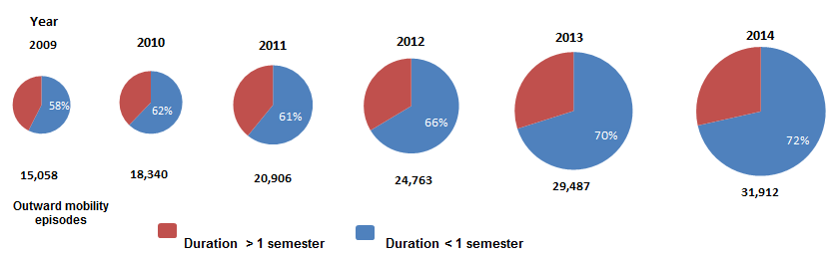
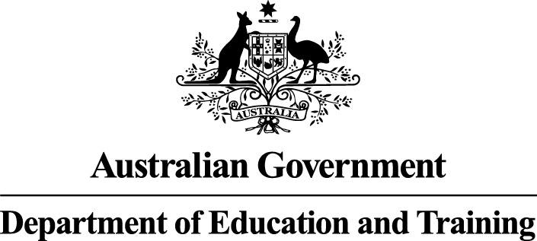
How many
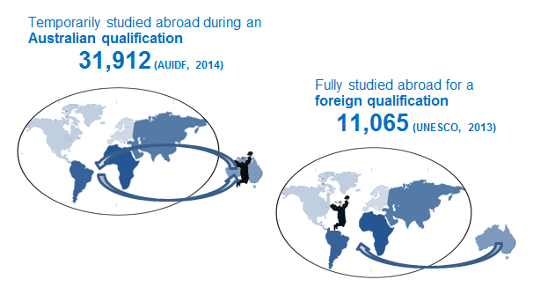
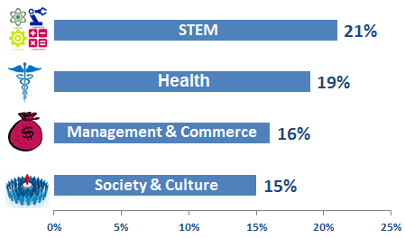
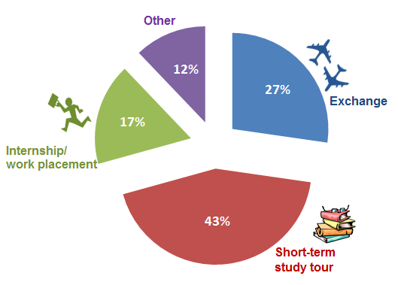
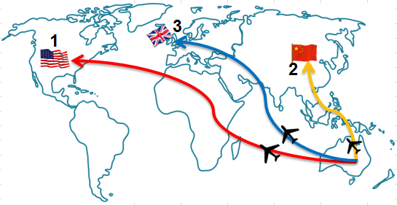
Graduated here
or abroad
International mobility of Australian university students
Type of
experience
Field of education

International mobility of Australian university students

This infographic provides data of internationally mobile students of Australian universities in 2014.

How many outward mobility episodes:

- In 2009, there were 15,058 study experiences with 58 per cent short-term programs of less than one semester and 43 per cent in exchange or greater than one semester programs.
- In 2010, there were 18,340 study experiences with 62 per cent short-term programs of less than one semester and 38 per cent in exchange or greater than one semester programs.
- In 2011, there were 20,906 study experiences with 61 per cent short-term programs of less than one semester and 39 per cent in exchange or greater than one semester programs.
- In 2012, there were 24,763 study experiences with 66 per cent short-term programs of less than one semester and 34 per cent in exchange or greater than one semester programs.
- In 2013, there were 29,487 study experiences with 70 per cent short-term programs of less than one semester and 30 per cent in exchange or greater than one semester programs
- In 2014, there were 31,912 study experiences with 72 per cent short-term programs of less than one semester and 29 per cent in in exchange or greater than one semester programs.
Top three destinations:

- USA
- China and
- UK
Type of Experiences?

- Exchange - 27%
- Short-term study tour - 43%
- Internship/Work placement - 17%
- Other - 12%
Field of Study?

In 2014, more students in health fields (19%) of study undertook learning abroad experiences followed by STEM (16%), Management and Commerce (16%) and Society and Culture (15%). STEM incorporates Science, Information Technology, Agriculture/Environmental studies and Engineering.

Graduated in Australia or abroad?

A total of 31,912 international study experiences were undertaken by Australian university students at all levels during their Australian qualification in 2014 as reported in AUIDF 2015.
The UNESCO data shows 11,065 Australian students studied abroad for two or more years leading towards a foreign qualification.

