

April 2018

International mobility of Australian university students

An annual survey of Australian universities1 found that students from 35 universities had undertaken 44,045 international study experiences in 2016 (Table 1). This was a 15.5% increase on the number of experiences reported by 36 universities in 2015. Around 62% of these experiences were undertaken by domestic undergraduates, 10% by international undergraduates and remainder by postgraduates in 2016.

The 27,320 international experiences undertaken by domestic undergraduates represented 20.9% of the graduating cohort from the same 35 universities. The equivalent figure for US undergraduates studying abroad in 2015-16 was 15.5%2.

Student exchange programs (26%) and faculty-led study tours (24%) were the most popular types of study experiences among undergraduates in 2016. Postgraduate research students most often travelled for research-related experiences (57%) followed by conferences or international competitions (40%) in 2016.

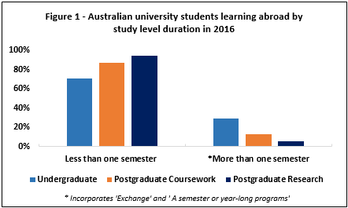The majority of study abroad experiences among undergraduates (76.1%) and postgraduate coursework (68.8%) were for non-compulsory academic credit. Almost half (49.2%) of postgraduate research students travelled abroad for non-credit status or for recognition (30.7%). Over three quarters (76.4%) of experiences were for less than a semester, the remainder being exchange and other semester or year-long programs at all levels. The majority of experiences for postgraduate coursework (87.0%) and postgraduate research (94.5%) students were for less than a semester (Figure 1).

In 2016, over one third of all experiences (38%) were in the top five destination countries (USA, China, UK, Italy and Japan) (Table 2). Students in science, technology, engineering and mathematics (STEM) fields were more likely to study abroad (21% of all experiences) than students in other fields.

In 2016, almost 17,250 university students travelled to countries identified as priority destinations under the New Colombo Plan3, an increase of 54.5 per cent on 2015. Almost 23.9 per cent of mobility experiences were undertaken in Indo-Pacific countries. The top 5 Indo-Pacific destinations were China (10% of total), Japan (4%), India (4%), Indonesia (3%) and Malaysia (3%).

Australia’s Higher Education Statistics Collection shows there were 5,685 Australian students enrolled in offshore Australian higher education campusesin 2016, slightly less than in 2015 (6075)5. It is likely that these students are also counted within the survey of Australian university students described above.

The latest UNESCO data show 12,330 Australian students enrolled in tertiary courses in other countries in 20164. This is a 3% increase since 2015. This statistic only count Australian students enrolled in a course of more than 2 years’ duration in another country. It is assumed that these students represent an additional cohort of Australians studying towards full qualifications in foreign institutions and who are hence not counted in the survey of Australian university students described above.

1 The ‘Learning Abroad 2015’ (2016) Australian Universities International Directors’ Forum (AUIDF) report by i-Graduate (unpublished). The data for earlier years were drawn from previous iterations of the AUIDF Research Agenda reports.

2 Fast Facts - Open Doors 2016 available at: <http://www.iie.org/en/Research-and-Publications/Open-Doors>,   
3 Information on New Colombo Plan 2015 Indo-Pacific host locations is available at: <http://dfat.gov.au/people-to-people/new-colombo-plan/scholarship-program/Pages/host-locations.aspx>

4 UNESCO data used in this research snapshot is from <http://data.uis.unesco.org/>. Students in countries which did not report to UNESCO are not included.

5 Unpublished data of Higher Education Statistics available on <https://www.education.gov.au/>

For further information about this research, Snapshot Series contact the International Research and Analysis Unit by email: [IEResearch@education.gov.au](mailto:IEResearch@education.gov.au).

The Research Snapshot series can be accessed from <https://internationaleducation.gov.au/research/research-snapshots/pages/default.aspx>