

January 2017

International mobility of Australian university students

An annual survey of Australian universities1 found that students from 36 universities had undertaken 38,144 international study experiences in 2015 (Table 1). This was a 19.5% increase on the number of experiences reported by 34 universities in 2014. Around 92% of these experiences were undertaken by domestic students in 2015, the remainder by international students.

The 24,715 overseas experiences undertaken by domestic undergraduate students represented 19.3% of the graduating cohort from the same 36 universities. The equivalent figure for US undergraduates studying abroad in 2014-15 was 15.1%2.

Student exchange programs (28%) and faculty-led study tours (26%) were the most popular types of study experiences among undergraduates in 2015. Postgraduate students most often travelled for research-related experiences (29%) followed by conferences or international competitions (19%) in 2015.

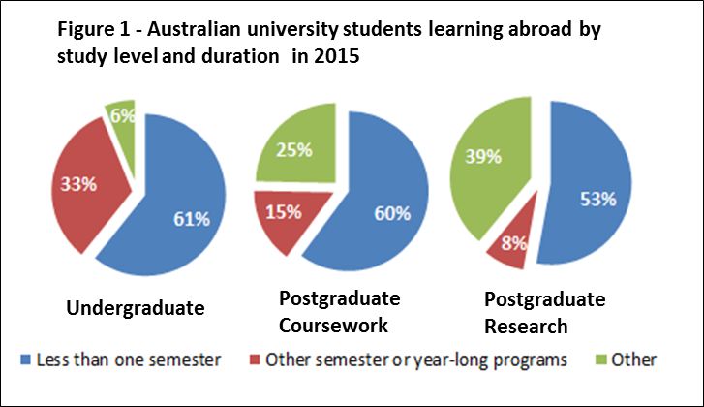The majority (77%) of study abroad experiences were for academic credit. Most (74%) experiences were for less than a semester, the remainder being exchange and other semester or year-long programs. Over half of undergraduate and postgraduate experiences were for less than one semester (Figure 1).

In 2015, over one third of all experiences (39%) were in the top five destination countries (USA, China, UK, Indonesia and Canada) (Table 2). Students in science, technology, engineering and mathematics (STEM) fields were more likely to study abroad (20% of all experiences) than students in other fields.

In 2015, 11,157 undergraduate domestic students travelled to countries identified as priority destinations under the New Colombo Plan3, an increase of 32% on 2014. The top 5 Indo-Pacific destinations for undergraduate domestic students in 2015 were China (19.3% of total), Indonesia (11%), Japan (9.6%), India (9.2%) and Cambodia (6.5%).

Australia’s Higher Education Statistics Collection shows there were 340 Australian students enrolled in an offshore Australian higher education campusesin 2015, slightly less than in 2014 (430)5. It is likely that these students are also counted within the survey of Australian university students described above.

The latest UNESCO data for 2014 show 11,447 Australian students enrolled in tertiary courses in other countries4. This is a 3.4% increase since 2013. This statistic only counts Australian students enrolled in a course of more than 2 years duration in another country. It is assumed that these students represent an additional cohort of Australians studying towards full qualifications in foreign institutions – and who are hence not counted in the survey of Australian university students described above.

1 The ‘Learning Abroad 2015’ (2016) Australian Universities International Directors’ Forum (AUIDF) report by i-Graduate (unpublished). The data for earlier years were drawn from previous iterations of the AUIDF Research Agenda reports.

2 Fast Facts - Open Doors 2016 available at: <http://www.iie.org/en/Research-and-Publications/Open-Doors>,   
3 Information on New Colombo Plan 2015 Indo-Pacific host locations is available at: <http://dfat.gov.au/people-to-people/new-colombo-plan/scholarship-program/Pages/host-locations.aspx>

4 UNESCO data used in this research snapshot is from <http://data.uis.unesco.org/>. Students in countries which did not report to UNESCO are not included.

5 Unpublished data of Higher Education Statistics available on <https://www.education.gov.au/>

For further information about this research, Snapshot Series contact the International Research and Analysis Unit by email: [IEResearch@education.gov.au](mailto:IEResearch@education.gov.au).

The Research Snapshot series can be accessed from <https://internationaleducation.gov.au/research/research-snapshots/pages/default.aspx>