|  |
| --- |
|  |
| **September 2017** |

Offshore course delivery in the VET sector, 2016.

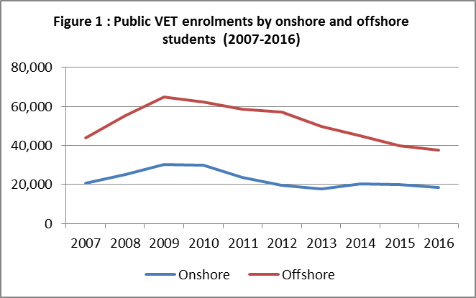This snapshot provides an overview of accredited vocational education and training (VET) delivered offshore by Australian VET providers in 2016. This information is derived from the national data reported to the National Centre for Vocational Education Research (NCVER) directly by the training providers or by the state training authorities[1]. This snapshot also compares VET program enrolments offshore with international student enrolments (onshore) in VET sector. The data on onshore enrolments relates only to international students studying in Australia on a student visa.[2]

In 2016, there were 242 accredited providers delivering Australian VET qualifications to offshore students, the number increased from 186 accredited providers in 2015. The total number of enrolments offshore declined by 7.5 per cent in 2016 (from 42,738 in 2015 to 39,526 in 2016). Onshore international student enrolments in VET sector grew by 11.6 per cent over the same period in 2016. Nevertheless, VET program enrolments with public providers declined both offshore (5.6%) and onshore (7.1%) in 2016 (Figure 1)[3].

**State**

More than half (59.4%) of VET enrolments offshore were with providers in Victoria followed by providers in New South Wales (NSW) (13.2%). Conversely, NSW was ahead in VET enrolments onshore (42.5%) followed by Victoria (28.3%). Since 2015, offshore VET enrolments declined in all states except Queensland, where the enrolments grew by 17.3 per cent.

**Location**

The top five countries for offshore VET provision in 2016 were China (67.0%), Kuwait (4.6%), United Arab Emirates (3.0%), Fiji (2.9%), and Mauritius (2.6%). For comparison, the top five source countries for VET international student enrolments onshore in 2016 were India (14.7%), the Republic of Korea (8.6%), Thailand (8.3%), China (7.4%) and Brazil (6.0%) (Table 1).

**Field of education**

In 2016, Management and Commerce was the top broad field of education for VET students studying either offshore (42.1% of enrolments) or onshore in Australia (54.0% of enrolments). The program enrolments offshore grew in some areas such as Education (by 20.2%), Information Technology (by 9.3%) and Mixed Field Programmes (by 1.0%) in 2016, compared to these fields of education delivered offshore in 2015.

1. NCVER 2017, *Australian vocational education and training statistics: total VET students and courses 2016 — pivot tables*, NCVER, Adelaide
2. International students data of the Department of Education and Training
3. Equivalent NCVER data for 2014 and previous years are available at: [https://internationaleducation.gov.au/research/transnationaleducationdata/pages/transnational-education-data.aspx](https://internationaleducation.gov.au/research/OffshoreEducationData/pages/transnational-education-data.aspx)