

**May 2018**

International students in regional areas

In 2017, according to the Australian Bureau of Statistics Australian Statistical Geography Standard remoteness structure, three per cent of onshore international student enrolments were at institutions in regional locations of Australia[1]. Queensland had the highest proportion (6%), followed by New South Wales with 1.2% of its international student enrolments in regional locations (Table 1).

The majority (89%) of international student enrolments in regional campuses across Australia were in the ten regions shown in Table 2. Students were predominantly in large regional cities where education campuses are present. For example, only seven of the 2,430 enrolments in the Northern Territory were outside of Darwin.

**Nationality**

China (24%) and India (12%) were the top two source countries for regional enrolments followed by Nepal (6%), Malaysia (4%) and the USA (4%). China and India together contributed a third (36%) of the total regional enrolments, although just three per cent of all student enrolments from these countries were in regional areas. In comparison, eight per cent of the USA’s enrolments were in regional areas. The USA had the highest proportion of regional enrolments out of the top ten nationalities represented in the regional areas.

**Sector, Level of Study and Field of Education**

Over half (52%) of students studying in regional areas were enrolled in higher education. The next most popular education sectors were VET, ELICOS, schools and non-award (see Chart 1).

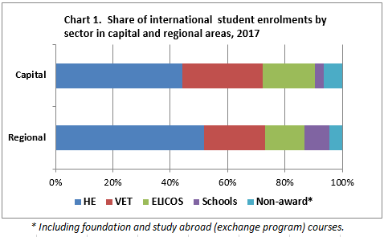Bachelor or Masters (by coursework) degrees were the most popular level of study for higher education students in both regional and metropolitan areas. Postgraduate research made up twelve per cent of enrolments in regional areas, compared with six per cent in metropolitan areas. Higher education students in regional areas were more likely to be studying in STEM[2] fields (40% of all enrolments) than those in metropolitan areas (28% of all enrolments).

**How international education contributes to regional communities**

It was estimated that onshore international students studying and living in the New South Wales region of New England and the North West contributed $33 million to the local economy and supported 243 full time equivalent (FTE) jobs in 2014-15 and those studying and living in Cairns (Queensland) contributed $36 million to the region, which supported 273 FTE jobs. In addition, regional economies also benefit indirectly from international students in metropolitan areas via supply chains. For example, spending by international students in Melbourne was estimated to contribute $888 million to regional Victoria[3] and supported 5,478 FTE jobs there.

1. *Regional for the purpose of this research snapshot includes all non-Major Cities areas as defined in the Australian Bureau of Statistics Australian Statistical Geography Standard (ASGS) Remoteness structure* [*http://www.abs.gov.au/websitedbs/D3310114.nsf/home/remoteness+structure*](http://www.abs.gov.au/websitedbs/D3310114.nsf/home/remoteness+structure)*. International student enrolments not be coded to the ASGS (1.5%) are excluded in this research snapshot.*
2. *Science, Technology, Engineering and Mathematics; incorporating the broad fields Natural Physical Sciences, Agriculture and Environmental Studies, Information Technology and Engineering.*
3. *Deloitte Access Economics (2016). The Value of International Education to Australia available at* [*https://internationaleducation.gov.au/research/research-papers/Documents/ValueInternationalEd.pdf.*](https://internationaleducation.gov.au/research/research-papers/Documents/ValueInternationalEd.pdf)

  