 June 2016

International students studying non-award courses in 2015

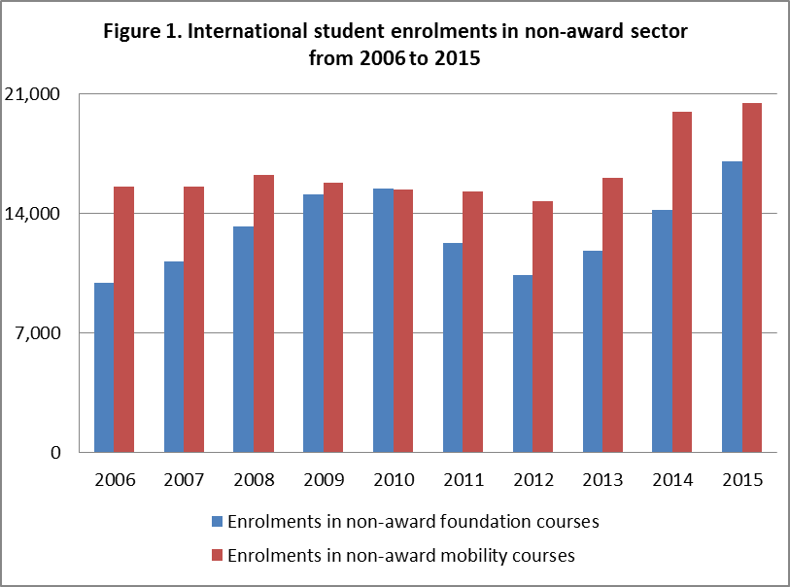This snapshot provides an overview of international student enrolments in courses that do not result in an award (or qualification) that is recognised under the Australian Qualifications Framework. Australian non-award courses include two broad types: **foundation** and other enabling courses; and **mobility** courses, including study abroad and study exchange programs.

There were 645,185[1] international student enrolments in Australia in 2015. Almost six per cent or 37,496 enrolments were in the non-award sector, which included 17,044 enrolments in foundation courses and 20,452 enrolments in mobility[2] courses.

**Trends**  Figure 1 illustrates the pattern of enrolments in non-award courses since 2006. Enrolments in foundation courses increased steadily between 2006 and 2010 at an average of 11.8% per year. However, they declined by 18% per year in 2012 from 2010, and enrolments have risen consistently by 18% per year from 2012 to peak at 17,044 in 2015. Conversely, enrolments in non-award mobility courses have remained relatively steady since 2006. They increased by 24.3% in 2014 from the previous year and have remained stable in 2015.

**Top nationalities**

In the non-award sector, 46% of international students were enrolled in foundation courses. The majority of these enrolments were students from Asia. By nationality, China accounted for 58% of enrolments. The top 5 nationalities, together contributed nearly three quarters of enrolments (75%) in non-award foundation courses (Table 1).

Of the 54% of non-award enrolments in mobility courses, 86% were either from the Americas or Europe. Table 2 outlines the enrolment contribution of the major source countries, and together the top 5 nationalities accounted for over 60% of enrolments in non-award mobility courses, comprising of 59% in study abroad programs and 41% in exchange programs or other short-term mobility activities.



1. International student data is available at the Department of Education and Training's website at [https://internationaleducation.gov.au/research/international-student-data/pages/default.aspx](https://internationaleducation.gov.au/research/international-student-data/Pages/defaultOLD.aspx). The YTD December 2015 data was used in this research snapshot.
2. All courses in the non-award sector were categorised into either foundation and other enabling courses or mobility courses. The enrolments flagged as foundation course enrolments in the data were supplemented by other un-flagged enrolments in the non-award sector that were also apparently foundation courses, based on the name of the course.