October 2017
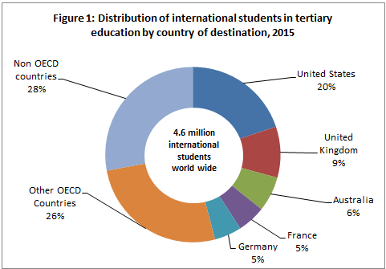
The global context of tertiary student mobility
OECD's Education at a Glance 2017 provides a picture of countries that international students around the world choose to study at. The OECD report only counts tertiary students enrolled in higher education including undergraduate and postgraduate programs, up to PhD level and also including vocational diploma programs, provided those programs are of at least two years duration. Hence, the OECD data is largely reflective of students studying towards full degrees in other countries and excludes the substantial number of internationally-mobile students who may be studying for course credit in other countries through study abroad and student exchange programs.
Major destination countries
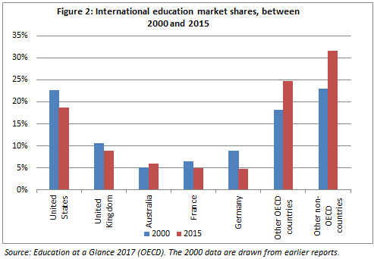
Almost 4.6 million international students were studying outside their home country in 2015. The USA hosted the largest number of international students with 20 per cent enrolled at the tertiary levels, followed by the United Kingdom (9%), Australia (6%), France (5%) and Germany (5%). Together these top five destination countries hosted 44 per cent of all international tertiary students pursuing their tertiary level studies abroad in 2015 (Figure 1).

The share of international students who chose the US and the UK as their choice of study destination has been declining since 2000 due to the growing prominence of other study destinations, including Australia (Figure 2). However, the global share of international students studying in the US remained highest (19%) with 907,251 international students followed by the UK (9%) with 430,833 international students in 2015. Australia’s global share was third (6%) with 294,438 international students in 2015.

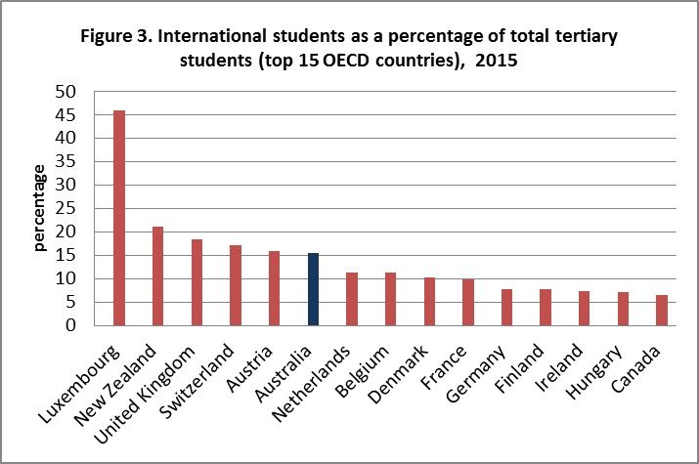
Across all OECD countries combined, almost 6 per cent of all tertiary students were international students in 2015. The OECD reported Australia as having the sixth highest proportion (16%) of international students in its total student population, behind Luxembourg (46%), New Zealand (21%), United Kingdom (19%), Switzerland (17%), and Austria (16%) (Figure 3). The same figure for the US was just 4.6 per cent.

Major source regions/countries

Asia (32%) was largest regional source of international enrolments abroad at all tertiary levels, followed by Europe (16%) and Americas (6%). The top source countries of internationally mobile students were China (20%), followed by India (7%), Germany (4%), Korea, France and Saudi Arabia (each ranging between 2- 3%).

Broad fields of Education

The 2017 OECD report noted that about one third of internationally mobile students in OECD countries were enrolled in Science, Technology, Engineering and Mathematics (STEM) fields. This was further broken down into engineering, manufacturing and construction (17%), natural sciences, mathematics and statistics (10%), and information and communication technologies (6%).

The OECD report ‘Education at a Glance 2017’ is available at: http://www.oecd.org/education/education-at-a-glance-19991487.htm. The OECD term 'international student' refers to those students who have left their country of origin for the purpose of study and ‘foreign student' refers to students who are not citizens of the countries in which they are enrolled, but may be long-term residents or were born in that country. The data do not include students enrolled in countries that did not report international or foreign students to the OECD or to the UNESCO Institute for Statistics.
UNESCO Institute for Statistics.

