December 2016
The global context of tertiary student mobility
In 2016, ICEF (International Consultants for Education and Fairs) reported that approximately five million tertiary students were studying abroad, an increase of 67 per cent since 2005. ICEF also speculated that this number may increase to 8 million students by 2025.
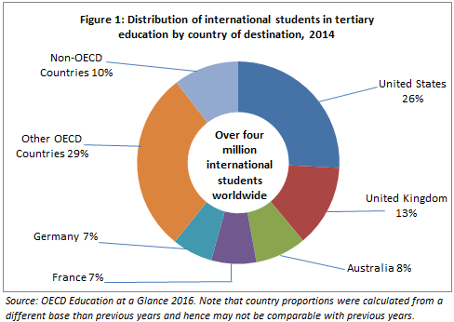
OECD's Education at a Glance 2016 provides a breakdown of countries in which international students choose to study. The OECD report counts tertiary students enrolled in higher education undergraduate and postgraduate programs up to PhD level and in vocational diploma programs, provided those programs are of at least two years duration. Hence, the OECD data is largely reflective of students studying for full degrees in other countries and excludes a substantial number of internationally-mobile students who may be studying for course credit in other countries through study abroad and student exchange programs.
Major destination countries
The USA hosted the largest number of international students with 26 per cent enrolled at the tertiary levels in 2014, followed by the United Kingdom (13%), Australia (8%), France (7%) and Germany (7%).
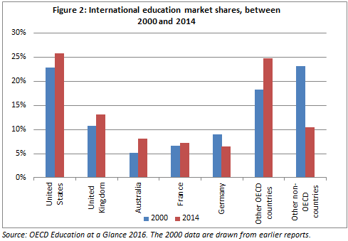
Together these top five destination countries hosted almost two-thirds of all international tertiary students pursuing their tertiary level studies abroad in 2014 (Figure 1)³.

The share of international students who chose the USA as their destination has been declining since 2000 (Figure 2) due to the growing prominence of other study destinations, including Australia. However, recent strong growth in students studying in the US has seen its global share grow to 26 per cent (842,384 students) in 2014. During the same period, Australia’s share increased to 8 per cent (266,048 students) in 2014.

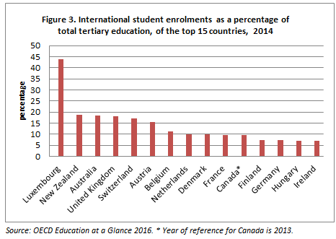
The 2016 OECD report noted that the immigration policies in several OECD countries have eased allowing international students to stay on after graduation, for example for three years in Canada and up to four years in Australia for post-study work. These options have made these countries more attractive destinations for international students.

Major source regions/countries

Students from Asia (53%) form the largest group of international students at the master’s and doctoral or equivalent levels studying abroad followed by Europe (25%) and Africa (10%). Chinese students in particular had the highest share in 2014, accounting for 22 per cent of international postgraduate tertiary students, followed by Germany (4%).

Across all OECD countries, an average of 6 per cent of tertiary students were international students in 2014. The OECD reported Australia as having the third highest proportion (18%) behind Luxembourg (44%) and New Zealand (19%) (Figure 3).

ICEF Monitor: http://monitor.icef.com/2016/11/four-megatrends-changing-competitive-landscape-international-education/
The OECD report ‘Education at a Glance 2016’ is available at: http://www.oecd.org/edu/education-at-a-glance-19991487.htm. The OECD term 'international student' refers to those students who have left their country of origin for the purpose of study and ‘foreign student' refers to students who are not citizens of the countries in which they are enrolled, but may be long-term residents or were born in that country. The data do not include students enrolled in countries that did not report international or foreign students to the OECD or to the UNESCO Institute for Statistics
Enrolment of international students by country of origin obtained from: http://stats.oecd.org/

