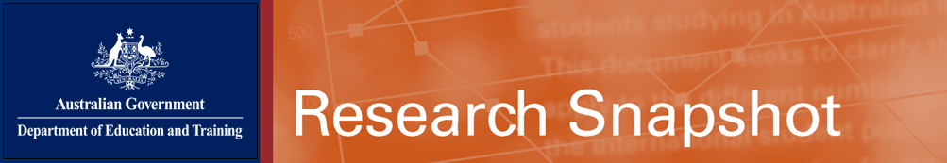
June 2016
Export income to Australia from international education activity in 2015

This snapshot highlights the latest data on international education exports released by the Australian Bureau of Statistics in its International Trade in Services series(a).
Size of exports

International education activity^{(b)} arising from international students studying and living in Australia contributed $18.8 billion to the economy in 2015. This is a 3.3% increase from the earnings recorded in financial year 2014-15 ($18.2 billion); up 10.4% on calendar year 2014 ($17.0 billion) and up 25.3% on calendar year 2013 ($15.0 billion).

The total export income generated by all international education activity was $19.4 billion. This comprised spending by onshore students (the ABS uses the term ‘education-related personal travel’ for this item), as well as offshore earnings from other educational services and royalties which generated an additional $555 million, as outlined in the table below.

Education-related personal travel is Australia’s 3rd largest export after iron ore ($49.0 billion) and coal ($37.0 billion). It is the largest services export (28% of total services exports), ahead of other personal travel services ($15.9 billion); and professional and management consulting services ($5.0 billion).
Education sector^{(c)}
In 2015, the higher education sector generated $12.9 billion in export income (68.6% of total on-shore earnings). VET was the second largest, generating $3.1 billion in earnings (16.4%). Export income from ELICOS was $1.0 billion (5.4%); schools, $728 million (3.9%); and non-award, $698 million (3.7%).
Export income by state and territory, 2015
(a) Sourced from the Australian Bureau of Statistics’ publication International Trade in Services, by Country, by State and by Detailed Services Category, Calendar Year, 2015 (ABS Catalogue no. 5368.0.55.004) published on 23 May 2016. (b) Includes international students studying onshore on student visas only. (c) International students from New Zealand and those on Department of Foreign Affairs and Trade/Defence scholarships contributed an additional $157m and $240m respectively. (d) Export income reported by the ABS does not include income generated through offshore tuition provided by Australian institutions.

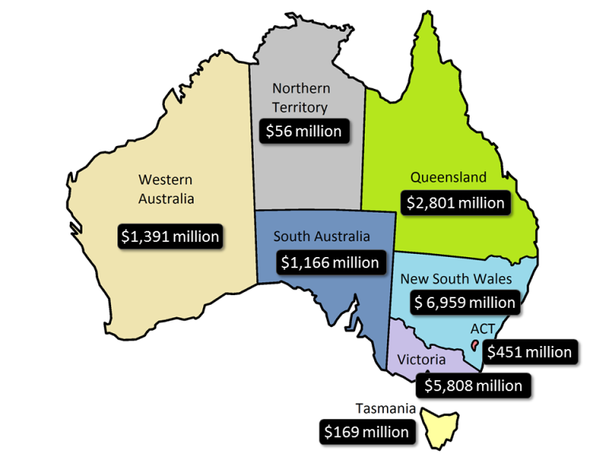

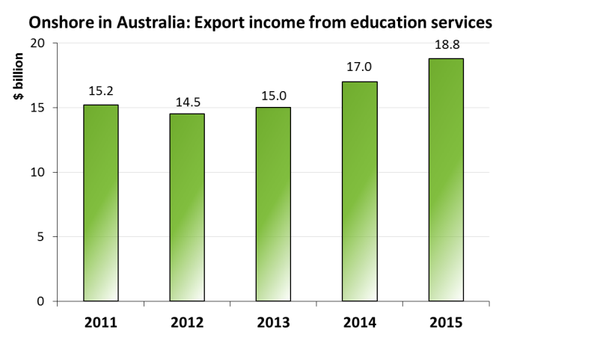

Australia's total exports of education-related services
 | A$ million |  |  | % share  of 2015 | % change  from 2014
 | 2013 | 2014 | 2015
Education-related personal travel | 15,010 | 17,037 | 18,801 | 97.1% | 10.4%
China | 4,068 | 4,469 | 4,971 | 25.7% | 11.2%
India | 1,248 | 1,704 | 2,148 | 11.1% | 26.1%
Vietnam | 825 | 988 | 1,016 | 5.2% | 2.8%
Republic of Korea | 740 | 762 | 784 | 4.1% | 2.9%
Malaysia | 714 | 733 | 780 | 4.0% | 6.4%
Thailand | 522 | 618 | 684 | 3.5% | 10.7%
Nepal | 436 | 558 | 657 | 3.4% | 17.7%
Indonesia | 552 | 572 | 608 | 3.1% | 6.3%
Pakistan | 379 | 459 | 527 | 2.7% | 14.8%
Brazil | 348 | 471 | 516 | 2.7% | 9.6%
Other countries | 5,178 | 5,703 | 6,110 | 31.6% | 7.1%
Other educational services^{(d)} | 478 | 558 | 524 | 2.7% | -6.1%
Education consultancy services | 145 | 140 | 162 | 0.8% | 15.7%
Correspondence courses | 13 | 9 | 12 | 0.1% | 33.3%
Services through educational institutions | 208 | 334 | 276 | 1.4% | -17.4%
Other education services | 112 | 75 | 74 | 0.4% | -1.3%
Royalties on education services | 33 | 31 | 31 | 0.2% | 0.0%
Total education-related services exports | 15,521 | 17,626 | 19,356 | 100.0% | 9.8%

