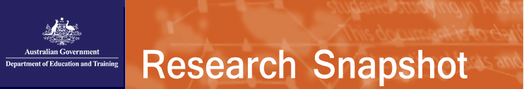

**August 2017**

International student enrolments in the ELICOS sector in 2016

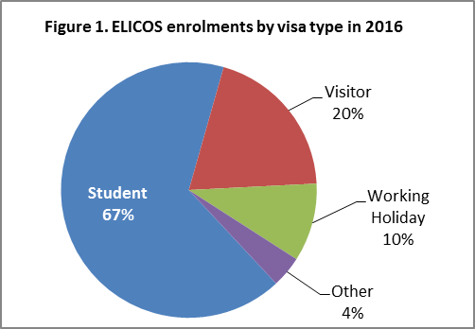This snapshot provides an overview of international students studying English Language Intensive Courses for Overseas Students (ELICOS) in Australia in 2016. The Department of Education and Training's international student data on enrolments and commencements relate only to international students studying in Australia on a student visa. The English Australia (EA) survey of English language studies in 2016 provides information about ELICOS students on all temporary visas, not just student visas. Findings of the EA survey are weighted against data from the department to provide a useful picture of the make-up of the total ELICOS student population. For a more current count of ELICOS enrolments by student visa holders, refer to the department's international student data.

In 2016, the EA survey showed that ELICOS enrolments grew by 2 per cent to 173,506 (from 170,628 in 2015). The majority of the students studying ELICOS were on student visas (67%) followed by visitor (20%), working holiday (10%) and other (4%)[1] visas (Figure 1). In comparison to 2015, the number of ELICOS enrolments on student visas and visitor visas increased by 3 per cent and 15 per cent respectively but the number of ELICOS enrolments on working holiday visas and other visas declined by 7 per cent and 39 per cent respectively (Table 1). Figure 2 illustrates the changing shares of ELICOS students on different visa types over the last seven years.

All states experienced overall growth in enrolments in 2016 when compared to 2015. South Australia had the largest growth at 11 per cent followed by Queensland (2%)[2]. A total of 7 per cent ELICOS students enrolments were in a regional area in 2016. The largest share of ELICOS student enrolments in a regional area was in Queensland 11% followed by NSW 8% and Victoria 6%.

**Nationality**

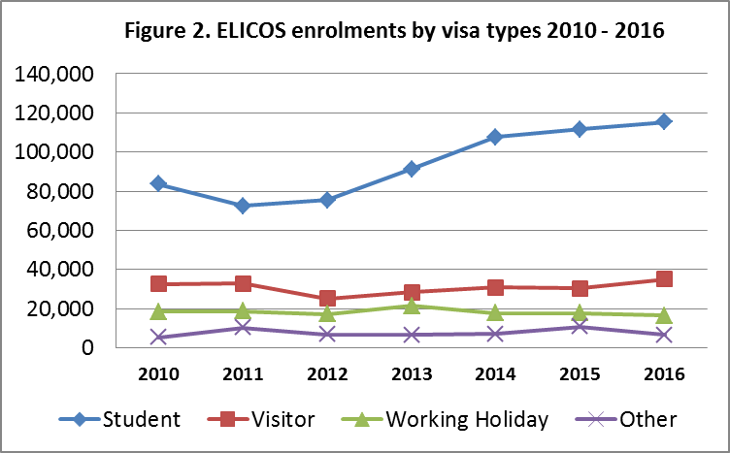In 2016, the ELICOS sector continued to draw most of its students from the Asia-Pacific (67% down from 68% in 2015). Student enrolments from China accounted for 22 per cent, making it the largest source country of all ELICOS student enrolments in 2016. The remaining top ten nationalities in order were: Japan, South Korea, Brazil, Thailand, Colombia, Taiwan, Vietnam, Italy and India. The top ten source countries together accounted for 75 per cent of ELICOS student enrolments in 2016. Six of the top ten source countries showed increases in the ELICOS student enrolments in 2016 compared to 2015.

Of these top ten source countries, 83 per cent of Chinese students held a student visa. Over half (53%) of Japanese students were on visitor visas which remain the most popular visa type for Japanese students. The student visas and working holiday visas were popular for students from South Korea (42% and 34%), Italy (47% and 34%) and Taiwan (58% and 20%) respectively. The majority (ranging from 84% to 98%) of students from other top nationalities held student visas in 2016.

**Duration of study**

In 2016, there was a slight increase in student weeks overall by a week. The average duration of study increased from 12.4 to 13.4 weeks. ELICOS students on student visas had a higher average number of study weeks (16.8) than those on any other visa types. Nonetheless, the average length of study for student visas also increased from 15.3 to 16.8 weeks between 2015 and 2016. The average length of study for all other visas increased slightly, compared with 2015 except a slight decline for visitor visa holders from 4.9 to 4.7 weeks.

1. Examples of Other visas include temporary relative, spouse or bridging visas
2. The data for small states (too few providers) were combined with large states i.e. NSW/ACT, VIC/TAS, QLD/NT