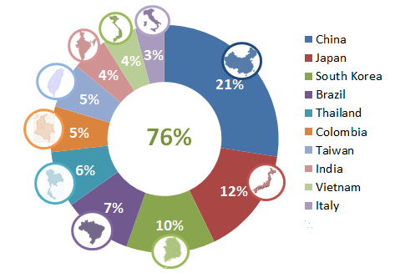
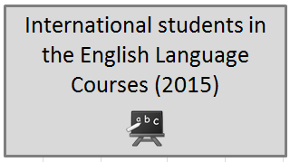
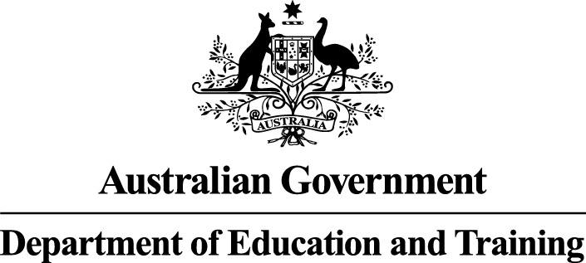
The top ten source countries for ELICOS students (making up 76% of all ELICOS)
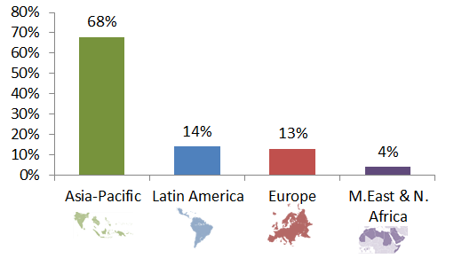
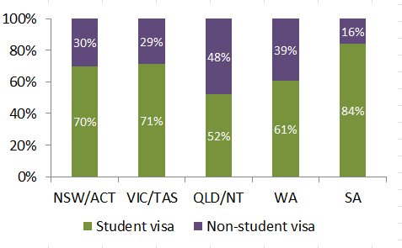
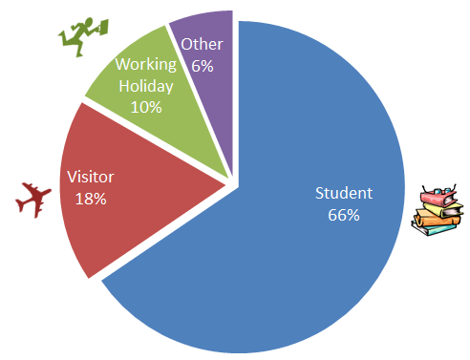
Source – English Australia survey of ELICOS Regional Markets 2015
ELICOS students in QLD/NT & WA were more likely to be on non-student visas than in other states
68% of all ELICOS students were from the Asia-Pacific region
The different visas held by people studying English Language Intensive Courses for Overseas Students (ELICOS)

International students in the English Language Courses in 2015
International student numbers in English language courses by type of visa
The proportions of different visas held by international students studying English Language Intensive Courses for Overseas Students (ELICOS) are given below:
Student visa: 66%
Visitor visa: 18%
Working Holiday visa: 10%
Other visas: 6%.
ELICOS students by nationality
The majority (76%) of ELICOS students were from the following top ten source countries:
China (21%)
Japan (12%)
South Korea (10%)
Brazil (7%)
Thailand (6%)
Colombia (5%)
Taiwan (5%)
India (4%)
Vietnam (4%)
Italy (3%).
Student visa versus non-student visa by state or territory
ELCIOS students in QLD/NT and WA were more likely to be on non-student visas than in other states:
NSW/ACT: 70% on student visa and 30% on non-student visas
VIC/TAS: 71% on student visa and 29% on non-student visas
QLD/NT: 52% on student visa and 48% on non-student visas
WA: 61% on student visa and 39% on non-student visas
SA: 84% on student visa and 16% on non-student visas.
ELICOS students by regions
Over two-thirds (68%) of ELICOS students were from the Asia-Pacific region. The proportions of ELICOS students from all regions were:
Asia-Pacific: 68%
Europe: 13%
Latin America: 14%
Middle East and North Africa: 4%.
Source: English Australia Survey of Major ELICOS Regional Markets in 2015

