July 2016
Australian scholarships and support for international students

In 2015, just over 255,000 international higher education students studied on a student visa in Australia. There were 18,946 enrolments by international students in postgraduate research courses (either Masters by research or PhD courses), including 4,787 commencements (new enrolments) in 2015.

These international postgraduate research students make an important contribution to Australian higher education. In the first six months of 2015, international research students made up 31 per cent of all postgraduate research students (including domestic students) studying in Australian higher education. Both the Australian Government and Australian universities invest heavily in scholarships to attract and support international research students.

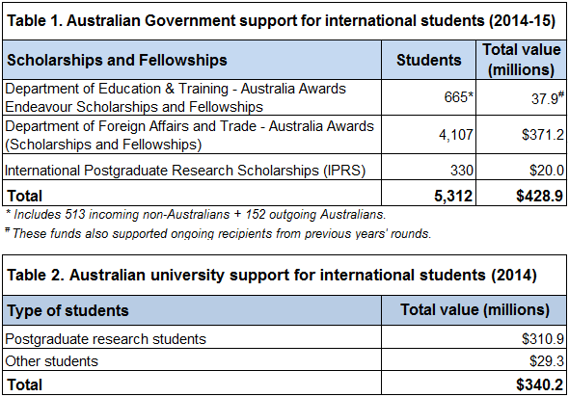
In 2014-15, the Australian Government provided over $428 million in scholarships and fellowships for internationally mobile students as outlined in Table 1.

In 2015, the Department of Education and Training awarded 665 Endeavour Scholarships and Fellowships and provided nearly $38 million to support both these and recipients from previous years. These comprised scholarships and fellowships for postgraduate and postdoctoral research, executive fellowships for professional development and scholarships for Vocational Education and Training. The department also awarded 330 International Postgraduate Research Scholarships (IPRS) in 2015, representing $20 million in additional funds.

In 2015 the Department of Foreign Affairs and Trade and the Australian Centre for International Agricultural Research (ACIAR) provided over $370 million to facilitate 4,107 new Australia awards for 80 developing countries, an increase of approximately 2,000 awards since 2010. Around 84 per cent of the Australia Awards in 2015 were offered to the Asia-Pacific region through Australian aid programs, which comprised of Australia Awards Scholarships, Australia Awards Pacific Scholarships and Australia Awards Fellowships.

Australian universities also provided financial support to international students in 2014 as outlined in Table 2. These figures come from an annual benchmarking study undertaken by the Australian Universities International Directors' Forum (AUIDF) . In 2014, 32 universities that reported data for the study spent $310.9 million, in scholarships and stipends to support commencing international postgraduate research students. This funding provided 3,022 full scholarships, 5,261 partial scholarships and 2,849 stipends in 2014.
In summary, the Australian Government and Australian universities invest nearly $770 million per annum to support international students studying in Australia. This represents around 12 per cent of the total value of tuition fees paid by international students studying higher education in 2015 ($6,417 million).

The departments' international student data at: https://internationaleducation.gov.au/Pages/default.aspx. Student data used in this Research snapshot was from the 2015 full year pivot table.
Table (i) Summary of student numbers for 2015 first half year student data, Higher education statistics at: https://docs.education.gov.au/node/39331
https://internationaleducation.gov.au/Endeavour%20program/Scholarships-and-Fellowships/Pages/default.aspx
IPRS at: https://www.education.gov.au/international-postgraduate-research-scholarships
http://dfat.gov.au/about-us/publications/Pages/australia-awards-statistical-profile.aspx
An unpublished report prepared by i-graduate in late 2015 and kindly provided to the department by the AUIDF. For further information about this Research Snapshot or the Research Snapshot Series contact the International Research and Analysis Unit by email at: IEResearch@education.gov.au. The Research Snapshot series can be accessed from https://internationaleducation.gov.au/research/research-snapshots/pages/default.aspx

