
Australian Education International

Thailand Regulatory

Fact Sheet

2013

COPYRIGHT
© Commonwealth of Australia 2013. This work is copyright. You may download, display, print and reproduce this material in unaltered form only (retaining this notice) for your personal, non- commercial use or use within your organisation.All other rights are reserved. Requests and inquiries concerning reproduction and rights should be addressed to Commonwealth Copyright Administration, GPO Box 2154, Canberra ACT 2601 or email commonwealth.copyright@dcita.gov.au.

DISCLAIMER
The Commonwealth of Australia, its officers, employees or agents disclaim any responsibility for any loss howsoever caused whether due to negligence or otherwise from the use of information in this publication. No representation expressed or implied is made by the Commonwealth of Australia or any of its officers, employees or agents as to the currency, accuracy or completeness of the information contained in this report. The reader should rely on their own inquiries to independently confirm the information and comment on which they intend to act.

Table of Contents
1. Introduction 1
2. Thailand 2
2.1. Fast Facts 2
2.1.1. Country Overview 2
2.2. Regional Overview 3
2.3. Thailand Development Strategy, 2012 - 2016 5
2.4. Population and Student Enrolment 6
3. Education Sector Overview 8
3.1. Overview 8
3.2. Formal Education 9
3.2.1. Basic Education Early Year Education 9
3.2.2. School Education 10
3.2.3. Vocational Education and Training 11
3.2.4. Higher Education 12
3.3. Non-formal Education 15
3.4. Informal Education 15
3.5. Research, Science and Technology 16
4. Education Sector Governance and Administration 19
4.1. Governance and Administration 19
4.2. National Education Policies 20
4.2.1. Ministry Of Education Policies and Strategies 21
4.2.2. Education Sector Priorities and Reforms 22
4.3. Education Sector Funding Arrangements 24
4.3.1. Student Loans 25
4.4. ASEAN Free Trade Agreement 26
5. Regulatory Controls and Quality Assurance for Education Sectors 27
5.1. Legislation and Regulations 27
5.1.1. Regulation of the Non-Formal and Informal Sector 27
5.2. Regulation of the Formal Sector 28
5.2.1. Centralised Quality Assurance 28
5.2.2. Regulatory Controls for School, Vocational & Other Non Higher Education 29
5.2.3. Higher Education Sector Regulation and Controls 33
5.3. Private Higher Education Institution 34
5.3.1. Legislative Requirements 35
5.3.2. Corporate Governance and Business Ethics 37
5.3.3. Summary of Relevant Bodies and Legislation 40
6. International Engagement 41
6.1. International Education 41
6.2. Inbound Students to Australia 45
7. International Cooperation 47
7.1. Opportunities for International Cooperation 47
7.2. Transnational Education 49
7.2.1. Australian Requirements 52
7.2.2. Transnational Education Quality Strategy 53
7.3. Other Cooperative Activities and Models 56
8. Business and Financial Requirements 60
8.1. Australia / Thailand Free Trade Agreement 60
8.2. Foreign Investment 60
8.3. Visa Requirements 61
8.4. Business Registration Process 62
8.5. Related Business Legislation 62
8.5.1. Taxation 62
8.5.2. Quality Assurance for Businesses 63
8.5.3. Repatriation of Funds 63
9. Cultural Considerations and Resources 64
9.1. Doing Business Tips 64
10. Additional References 65
11. Key Contacts/ Agencies 66
12. Bibliography 67

Introduction
The purpose of Country Regulatory Fact Sheets is to provide up-to-date information on the regulatory and business requirements for establishing education and training services in overseas countries. The fact sheets contain publicly available information on a country’s education and regulatory and business environments, together with contact details of agencies and authorities in those countries that have responsibility for administering those regulations.

Prospective offshore providers are still advised to undertake their own investigations and due diligence when planning business in other countries; for example, references to laws and regulations must be independently checked for currency and applicability to an institution’s particular circumstances. A summary of the Australian Transnational Quality Strategy for offshore education and training is attached to this fact sheet for your information.
General Country/Economy business fact sheets are available for most countries from the Department of Foreign Affairs and Trade website at www.dfat.gov.au/geo/fs.

Thailand

Fast Facts
Official Name | Kingdom of Thailand
Area | 513,120 sq km (land and sea)
Population | 67,091,089 (July 2012 est.)
Capital | Bangkok
People | Approximately 75 percent of the population are ethnic Thais, with 14 percent of Chinese descent. The remainder is a mix of other regional ethnicities.
Languages | Thai and other regional and ethnic dialects. English is the second language of the elite.
Prevailing Religions | Buddhist (official) 94.6 percent, Muslim 4.6 percent, Christian 0.7 percent, other 0.1 percent (2000 census)
Form of government | Constitutional Monarchy with bicameral National Assembly

Country Overview
Thailand is located in South East Asia. Its neighbors include Myanmar, Laos, Cambodia, and Malaysia. The capital and largest city is Bangkok, which is Thailand's political, commercial, industrial, and cultural hub. Thailand has 76 provinces that are further divided into five geographic regions including: North Thailand (17 provinces), Central Thailand (19 provinces), North East Thailand (19 provinces), South Thailand (14 provinces), and East Thailand (7 provinces). There are also two Special Governed Districts: the city of Bangkok and the city of Pattaya.

Thailand is the 20th most populous country in the world, with around 64 million people. About 75 percent of the population is ethnically Thai, 14 percent is of Chinese origin, and three percent is ethnically Malay.The remaining population belongs to minority groups including Mons, Khmers, and various hill tribes. Buddhism is the primary religion, practiced by around 95 percent of the population.

Thai is the official language of Thailand, spoken throughout the country, and is the principal language for education and government. The standard language is based on the dialect of the central Thai people, and it is written in the Thai alphabet. Other dialects exist and coincide with the regional designations. Thailand is also host to several other minority languages including Chinese, Lao and Malay derivatives while numerous tribal languages are also spoken. English is a mandatory school subject, but the number of fluent speakers remains very low, especially outside the cities.

Thailand has a well-developed infrastructure, a free enterprise economy, and strong export industries. Thai exports including machinery and electronic components, agricultural commodities, and jewellery drive the economy and account for more than half of the GDP. In 2010, Thailand's economy expanded 7.8 percent - its fastest rise since 1995 - as exports rebounded from depressed 2009 levels. The Bank of Thailand anticipates the economy will grow by 4.9 per cent in 2013.

The country is a constitutional monarchy, headed by King Bhumibol Adulyadej who has reigned since 1946. The head of the government, elected in July 2011 is Prime Minister HE Yingluck Shinawatra; the first female and the youngest Prime Minister in the country’s history.

Regional Overview
Thailand Provinces
- Chiang Rai | - Mukdahan | - Ayuthaya
- Payao | - Amnat Charoen | - Nakhon Pathom
- Nan | - Maha Sarakham | - Sing Buri
- Chang Mai | - Roi-Et | - Pathum Thani
- Mae Hong Son | - Yasothon | - Bangkok
- Lampang | - Nakhon Ratchasima | - Samut Songkhram
- Lampun | - Buriram | - Samut Sakhon
- Phrae | - Surin | - Nonthaburi
- Uttaradit | - Sri Saket | - Samut Prakan
- Sukhothai | - Ubon Ratchathani | - Phetchaburi
- Tak | - Kanchanaburi | - Prachuap Khiri Khan
- Phitsanulok | - Chai Nat | - Chumphon
- Loei | - Lop Buri | - Ranong
- Kamphaeng Phet | - Prachin Buri | - Surat Thani
- Nong Khai | - Sra Kaew | - Phang Nga
- Sakon Nakhon | - Suphan Buri | - Krabi
- Nakhon Phanom | - Ratchaburi | - Nakhon Sri Thammarat
- Udon Thani | - Chachoengsao | - Trang
- Nong Bua Lamphu | - Chon Buri | - Patthalung
- Petchabun | - Rayong | - Satun
- Phichit | - Chanthaburi | - Songkhla
- Nakhon Sawan | - Trat | - Pattani
- Uthai Thani | - Sara Buri | - Yala
- Chaiyaphum | - Nakon Nayok | - Nara Thiwat
- Khon Kaen | - Ang Thong | - Phuket
- Kalasin | - Phra Nakhon S

Provincial Map of Thailand
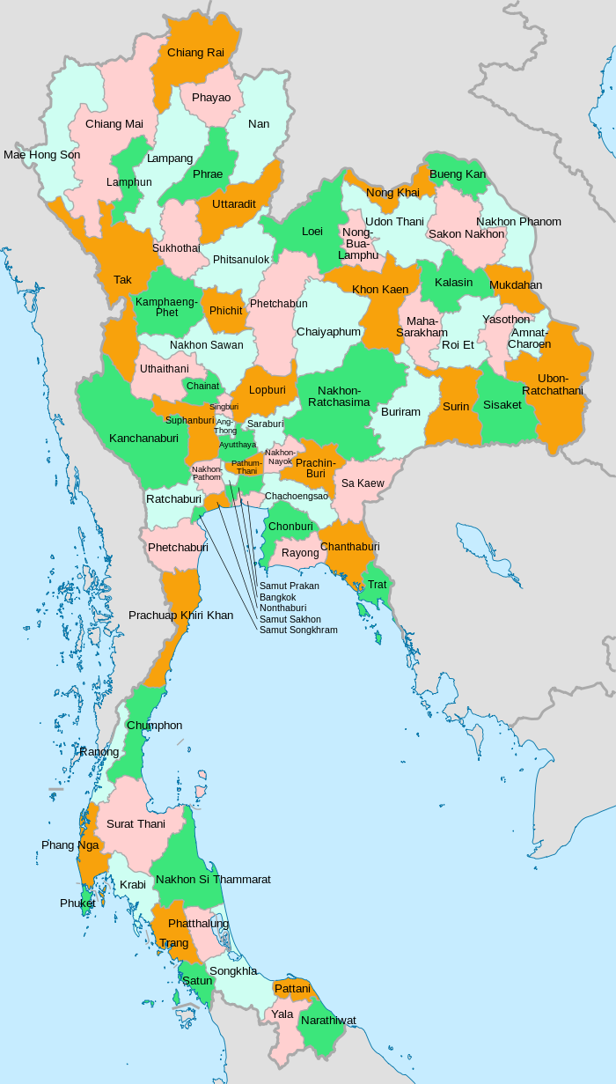

Thailand Development Strategy, 2012 - 2016
Thailand’s Eleventh National Economic and Social Development Plan (2012 - 2016) is a medium-term strategic plan aimed at achieving the “Vision 2027”:

“Thai people are proud of their national identity, in particular hospitality. They also follow the path of sufficiency economy with democratic values and good governance. Quality public services are provided throughout the country. Thai people live in a caring and sharing society in a safe and sound environment. Production process is environmentally friendly, and food and energy resources are secure. The economy is based on self-reliance and increasing linkages and competitiveness on the global market. Thailand actively contributes to the regional and world communities with dignity.”

The Eleventh Plan is the first step towards a longer-term, holistic vision of “A happy society with equity, fairness and resilience.” One of the key strategies outlined in the Eleventh Plan is the development of a lifelong learning society. Key activities of the strategy relate to education and training and include:
- The Quality of Thais at all ages will be increased. Skills for lifelong learning will be developed, focussing on knowledge, innovation, and creativity, and based on the development of five minds—disciplined mind, synthesized mind, creative mind, respectful mind and ethical mind in order to be capable of working in various jobs over a lifetime, relevant to the changing labor market.
- Promotion of lifelong learning. Learning habit will be instilled in all Thais from an early stage in life. Roles of development partners will be promoted as sources of creative learning. Alternative education relevant to needs will be encouraged with the promotion of a learning society and factors conducive to lifelong learning.

These strategies build on work already undertaken during the Tenth National Economic Development Plan (2006 – 2011). These strategies included:
- Invest in raising the quality of the entire educational system to address the development of teachers, curricula, instructional media, and information technology.
- Ensure that every Thai citizen has access to no fewer than 12 years of basic education, free of charge.
- Adjust teacher training and development to ensure quality and high moral standards among teachers.
- Promote the intensive use of information technology to enhance learning efficiency.
- Develop the quality and standard of higher education institutions.
- Promote and adjust regulations to support the decentralisation of educational administration and management to district education offices and academic institutions.
- Encourage the involvement of private sector in educational management.

Population and Student Enrolment
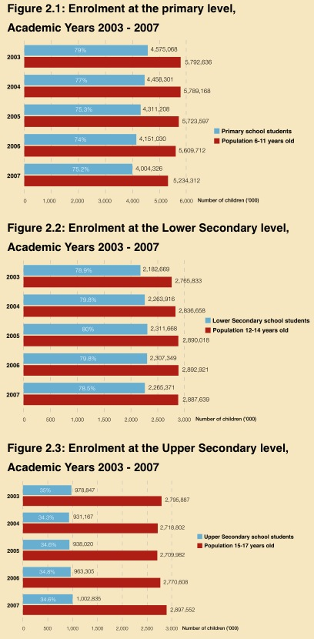
The population of Thailand was 69,122,000 in 2010. The Thai Ministry of Foreign Affairs suggests that, with unregistered individuals added to the official total, the Thailand population is actually nearer to 70 million.
Figures 2.1-2.3: Gross Enrolment Rates By Educational Level, 1987-2005

There has been a steady and substantial increase in student participation at all levels of education in Thailand over the last twenty years. This is the result of explicit government policies.
- The 1997 Constitution provides for all Thai people to have an equal right to receive free, good quality, basic education for at least 12 years.
- The 1999 National Education Act (NEA) established goals in terms of achieving universal lower secondary education by 2006 and universal upper secondary education by 2015. The NEA further mandated the Government to provide general, per-student subsidised expenditure for basic 12-year education (for both public and private educational institutions) and also raised the level of compulsory education from six to nine years.

Thailand has steadily increased gross enrollment rates in lower secondary (from 76 percent to over 100 percent), upper secondary (from 58 percent to 65 percent), and higher education (from 39 percent to 50 percent) between 2001 and 2007.
Student participation decreased due to the financial crisis of 1997 but has recovered and continued to grow. Despite high gross enrollment rates, when looking at the age group trend, it is noteworthy that higher education participation by the appropriate age cohort (18 to 21 years old) is only 25 percent, indicating that the higher education system is significantly populated by over-aged students.

Student Enrolments in Educational Institutions in Thailand

Type of Institution | Enrolments
Kindergarten | 1,591,706
Primary School | 4,817,764
Lower Secondary School | 2,636,288
Upper Secondary School | 647,029
Vocational College/ General High School | 1,190,192
Post Secondary Vocational Education | 324,267
Higher Education (inc teacher training) | 1,721,632
Total | 12,931,543
Sources: Basic Statistics of Ministry of Education (2007)

Education Sector Overview

Overview
Education in Thailand is categorised as formal, non formal or informal.
- Formal education is offered in schools, colleges, institutes, and universities and follows specified standards in each of these sectors.
- Non formal education includes pre-school education and a number of specialised forms of education and training for people outside the formal school system such as language courses, short courses, and adult education programmes.
- Informal education includes a wide range of individual and community mechanisms to facilitate learning such as libraries, museums and public media.

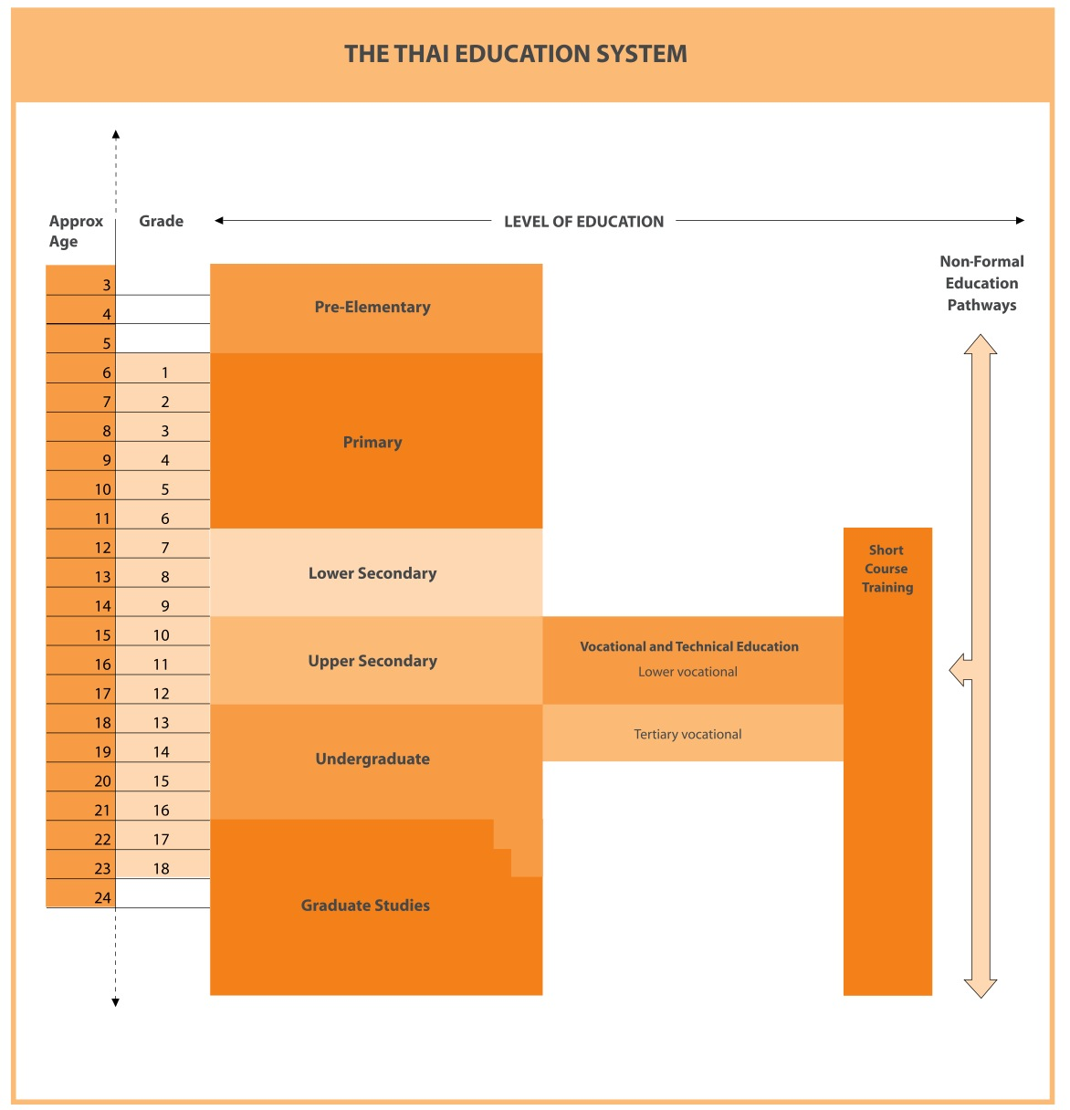

Formal Education
Formal education in Thailand comprises:
- Basic Education, including Early Years Education
- Vocational and Technical Education
- Higher Education

The Thai formal education system - divided into primary and secondary - provides nine years of compulsory education. 12 years of free basic education is guaranteed by the Constitution with an additional two years of free pre-primary education. Enrollment in basic education begins at the age of six. The academic year currently runs from June to March for higher education and from mid May to the end of March for the other sectors. Please note that as of September 2014, the Higher Education Commission plans to shift the commencement date from July to September for all universities to align with the northern hemisphere commencement dates.

Basic Education Early Year Education
Pre-primary education (Anubaan) targets children aged 0-5 years. There are three types of pre-primary education depending on the local conditions:
- preschool classes
- kindergartens
- child care centres

Private schools usually offer a three-year kindergarten program. Two-year kindergarten and one-year pre-school classes are available at public primary schools in rural areas. Pre-school education is not compulsory and has been free since 2009. The government policy on pre-school education has clear direction to expand and improve the provision of pre-school education in state schools in rural areas on a nationwide scale in order to give better education opportunities for economically disadvantaged children in rural areas.

Over 74 percent of children aged three to five receive early childhood education. While the majority of early years education is provided by government primary schools, the Ministry of Education has actively encouraged private schools and local government to take a more significant role. As a result, there has been a marked expansion in the provision of early years education by the private sector. This is particularly evident in the Bangkok metropolitan area where the private sector provides 59 percent of total early year education compared with the national average of 28 percent.

School Education
There are approximately 37,494 schools, 12 million school students and 683,538 teachers in Thailand. The Ministry of Education (MOE), under the Office if Basic Education Commission (OBEC), is responsible for around 36,694 schools, with the remainder under the auspices of other ministries such as Ministries of Interior, Fine Arts, Sport and Tourism. To help facilitate the decentralisation of authority and power to the local level, 178 educational service areas have been established in the 76 provinces, with 175 of these areas in 75 provinces and 3 areas located in Bangkok. This devolution allows schools to provide education relevant to local needs.

There are 12 years of schooling following a 6.3.3 model - six years of primary schooling (Pratom Suksa), three years of lower secondary, and three years of upper secondary school (Matayom Suksa). Education is compulsory to the end of the ninth year on completion of lower secondary education. After lower secondary education, students may continue in upper general education secondary schools or in vocational colleges.

Upper secondary school education consists of Matayom 4-6 and is more specialised. Government upper secondary schools are either general (academic), which lead to university, vocational, which lead directly to employment, or comprehensive institutions which offer both general and vocational programmes. Approximately 83 percent of year nine students continue to the upper secondary level - 33 percent in the vocational colleges and 50 percent in the general education secondary schools.

Admission to most government and private secondary schools is by means of an entrance examination set by the school or by a Government lottery method to admit students to public schools.

Progression from one level of schooling to the next has historically been via entrance examinations, with a zoning program introduced to exempt a percentage of ‘local’ students from the entrance examinations for lower secondary school. This system of progression has been further modified with the introduction of national tests, taken in year three (tested in Mathematics and Thai), year six (tested in Mathematics, Thai. Science and English) and year nine (tested in Mathematics, Thai, Science, English and Social Sciences). The entrance examinations for upper secondary school are normally held after the examinations at the completion of Matayom 3. Students then choose between the academic stream and the vocational stream.

There are around 8,000 private schools in Thailand which operate under the Private School Act (1982), including around 133 international schools in Thailand licensed by the MOE. The academic year for most international schools follows the northern hemisphere school year from September to June. Although the quality is variable, there has been substantial interest from parents eager for their children to have an affordable, ‘international’, domestic education. Attending such schools is considered by some to increase a student’s chances of competing for places within international higher education. International schools generally follow international curricula (for example, the International Baccalaureate IB) and many are linked with or affiliated to parent bodies in other countries (e.g., UK, US). The following private schools in Bangkok are using Australian curricula in their school system:
- Lad Prao Bilingual School - Tasmania curriculum
- St Mark International School - Victoria curriculum
- The International Prep Academy - New South Wales curriculum

Vocational Education and Training
Formal vocational and technical education is conducted at three levels: upper secondary (leading to the Lower Certificate of Vocational Education), post secondary (leading to a Diploma or Vocational Associate Degree), and university level (leading to a Degree).

There are around 744 public and private institutions providing formal VET programmes, including around 416 public colleges and 328 private colleges, as well as many training providers in the private sector. There are an estimated 1.05 million participants in public and private vocational education (2012 data). Around 661,326 students were enrolled in public VET colleges in 2010. Approximately 311,009 students enrolled in private colleges during the same year, with a gender ratio of around 60 percent male to 40 percent female (Current disaggregated data to match the 2012 aggregated data above is not available).

Current data is not available; however, in 2006, around 53percent of participants enrolled in Trade and Industry courses, 35percent in Business Administration, 3percent in Home Economics, 5percent in Agriculture, 2percent in Arts and Crafts and the remainder in Tourism, Fisheries, Textiles and Information and Communication Technology.

Public formal and non-formal post-secondary technical and vocational education is provided through 5 types of colleges: vocational, technical, agricultural and technological, polytechnic, and industrial and community special colleges. Advanced vocational training to technician level is offered by specialised institutes, colleges, and universities. Some higher education institutions including the Rajamangala Universities (Institutes of Technology) and the Rajabhat Universities/Institutes also provide some advanced technical and vocational education.

Significant technical training for people in the workforce is provided under the authority of the Ministry of Labour through provincial skills training centres and a number of other agencies which train personnel to meet specific skill and professional needs. Private vocational schools and colleges offer programmes at both upper secondary and post-secondary level in the fields of agriculture, commerce, business education, and a range of industrial specialisations.

Thailand struggles with quality in many of its vocational institutions, and industry complains that, on the whole, graduates do not have adequate or appropriate skills. Consequently, industry, through individual employers, is forced to take on the responsibility for making graduates job-ready. There is recognition within the Vocational Education Commission of this and of the general mismatch between education supply and labour market demands, both in terms of quality and relevance, yet it struggles with how to respond.

In July 2012, The Ministry of Education issued a new VET policy statement called “Vocational Education Guidelines for Policymaking, Goal Setting and Development of Vocational Manpower”. The policy document is intended to guide policy for the forthcoming 15 years. It lays out four policies, 10 strategies, 28 approaches and 93 flagship projects with an emphasis on multi-dimensional development in such areas as academics, instructorship, teaching capabilities, research competency, and professional capabilities relevant to fields of study at every working phase. In addition, there are procedures for monitoring, teaching orientation by experienced experts emphasising on-the-job training in real sector, society and professional associations in response to changes, and ASEAN manpower competition.

The document was developed by the MOE’s Vocational Education Sub-Committee (VESC) after consultation with stakeholders in the public and private sectors, three working groups, and additional relevant parties to ensure that the proposed policies and strategies will produce the desired qualitative production and improvement of manpower in Thailand. The four key policy objectives are as follows:
- Policy 1: To produce vocational manpower in response to labor market demands.
- Policy 2: To raise the quantity and quality of teachers, faculties and personnel in vocational education.
- Policy 3: To develop the quality of educational institutions and new learning sources.
- Policy 4: To develop management efficiency.

Higher Education
Higher education in Thailand has undergone dramatic changes in the past four decades. The country now has a total of 150 higher education institutions and 19 community colleges with approximately two million students in 2010. This sector consists of 80 public higher education institutions, 14 autonomous universities, 16 traditional universities, 40 Rajabhat universities, nine Rajamangala Technical universities, and one Pathumwan Institute of Technology. The sector also provides 71 private higher education institutions and 19 community colleges.

Over 2.2 million students are currently enrolled in the higher education sector, and participation rates of university age students has increased significantly over the last few years, from an average of 26 percent to the current average of 40 percent.

The following tables show the number of students and the awards undertaken in the academic year, 2007, and the ratio of students enrolled in public and private institutions.

Type of Institution | Total  Students | Lower than Bachelor | Bachelor | Graduate Diploma | Master’s | Higher Graduate | PhD
Public | 1,462,463 | 9,170 | 1,308,670 | 3,545 | 123,640 | 1,004 | 12,644
Private | 161,529 | 102 | 145,853 | 749 | 13,236 | 0 | 1,021

Ratio of Student enrolments b/w in Public & in Private Institutions | Total | Bachelor | Master’s | PhD
 | 90:10 | 90:10 | 90:10 | 93:7
Source: Commission on Higher Education, 2012

The public universities dominate overwhelmingly in all sectors due to the strong preference by Thai students to enroll in public universities which are considered to be of higher quality and prestige than most private universities. Around 78 percent of the final year students in secondary school pursued undergraduate degrees in 2005.

In 2010, the majority of academic staff in public universities was lecturers (67 percent) followed Assistant Professors (20 percent), Associate Professors (11 percent), and Professors (1 percent). The shortage of senior academics in Thailand is partially caused by early retirements, with CHE suggesting a need for more than 10,000 university lecturers in Social Studies, Science and Technology and Medicine to minimise the shortages.

In 2006, the MOE implemented a new system for gaining access to a Thai public university, moving away from an Entrance Examination to the Central Universities Admissions System (CUAS) and introducing the Advanced National Educational Test (A-Net) and the Ordinary National Education Test (O-Net) as well as the Grade Point Average (GPA) criteria. The percentage weightings will change annually as follows:

 | 2006-2009 | 2010
GPAX* | 10% | 20%
GPA* | 20%
O-NET* | 35-70% | 30%
A-NET* | 0-35% | Aptitude Test 50%
*GPAX – overall cumulative GPA for grades 10-12
*GPA – grade point average in grades 10-12 (3 to 5 of the 8 subject groups of the core curriculum).
*A-Net – focuses on analytical thinking abilities, problem-solving skills and special skills required by some university departments
* O-Net - focuses on subject knowledge

The advantages of an admissions system allow students to fully focus on the studies in class rather than tutorials from outside the classroom since their GPAX, GPA and ONET scores are highly considered to gain admission to the universities. This method enhances the standard of teaching and studying in high schools to be more effective and efficient. However, some academics question inequalities in institutional standards as disadvantaging students. For example, a low percentage of A-NET score are considered as well as the chance to take the A-NET exam per subject only once in a year.

In 2010, MOE developed an admissions system by adding GAT (General Aptitude Test) and PAT (Professional Aptitude Test), which replace A-NET. Students can take GAT and PAT twice a year and they may choose the higher scores when applying to the universities, combining their GPAX and O-NET scores. The percentage weightings are as following:

 | 2010-2012
GPAX* | 20%
GPA* | 30%
O-NET* | 10-50%
A-NET* | 0-40%

Many Presidents of Thai public universities have expressed concern with the CUAS system which has received significant attention in the Thai media in 2007. It is anticipated that significant changes will be made to the admissions system for 2010.

The main institutions offering teacher education are Rajabhat Universities under the responsibility of the CHE. In 2006, around 70 percent of lecturers had obtained Master degrees, 18 percent held Bachelor degrees, and approximately 9percent possessed PhD. The MOE ten year strategy to 2013 is focusing on enabling teachers to improve their ability to manage and facilitate teaching and learning activities in the classroom in line with the new curriculum, approaches, and standards. Other initiatives include reducing teaching workloads, professional development vouchers, teacher standards, strategies for addressing teacher debts and teacher shortages, and refining enabling legislation.

The administration and supervision of higher education is under the Office of the Higher Education while the Office of the Private Education Commission supervises and subsidises private educational institutions. Both offices are under the Ministry of Education’s administrative structure. In accordance with recent educational reforms, public universities have become autonomous, and they exercise greater control over the management of their own affairs to enhance efficiency and accountability.

Non-formal Education
Thailand supports and encourages non-formal education as a means of providing lifelong learning opportunities to the out-of-school population. Initially aimed at literacy in primary levels, non-formal education services have expanded significantly into secondary and vocational levels. Thailand’s active strategies to facilitate this include developing a range of life skills through distance learning, establishing workplace and community learning centres, and promoting the joint sharing of resources with the formal school sector.

In order to support the promotion of a lifelong learning culture in the non-formal education sector, internet connections have been made increasingly accessible in rural areas and system improvements have been implemented to provide recognition of prior learning and facilitate credit transfer.

Informal Education
Thailand’s vision of developing a learning society includes a clear need to promote the idea that learning can also take place outside the formal classroom. Support for informal learning is reinforced by a network of over 800 libraries, at district and provincial levels, together with a network of 15 science museums. Educational television and radio programmes providing direct teaching as well as enrichment activities are broadcast nationwide through seven satellite transmitted channels from the Royal Sponsored Project and the Ministry of Education.

Research, Science and Technology
Thailand is a developing science and technology nation, modest in terms of scientific output and research intensity by global standards. Its regional neighbours include high output nations such as China, Japan, the Republic of Korea, and Singapore. However, Thailand has placed importance on developing its science and technology system further and encouraging innovation in its industries.

The government is the main source of science and technology funding, with limited funds from the business sector, although business investment in R&D is rising over time. Thailand currently spends 0.28 percent of GDP on Science and Technology, which is considered as relatively low compared to other regional countries such as Malaysia, Singapore, Taiwan, and Korea; however, the Thai government is keen to increase that expenditure.

In 2010, Thailand ranked 41st in the world for global published output, contributing 0.44% to global output. Thailand’s top fields for publishing in English-based journals were infectious diseases; public, environmental & occupational health; pharmacology; and tropical medicine.

The Ministry of Science and Technology (MOST) develops and implements national science and technology policies, with a strong focus on deriving socioeconomic benefits from science and innovation.

NSTDA is the major science and technology research organisation, with 1600 fulltime employees, of whom 68% are research staff and 25% are qualified at doctoral level. Its annual budget from MOST is $112 million in 2011. It administers four research centres and a technology management centre.

Governance of the bilateral science and technology relationship is underpinned by the 2004 Agreement on Bilateral Cooperation between the Government of the Kingdom of Thailand and the Government of Australia, which provides a framework for closer cooperation across a range of bilateral activities including science, technology and energy. This treaty-level agreement builds on the earlier MoU between the Government of Australia and the Government of Thailand concerning Scientific and Technological Cooperation (6 July 1987). Other science and technology agreements with Thailand include those between the Australian Academy of Technological Sciences & Engineering and the National Science and Technology Development Agency Thailand (31 August 1995); and between CSIRO and the Thailand Institute of Scientific and Technological Research (26 May 1993).

Thailand was Australia's 25th highest publication partner country in 2010 with 279 joint publications. Australia was Thailand's 4th highest publication partner country in 2008, participating in 4.69% of Thailand's joint publications. The fields of Australia-Thailand joint research publications generally match Thailand's research strengths: infectious diseases; pharmacology & pharmacy; immunology; public, environmental and occupational health; microbiology; environmental sciences; and plant sciences.

In terms of attracting international students, Australia’s profile in science and technology is more limited than our key competitors in the US and the UK. Australia’s limited science and technology profile is limiting the demand for education in the sciences and cutting edge research fields where preference for the US prevails. In Thailand, excellence in science and technology is also equated with the quality of a country’s education system.

A number of key Science and Technology agencies operate research programmes in Thailand, as do many Thai universities. The Ministry of Science and Technology (MOST) - http://www.most.go.th/ oversights a number of key science and technology agencies and research institutions such as the National Science and Technology Development Agency (NSTDA) - http://www.nstda.or.th/icd and its key research agencies. NSTDA is the umbrella agency hosting a number of key science and technology centres including:
- National Centre for Genetic Engineering and Biotechnology (BIOTEC)
- National Metal and Materials Technology Centre (MTEC)
- National Electronics and Computer Technology Centre (NECTEC)
- National Nanotechnology Centre (NANOTEC).

A number of research policy and funding agencies operate including:
- National Research Council of Thailand (NRCT) – sets research policy http://www.nrct.net/eng/
- Thailand Research Fund (TRF) – delivers funding and some programmes http://www.trf.or.th/
- Thailand Development Research Institute (TDRI) - http://www.info.tdri.or.th/
- Health Systems Research Institute (HSRI) – http://library.hsri.or.th/en/index.php?

The Ministry of Public Health (MOPH) MOPH has responsibility for a number of health excellence centres and research institutes conducting biomedical, clinical, and health systems research including traditional medicine, herbal products and alternative medicine.

The Commission on Higher Education (CHE) has a carriage of university research networks through Thai universities. http://www.inter.mua.go.th/Publication/ bookpercent20studypercent20inpercent20thai/Bookpercent20study.pdf

The MOE Institute for the Promotion of Teaching Science and Technology (IPST) undertakes studies and research into Science, Mathematics and Technology education http://www.ipst.ac.th/EnglishVersion/establishment.html

These organisations are the key agencies that can provide a firm basis for entering into academic and research partnerships. The inaugural Thai-Australian Research Symposium in 2007 raised important issues for nurturing sustainable institutional linkages. The development of a good relationship with Thai institutions requires a coordinated approach to relationship building at the executive level of the institutions as well as at the academic and research levels.

Education Sector Governance and Administration

Governance and Administration
There have been considerable changes in the structure of management and administration in Thailand in order to support the key teaching and learning changes stipulated by the 1999 National Education Act. Principles of the 1997 Thai Constitution commit to educational reform in harmony with social and economic change, and include the provision of 12 years of free public education. These are being implemented through the 1999 National Education Act and the National Education Plan (2002-2016) which govern the administration and provision of education and training. The underlying principles in the reform of the education system emphasise a unified policy, flexible implementation, decentralisation, quality assurance, and improvement in the professional education of teachers at all levels, together with the mobilisation of resources and partnerships with all parts of society. The Ministry of Education is responsible for:
- promoting and overseeing all levels and types of education
- formulating education policies, plans and standards
- mobilising education resources
- monitoring and evaluating education providers
- supporting religious affairs, art, culture, and sports in relation to education.

At the central level, administration and management is divided among five main offices as noted below:
- The Office of the Permanent Secretary (OPS) is responsible for general administrative works, preparing the Ministry budget and work plans, and coordinating activities within the Ministry and international engagement.
- The Office of Basic Education Commission (OBEC) supervises basic education provision which include pre-primary, primary and secondary education. The OBEC is responsible for creating basic education policies, work plans, standards, core curricula, mobilizing resources, monitoring and evaluation, and teaching innovation.
- The Office of the Higher Education Commission (OHEC) is responsible for all aspects of higher education administration, covering both public and private institutions.
- The Office of the Vocational Education Commission (OVEC) is responsible for overseeing technical and vocational education at the upper secondary level and for post-secondary VET education.
- The Office of Private Education Commission (OPEC) within the OPS is responsible for Approval of private pre-school, school and vocational education campuses or institutions and has responsibility for administration of the Private Schools Act.
- The Office of the Education Council (OEC) is responsible for preparing the National Education Plan, education policies, plans and standards for implementation, coordination and promotion.
Structure of the Thailand Education System
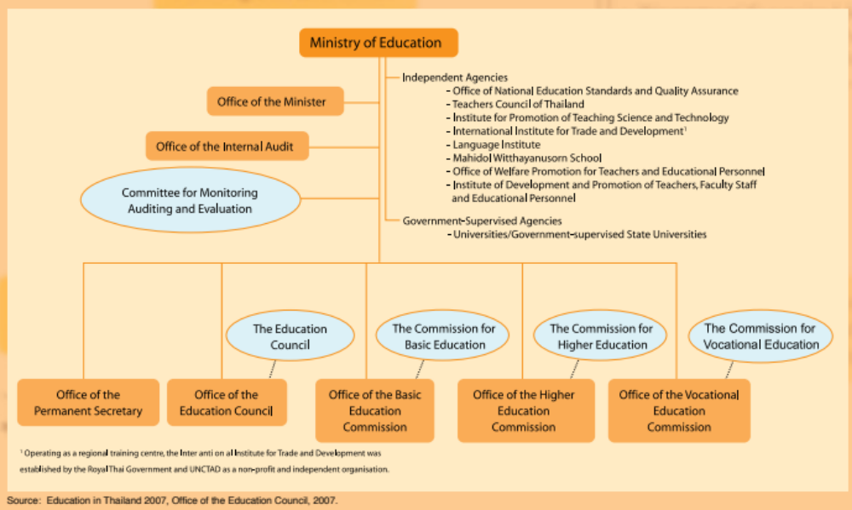

The three Commissions - Basic Education, Vocational Education and Higher Education - have responsibility for the administration of the systems of educational institutions including both public and private organisations. Arrangements for private higher education (including international provision) are administered by the CHE. Arrangements for private provision in the schools and VET sectors are administered by the Office of the Private Education Commission within the OPS. The Thailand Ministry of Labour, through the Department of Skill Development, also has a role in terms of vocational and skills development and training, and the development and promotion of occupational skills standards.

Within Thailand, there are 76 provinces in 12 regions in addition to the Municipality of Bangkok. The provinces have administrative responsibility for primary education and some responsibility for the management of secondary and vocational education through 178 educational service areas. However, despite moves towards devolution, most major decisions are made centrally; for example, the approval of private education delivery as well as the approval of international institutions to operate in Thailand.

National Education Policies
The basic guidelines of education in Thailand are contained in the Constitution promulgated in October 1997, which states that every person shall enjoy the equal right to receive basic education for the duration of not less than twelve years. The Constitution also emphasizes the role of the private sector in providing education at all levels. In addition, it ensures the right of local organizations to participate in the provision of education.

The 1999 National Education Act (amended in 2002) stipulates that Thai people have equal right to receive basic quality education free of charge for the duration of at least twelve years. The Act represents an unprecedented and long overdue break from traditional Thai educational norms, such as lecturing and rote learning, as it sets the foundation for a more creative, questioning approach to studying. The Act also sets out to decentralize finance and administration, giving individual teachers and institutions more freedom to set curricula and mobilise resources, which in turn will tend to increase accountability and ensure that funds are targetted in the right areas.

In October 2002, a 12-year free basic education scheme covering six years of primary and six years of secondary education was granted to students throughout the country for the first time in history. As of May 2004, free basic education was extended to 14 years, including two years of pre-primary schooling.

Ministry Of Education Policies and Strategies
The Ministry of Education has developed a report on policies and strategies on Education Development of the Ministry of Education 2012 – 2015 to outline the direction for this period. This document can be used as a general guide to prioritise themes and activities that will drive education policy up to 2015. The report describes the proposed vision:

Quality, student-centred education is provided for everyone with distribution of equitable education opportunities, in cities, rural, outreached areas. Education builds to people’s resolve. Vigorous and knowledgeable people are powerful capital with which to fight poverty.

The key mission statements of the plan are;
- Providing equitable quality education for every child, youth, disabled and disadvantaged person , in cities, rural and outreached areas, by public and private authorities from early childhood until year six of secondary education and equivalent;
- Developing Thai students living in a knowledge-based society at vocational and higher education levels to be professionals, modern citizens of the world with diverse skills, competitiveness in global markets.

The key strategies proposed include:
- Quality education development at all levels, emphasizing a student-centred approach;
- Creation of equal education opportunities for all groups of people;
- Teacher reform in order to uplift status and profession of teachers to advanced professional level;
- Provision of higher and vocational education and occupational training to accord with labour markets in quantity and quality;
- Development of ICT application to equalise education to international level;
- Development support to create an intelligence capital of the nation;
- Increase competitiveness of human resources to serve the liberalization of ASEAN Community.

Education Sector Priorities and Reforms

4.2.2.1 English Language
English language skills remain a priority with the government in developing a five year plan (2006-2010) for making English language teaching and learning a central theme across all levels of education. A large number of public and private schools have targetted English programmes and use bilingual approaches. However, recent indications from MOE suggest that while around 90 percent of English language teachers have received English language training, only a small percentage have attained advanced levels and many schools are employing overseas teachers. A new English Language Institute has been established under OBEC with responsibility for English language policies and strategies for teaching and learning for basic education at primary and secondary school levels which will provide future opportunities for capacity-building and curriculum procurement. The institute is expected to focus on teaching and learning methodology, curriculum and assessment, and improvements to student achievement levels.

4.2.2.2 VET Sector
The VET system priority is to become more responsive to labour market needs and develop a competency-based, industry-driven system. These initiatives include pathway concepts through recognition of prior learning approaches, professional development for technical teachers to underpin competency approaches, and the improvement of the profile and parental perceptions of vocational education. Traditionally, Thailand has been a very ‘higher education prestige oriented’ society.

In November 2011, the Government set up the Thailand Professional Qualification Institute (TPQI) whose overall goal is to strengthen Thailand’s skills and competency training at the national level and to prepare Thailand for the launch of the ASEAN Economic Community (AEC) in 2015 and beyond. To this end, TPQI’s main objectives are to:
- Develop a national training system and framework to ensure workforce skills training that meets international standards.
- Develop skill standards in collaboration with the industry and stakeholders.
- Accredit organisations (or registered training organisations) to undertake assessments of the skilled workforce.
- Provide services and information in relation to the national training systems.
- Evaluate and validate organisations which provide accreditation to skilled workforce.
- Collaborate with public and private stakeholders for further development of the national training systems.
- Support community skills training through provincial and local level authorities using initiatives such as the One Tambon, One Product (OTOP) program.

4.2.2.3 Higher Education
Higher education has undergone major reforms since the 1990’s with the establishment of 24 private universities which coincided with the liberalisation of Thailand’s economy and the initiation of wide-scale public sector reforms. The excess demand is now being taken up by the revamped Rajabhat and Rajamangala universities. The growth has occurred in both rural and urban areas, with many of the urban public universities having campuses in rural provinces. More recently, newer universities, such as Princess of Narathiwat University in the South and Nakhon Phanom University in the Northeast, have been established to provide increased higher education opportunities. These have also been identified as centres for Islamic Studies and Indo-Chinese Studies, respectively.

These changes are making higher education more diverse and more accessible. However, there is also more pressure for institutions to maintain standards and to be in a position to measure the skills and knowledge expected of graduates as well as improving internal governance, institutional performance, and quality assurance. There is also a move towards grouping universities (Research/ Postgraduate University, Science & Technology/specialised/or comprehensive university, Liberal Arts University, and Community college) as part of the new CHE direction under the 2nd Framework of the Second 15-Year Long Range Plan on Higher Education of Thailand from 2008-2022. Australian expertise is being used to refine the higher education qualifications framework to support Thailand’s quality assurance regime.

University autonomy has also been a major policy direction of the government. During 2007-2008, the National Legislative Assembly (NLA) has approved seven public universities to become autonomous. These newly independent universities will join the six existing autonomous universities in Thailand. It should be noted that the level of autonomy of Thai universities it not comparable to that of Australian institutions.

Education Sector Funding Arrangements
Financial resources for education in Thailand are sourced both publicly and privately. Public expenditure for education includes the budget from the central government and subsidies from local funding. Private resources for education come from individual households, the business sector, and non-governmental and non-profit organizations.

The largest share of the government budget in Thailand is spent on education. After the 1997 financial crisis, Thailand’s fiscal expenditure was tightened, resulting in a decrease of almost eight percent in the education budget. It took more than three years before the country returned to pre-crisis education expenditure levels. In 2007, the Government allocated more than 20 percent of the national budget to education (about 4 percent of its GDP). In 2011, the World Bank estimated the percentage of education expenditure of GDP to be 3.8 percent.

The National Education Act (NEA) led to a major overhaul of the education system. The NEA decentralized authority over curricula and spending to local authorities in order to make education more responsive to local needs. The NEA obligated the state to provide general subsidies for per-student expenditure for basic 12-year education, whether the education is provided by state or private institutions. In 2004, free basic education was extended to 14 years to include 2 years of pre-primary.

Under the Ministry of Education, there are two major administrative bodies: Education Service Areas (ESA), under the MOE, and Local Administrative Organizations (LAO), under the Ministry of Interior (MOI). The ESAs have been established under the jurisdiction of the Office of Basic Education Commission to handle education management at a decentralized level. An ESA is responsible for: overseeing, monitoring, evaluation and dissolution of basic education institutions, coordinating and promoting private institutions in the area, coordinating and promoting Local Administrative Organizations (LAO), and allocating budgets to schools in the area.

Under the new decentralised model, funds are allocated directly to schools through ESAs in block grants. To date, no explicit school funding formula exists. All schools across the country, whether large or small, located in rich or poor areas, receive the same per-student subsidy for the same level of education. Apart from teacher salaries, subsidies in the forms of block grants cover the major share of education expenditure. Thai educators are debating whether these subsidy rates provide adequate resources for the provision of good-quality, standardized education. The current rates are noted in the table below.

It should be noted that there is an increasing demand on the country’s education budget due to the expansion of basic education from nine to fourteen years, demands for improvements to the quality of public schools, the prohibition of additional fee collection, and parental contribution.

Expenditure on kindergartens, schools and vocational colleges has continued to increase to support education reform initiatives and increase access, particularly in regional areas. The MOE 2007 budget allocation provided for additional funding to fully subsidise Thailand’s 12 years of free basic education. Academic entitlement allowances for qualified state teachers are also being paid to supplement teacher incomes and to make the teaching profession more attractive to college graduates.

Funding for higher education has not increased to the same extent because of the expansion through private higher education provision. A revolving fund for loans to assist private higher education institutions has been established with an allocation of one billion baht. The funds can be used by institutions for the development of facilities and human resource development. At the level of basic education, government subsidies are paid at rates per student.

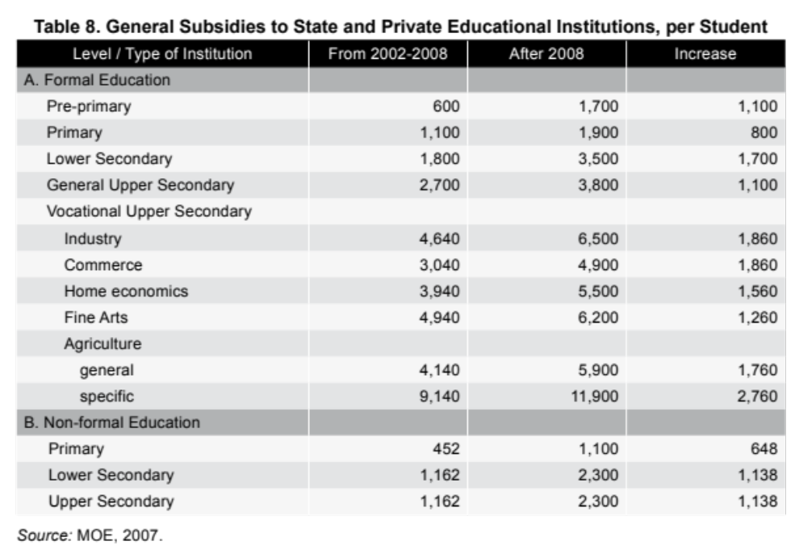

Student Loans
Demand for higher education has increased in Thailand because of the rising demand for human resources with the skills required for modern economic development as well as improved access to higher education provided by student loan schemes.

There are several sources of financial support for students. Loans are available through a Student Loans Fund (SLF) for secondary and higher education students from low income families with a low interest rate of 1 percent per annum, which increases if there is a default. An Income Contingent Loan scheme (ICL) comparable to Australia’s Fee Help program was introduced for university students in 2006, but the scheme was suspended by the previous government because it was plagued with defaults. The scheme, which was launched by the Thaksin Shinawatra government, ran into budget constraints. A fundamental flaw was its lending criteria which did not adequately screen people who were unqualified for the loans such as students from wealthy backgrounds.

ASEAN Free Trade Agreement
Established in 1967, the Association of Southeast Asian Nations (ASEAN) aims to accelerate economic growth, social progress, and cultural development in the region, and to promote regional peace and stability through the rule of law and adherence to the principles of the United Nations Charter. The ASEAN Charter, which entered into force on 15 December 2008, provides a legal and institutional framework to support the realisation of ASEAN's objectives, including regional integration.

ASEAN comprises ten countries: Brunei Darussalam, Cambodia, Indonesia, Laos, Malaysia, Myanmar, Philippines, Singapore, Thailand, and Vietnam.

The ten ASEAN countries have a population of 570 million people - third after China and India - and a combined GDP estimated at approximately US$1 trillion, second only to China in emerging Asia. As a group, ASEAN is a larger trading partner for Australia (16 per cent) than any single country, including Japan (13 per cent), China (12 per cent) or the United States (11 per cent). However, ASEAN attracted only a modest 5 percent of Australia’s foreign direct investment as at December 2007.The ASEAN Education Ministers affirmed the vital role of education in the promotion of ASEAN integration and the establishment of the ASEAN Socio-Cultural Community when the ten member countries in South-East Asia integrated fully. They noted that higher education has a major role to play in enhancing human resource development in all sectors of member countries by means of quality education, upgrading of skills and competencies as well as re-training of existing workforce. This is to ensure ASEAN workforce will be suitably prepared for mobility and all members will benefit from a single market.

Regulatory Controls and Quality Assurance for Education Sectors
Quality assurance and other regulatory requirements differ across the sectors of the education system.

Summary of Thailand Regulatory Controls and Quality Assurance
- Approval of private pre-school, school and vocational education campuses or institutions is managed by the Office of the Private Education Commission which has responsibility for administration of the Private Schools Act.
- The vocational education system is managed by the Office of the Vocational Education Commission (OVEC).
- Approval of private higher education campuses and institutions is managed by the Commission on Higher Education, which has responsibility for administration of the Private University Act. Under current arrangements, this includes any degree granting program even if these offer vocational education studies.

Legislation and Regulations

Regulation of the Non-Formal and Informal Sector
The Office of the Non-Formal and Informal Education (ONIE), established in 2008 by changing the status of the Office of the Non-Formal Education Commission, has the following functions:
- act as the central organization in promoting the support and coordination of non-formal and informal education as well as to undertake the secretarial work of the Coordinating Committee for Promotion and Support of Non-Formal and Informal Education;
- make recommendations on non-formal and informal education policies, plans, strategies, and standard to present to the Committee;
- promote the support of quality development of academic matter as well as research, curriculum, innovation, personnel, and information system concerned with non-formal and informal education;
- promote, support and undertake the transfer of equivalency educational results, knowledge and experience as well as the equivalency determination of educational levels;
- promote, support and collaborate among individuals, families, communities, communal societies, local administration organizations, private bodies, professional bodies, religious institutions, business operators and other bodies to build up network parties for promoting the strength in the implementation of non-formal and informal education;
- prepare recommendations regarding the beneficial uses of information communication technology networks, educational radio and television stations, local radios, science centres, public libraries, museums, community learning centres and other learning resources to promote learning and improve quality of life of the people continuously;
- undertake the monitoring, inspection and evaluation of the implementation outcomes of non-formal and informal education;
- undertaking other missions have been enacted as the functions of the Office or as assigned by the Minister of Education. There are other government departments and ministries which have been carrying out non-formal education activities, such as the Ministry of Labour, through regional institutions and provincial skills training centres. Private voluntary agencies and various foundations have also been involved in the organisation of non-formal education. Industrial factories have also organised non-formal education programmes for their employees.

Regulation of the Formal Sector

Centralised Quality Assurance
Quality assurance at all educational levels was included as a commitment of the Thailand 1999 National Education Act and has received significant public attention in recent years. National education standards for internal quality assurance and external quality assessment oversighted by the three MOE Commissions have been approved by the Council of Ministers. External assessment is conducted by the independent Office of National Education Standards and Quality Assessment (ONESQA). In 2006, a major assessment of around 30,000 public and private primary and secondary schools indicated that two-thirds of the schools fell below the MOE determined educational standards with major concerns expressed over the quality of teachers. The quality of vocational instructors has also been an area of concern. External quality assessment in higher education by ONESQA includes analysis of annual reports and other quality assurance documentation. The first round of assessments, completed in 2006, found that only half of the higher education institutions passed the external quality assessment. A second round of external assessments is currently underway and expected to be completed in 2010 (Prof. Pitiyanuwat, the Independence of the Quality Assurance Agency in Thailand ONESQA, 2007, p. 2).

Guidelines for internal evaluation of educational institutions have been formulated as follows:
- All educational institutions should conduct internal quality assurance annually.
- The continuous process of internal quality assurance of all educational institutions consists of planning, evaluation, and improvement of their performance. Each institution is required to prepare its own education development plan in line with the objectives and principles of the National Education Act, the National Education Standards as well as the aims, philosophy, and charter of the institution. Institutions should also clearly determine the time frame of its implementation, continuously follow-up and evaluate its own performance, and finally use the evaluation results to improve and develop the quality of education.
- At all stages of internal quality assurance, emphasis should be placed on the coordination and participation of all parties concerned, i.e. institutional personnel, the institution board, the parents as well as the personnel of various agencies and organizations in the communities, educational service areas and the regions.
- Each educational institution is required to complete its internal quality assurance report before the beginning of the following academic year, presenting the evaluation results for educational quality as well as guidelines or program for improvement and development of educational quality in the following year. The report must be submitted to its parent organization, the agencies concerned, the OESE and be made available to the public.
- The educational standards for external evaluation at the basic education level were approved in January 2000. The standards are to be used as a framework for external evaluation and guidelines for the agencies concerned, and all educational institutions are to develop the quality of education in the same direction.

Regulatory Controls for School, Vocational & Other Non Higher Education
There are a number of administrative requirements and curriculum regulations for public schools that are determined by the Office of the Basic Education Commission and for vocational education by the Office of the Vocational Education Commission. Administrative responsibility is shared between those Offices and the provinces. While these requirements and regulations for public educational institutions have general applicability to private and international institutions, there is some flexibility to meet different requirements for different community groups in the case of private schools and international institutions.

Legislative requirements for private and international education other than higher education are contained in the Private Schools Act of BE 2525 (1982). Administrative responsibilities under the Act for these schools and other institutions are managed by the Office of the Private Education Commission (OPEC).

OPEC provides policy advice and support, gives approvals, and exercises oversight of several different categories of schools and other institutions including non-formal education.. There are three sets of regulations dealing with requirements for basic education (primary and secondary), vocational and technical institutions, and international schools.

Details of requirements can be obtained from the relevant unit within OPEC or accessed from the website at: http://www.moe.go.th/English/ Regulation.htm. For a school offering a normal curriculum at primary or secondary levels, the relevant unit is the Basic Education Unit; for an institution offering vocational education, the relevant unit is the Vocational Education Unit; for an institution offering a foundation year or language program, the relevant unit is the Non-formal Education Promotion Unit, and for a school offering an international curriculum, the relevant unit is the International Education Promotion Unit.

Despite the existence of different regulations, there are many common elements in the requirements. Major provisions of the Act specify:
- Application conditions for a licence to establish a private school must be satisfied.
- Powers and responsibilities of the licensing authority (the Office of the Private Education Commission);
- Categories of schools or institutions covered by the Act, including providers of both formal and informal education;
- Governance arrangements including requirements for directors and the responsibilities for principals and school managers;
- Some staffing provisions and authority for the Minister to establish employment conditions;
- Requirements for contributions to a provident fund for the benefit of staff.
- Processes for resolution of disputes and appeals relating to employment matters;
- Establishment of oversight and supervision authority for the Commission including penalties for failure to comply with requirements.

5.2.2.1 Regulatory Environment for Private Schools and Vocational Education
The provisions of the Private Schools Act and the regulations that have been made are detailed and should be studied carefully. Some of the major provisions are:
- Regulations require appointment of a manager and a principal or head who must be a Thai national. Their major responsibilities are defined in the Act. The manager’s position is a very senior one, and the person appointed to that role must receive a licence from the Ministry. A manager can carry responsibilities for more than one school, but a principal must be appointed for each school.
- There are minimum qualification requirements for these positions, normally requiring at least a Bachelor’s degree with relevant specialisations and experience for senior teaching responsibilities.
- Minimum staff conditions are specified by the Ministry. Employment contracts in a required format must be used and must include a number of specified items. As for higher education institutions, the conditions must be at least equivalent to the requirements of Thailand’s Labour laws.
- Schools may teach the Thai curriculum, have a school developed program or teach an international curriculum. However, there are a number of required areas of study including teaching of Thai language and culture, and approval and accreditation requirements that are described below.
- There are a number of facilities requirements specified in regulations including class size and amount of space for students, availability of medical facilities and services, showers, toilets, library or learning resource areas, administrative areas, etc. These requirements vary with the level of schooling, and the design of facilities must be approved as part of the approval process.
- If a school wishes to take on different activities after a licence is issued, the changes must be approved. A school can also have a change in ownership, but this must also be approved.
- Fees to be charged must be consistent with policies set by the Ministry and must be approved by the Office of the Private Education Commission. A school or other private institution offering formal education must have a Board of Directors with a specified membership structure including a majority of Thai nationals, parent and teacher representation, and a representative of the Ministry of Education. The responsibilities of the Board have been broadly defined to include supervision to ensure the school operates consistently with the Act and other laws, and with the Manager and Principal or Head defined in the Act. A school offering non-formal education does not require a Board of Directors. An Employment Protection Board has been established to conduct investigations relating to internal disputes, and there are regulations to avoid conflicts of interest in any such dispute. As for higher education institutions, the Private Schools Act gives extensive powers to the licensing authority to monitor activities and investigate complaints, require co-operation from the institution, and provide for penalties for improper activities or breaches of requirements.

5.2.2.2 Licensing, Approval/Accreditation & Registration Processes for Schools & Vocational Education
An application to establish a private school or other educational institution covered by the Private Schools Act must be submitted to the Office of the Private Education Commission.
An applicant for a licence must be a Thai national by birth, or a juristic person. The directors of a company or a foundation must have a majority of Thai nationals, and the person signing documents on behalf of a juristic person must be a Thai.

A detailed proposal must be submitted with details of the proposed curriculum, internal regulations, land provision and building design, financial support, and budget. There are a number of requirements; for example, the land to be provided (either owned or under a long term lease from a government agency) must be at least one rai* for pre-primary, two rai for a primary or secondary school, and must be in an appropriate location. *(one rai is equal to 0.16 of a hectare)

All documentation must be in Thai Language. The proposal will be checked for consistency with requirements and considered in detail by a sub- committee. The sub-committee will include people with expertise in the level and nature of education to be provided, with representation from the relevant Commission (Basic Education or Vocational Education).

A formal application is then made for the licence. Details are verified by the Office and if satisfactory, a licence is issued enabling the school to commence operations.

An international school must apply for accreditation from an appropriate and approved accrediting body within one year of receiving a licence. (School registration bodies in each Australian State would meet this requirement). International accreditation must have been achieved within six years of commencement. Regular reports on progress must be submitted annually while this accreditation process is under way. It is possible to apply for an extension of up to one year, but if accreditation cannot be achieved, the school must be closed within two years. The Act and regulations set out therein details the procedure of a school’s closure.

In addition to these requirements, the school or other institution must seek quality assessment by the Ministry within one year of commencement and must receive a positive assessment within three years.

5.2.2.3 Quality Assurance and Audit Requirements for Schools & Vocational Education
The regulations for accreditation described above, in combination with oversight by the Office of the Private Education Commission and external quality assurance by ONESQA, provide for educational quality assurance.

Financial accounts must be maintained in a way that conforms to regulations established by the Ministry. Independent annual financial audits are required, and financial reports in a format established by the Office of the Private Education Commission, together with audit reports, must be provided to the Ministry annually.

In addition to the internal quality assurance and reporting requirements of the Office of the Private Education Commission, institutions are subject to the external quality assurance processes of the Office for National Education Standards and Quality Assessment. ONESQA has developed 14 standards and 49 indicators for pre-primary education, with 14 standards and 68 indicators relating to learners, inputs and processes for other levels.

Higher Education Sector Regulation and Controls

5.2.3.1 HE Regulatory Environment
In terms of national strategic policy framework on higher education, OHEC launched two higher education policy papers including the roadmap for higher education quality development and the Second 15-Year Long Range Plan on Higher Education (2008 – 2022). The roadmap for higher education quality development has a prime objective of producing good quality graduates and researchers who will contribute to the countries social and economic development. It focuses on the improvement of higher education in four aspects, namely:
- quality of graduates;
- quality of faculty members;
- quality of research;
- quality of education provision.

The roadmap was in force during 2005-2008, and was followed by the launch of the Thailand Qualifications Framework for Higher Education in 2009.

The Second 15-Year Long Range Plan on Higher Education focused mainly on the quality issues of the Thai higher education system. Such a system will lead to the production and development of graduates of quality, capable of life-long work and adjustment. The major outcomes of the Plan included the development of knowledge and innovations, basic and critical to the country’s competitiveness and supportive of sustainable development of all sectors in Thailand. The quality system will be achieved through management mechanisms and measures of good governance, financing management, higher education standards, and university networking. Foundational to this is universities’ academic freedom, diversity, and unity of the system.

Thai public universities administered under this new administrative system are called “autonomous universities”. At present, the government has promulgated 13 Acts to safeguard the operation of autonomous universities. Consequently, they are empowered to govern their overall administration including personnel, financing, academic, and other university management system under the delegated authority of university council. Autonomous universities also receive regular budget allocation from the government, and autonomous university employees are entitled to similar privileges as other government officers.

In addition to public university governing act, the government had passed additional legislative acts on personnel management and internal administration in order to empower public universities to manage internal affairs independently and efficiently. These Acts are:
- The University Personnel Act of 2004 and its Second Revision of 2008 – this regulation had been in force with an aim to decentralise authority to universities under jurisdiction of OHEC and to allow universities to formulate their own rules and procedures. The delegated authorities included personnel management, appointment of academic tenure, and recruitment of personnel on merit and equity principles, in conformity with the universities mission and philosophy, academic freedom and excellence. According to the Act, University Personnel Committee will be established to institute policies, standards, principles and criteria applicable to higher education institutions.
- The Administration of Higher Education Institution Internal Affairs Act of 2007 - The Act gave authority to public universities to establish their own internal agencies with support from their own generating budget. The internal administrative affairs and management system had been enhanced so as to allow the Thai public higher education institutions to acquire better flexibility and good governance.

Private Higher Education Institution
The establishment of private higher education institutions should comply with the Private Higher Education Institution Act. A private higher education institution has the right and authority to deliver higher education equivalent to that of public universities. However, private higher education institutions are not entitled to receive national budget support from the government. Financial support for institutional operations comes from its own revenue and their licensee. The government has defined more stringent holistic monitoring and evaluation mechanisms to oversee more private higher education institutions than public universities.

In the same manner as public universities, private higher education institutions could operate independently and develop their own administrative system that is flexible, having their own academic freedom under the supervision of the University Council. OHEC is responsible for scrutinising and proposing policies, development plans and educational standards in a more appropriate manner that ensures secured development and enhances the expansion of private higher education administration more effectively. It is essential to enforce this Act so that public and private higher education institutions are subject to supervision and quality evaluation with the same educational standards.

Under the Act, there are some particulars that need to be approved by the Higher Education Commission:
- amendment of the university regulations regarding the institution’s name and type;
- the institution’s objectives;
- location and plan showing land area and buildings;
- capital received from the licensee and the expenditure plan;
- the university seal, insignia or symbol, gowns and pins;
- receipts of financial aid, educational equipment or other benefits from any person and the amount or value thereof exceeding the limit specified by the Higher Education Commission;
- borrowing of money once or several times accumulatively and exceeding 25 percent of the present value of the assets of the private university;
- lease of assets with the lease fees exceeding the limit specified by the Higher Education Commission;
- purchase, hire purchase or disposal of the assets to the value exceeding the limit specified by the Higher Education Commission.

Legislative Requirements
Higher education institutions are subject to legislative controls and to a number of ministerial regulations and statements of standards setting out academic and administrative requirements in greater detail. In public universities, joint ventures or other partnership arrangements can be approved by the university council. New programmes can be introduced following approval by the university council and must be accredited after they have been introduced. Regulations for private institutions have been modified to bring them closer to the requirements for public universities, but new curricula must still be endorsed by the Commission on Higher Education before programmes are introduced.

An international institution wishing to operate in Thailand is treated as a private institution. Legislative requirements for establishment of private higher education institutions are contained in the Private University Act, BE 2546 (2003).The Act sets out a number of detailed requirements for the approval and management of a private university, institute or college, and should be studied in detail. There are some differences in the requirements for these types of institutions, which are detailed in Ministerial regulations. Sections of the Act specify:
- Details of requirements when applying for a licence and establishing an institution;
- Powers and responsibilities of the Commission on Higher Education relating to private higher education institutions;
- Administrative systems and governance requirements for the institution including the membership and powers of the university council and the rector;
- Regulations for the granting of academic awards;
- Financial, accounting and auditing requirements;
- Authority for government subsidies and supports, and employment conditions for staff;
- Authority for supervision and oversight by the Commission on Higher Education, procedures and penalties if an institution fails to comply with requirements, and provisions for dissolution of the institution or transfer of its licence.

5.3.1.1 Private HE Regulatory Environment
The provisions of the Private University Act and associated regulations are detailed and include such things as approval of curricula, appointment processes, and duties and responsibilities of the council and rector or president. Initial programmes must be approved and both the institution and the programmes accredited at an early stage after assessment in relation to specified standards. In addition to a number of generally stated standards that deal with all sectors of the education system, there are three key documents published by the Ministry of Education: the Standard Criteria of Diploma programmes, the Standard Criteria of Undergraduate programmes, and the Standard Criteria of Graduate programmes. These standard criteria detail a number of requirements, including semester hour requirements for general education and professional or academic majors.

Arrangements for the initial approval of programmed and/or subsequent changes have been modified to decentralise authority for curricula to institutions subject to quality controls and to place private institutions in a nearer comparable position to public institutions. The academic programmes must still meet all local requirements, and institutions will have to meet a set of institutional standards. In private universities, curricula must be approved by the university council and endorsed by the Office of the Higher Education Commission. Programmes will be considered for accreditation after the first year of offering and re-accredited on a five year cycle.

It is possible to gain approval for internationally or locally developed programmes that are judged as equivalent even if some of the details are specified differently. For example, if a private institution wants to offer a joint program or part of an Australian qualification (i.e. course or full program) that is not structured according to Thailand’s credit hour formula, its council can approve and submit the proposed program details to the CHE for endorsement for approval if they are judged to be equivalent to the local requirements.

The Ministry has developed a number of criteria for approval to offer and manage degree programmes using distance education systems. These are detailed and deal with such issues as program management and staffing, resources, student support monitoring of student involvement, and student identity checks in tests and examinations. There must be adequate provision of learning resources, preparation and orientation of students, and provision of services. The criteria deal with three different delivery modes: use of print media, broadcast, and eLearning, and take account of both the main delivery mode to be used and supplementary provisions. Programmes must follow the standard time schedule for higher education programmes and meet the structural requirements of the standard criteria. Details of requirements are included in an Announcement of the Ministry of Education on Criteria for Asking Permission to Offer and Manage Degree programmes in the Distance Education System.

These provisions apply to the establishment of a higher institution as a free standing entity. There is also provision for joint ventures between international and Thai institutions. These joint ventures could involve a range of activities including teaching, research or spin off development projects. They do not require approval by the Minister or the Commission on Higher Education. However, there are other requirements that must be met including following Thailand’s regulations for international co-operation and permission from the Ministry of Commerce.

Co-operative arrangements with Thai universities are encouraged and can be negotiated with those institutions directly. However, it is necessary to follow regulations for international co operation that include, among other matters, approval by the university council in the Thai institution and the permission of the Ministry of Commerce. If a foreign university wishes to operate in the country as a separate entity, it is treated under current regulations as a private institution and must meet the requirements of the Act.

Corporate Governance and Business Ethics
The Private University Act specifies the structure of a private university council that must include:
- The president of the university council proposed by the licensee and appointed by the Minister.
- The rector of the university.
- Not less than seven or more than 14 members (including at least one representative of the faculties) proposed by the licensee and appointed by the Minister.
- Not less than three persons selected by the Minister of Education from a list provided by the private institution.
- At least half of the total membership must be of Thai nationality.

The Act also specifies the responsibilities of the council for governance and approval of a number of matters and defines conditions, terms of appointment, responsibilities of the rector and vice rectors. Appointment criteria for both council members and the rector include good moral conduct. There are also a number of provisions that impose punishments of fines or imprisonment for a number of inappropriate activities including misrepresenting the accreditation status of the institution or its programmes, unauthorised use of university insignia, seal or symbols, false claims of qualifications and breaches of regulations relating to financial matters and approvals of the CHE. The list of matters identified in Chapter 9 of the Act is extensive and should be read with care.

5.3.2.1 Licensing, Approval/Accreditation for Higher Education
The first step in establishing a private higher education institution is to apply to the Minister through the Commission on Higher Education for a licence. Major requirements are as follows:
- a licence to establish a private university, institute or college must be granted by the Minister;
- a licensee may be a Thai national or a company or foundation established in Thailand;
- land on which the institution is to be established must be either owned by the licensee or leased from the Government and able to be transferred to the institution without encumbrance. This transfer must be within 60 days after the licence is granted for land that is owned by the licensee or 90 days for land leased from the Government. Money and other assets that represent the capital for the institution must be transferred within 60 days. The minimum amount of land required for a university is 100 rai (6.25 hectares) and for a college or institute, six to 10 rai;
- there are requirements set out in regulations for different types of institutions established under the Private University Act. A university must offer programmes in Sciences, Humanities and Social Sciences, must offer post graduate programmes, and undertake research. An institute may offer programmes up to doctoral level in specific programme areas. A college may offer a smaller range of programmes than a university but can also offer programmes at any level. All institutions must satisfy criteria relating to contributions to research, teaching and service to the community, and the adequacy of proposals will be assessed by committees established to review them;
- for a company or foundation, a number of documents showing details of the establishment of that entity must be provided;
- a detailed project proposal must be submitted including the institution’s name, philosophy and objectives, a master plan for facilities, an academic plan showing curriculum structure of proposed programmes, admission requirements, arrangements for programme delivery including staffing provisions, texts and references and equipment to be provided, a financial plan including a number of specific requirements, and the proposed council membership. Details of these requirements are set out in the Act and in Ministerial Regulations which can be obtained from the Commission on Higher Education.
- an application for a licence for a higher education institution will be considered by officers in the Commission to ensure compulsory requirements are met. It will then be reviewed by a screening committee with expertise in different elements in the proposal and if supported, submitted to the Private Higher Education Board for approval. The Board’s recommendation will then be submitted to the Minister.
- if a licence is granted, assets must be transferred to the institution and action taken to establish the institution within specified time periods.
- Each program must also be approved through a comparable process. A program proposal is submitted to the Commission where it is assessed in relation to specified standards for undergraduate and postgraduate programmes. These standards cover matters such as faculty qualifications, staff student ratios, laboratories and equipment, library and reference materials and facilities. If standards are met, the program proposal is then reviewed by a Curriculum and Accreditation Committee (dealing with 25 subject fields) for a detailed academic assessment of the proposal. The Committee may establish conditions. If approved by the Committee, the proposal is considered by the Private Higher Education Board for its approval. Final approval of the curricula is given by the Minister.
- Institutional accreditation must be sought before degree programmes are offered, and this process is normally initiated concurrently with the submission of the first programmes for approval.

Summary of Relevant Bodies and Legislation
Type | Sector | Office | Regulatory Act / Guidelines
Informal and Non-Formal Sector |  | Office of Informal and Non-Formal Education (OINE) | - Non-Formal and Informal Education Act, 2008
Formal Sector | All | Ministry of Education  Office for the National Education Standards and Quality Assessment (ONESQA) | - Constitution of the Kingdom of Thailand (1997)  - National Education Act (2002)
 | Schools | Office of Basic Education Commission (OBEC) | - National Education Act (2002)
 | TVET | Office of Vocational Education Commission (OVEC) | - Vocational Education Act (2008)  - Vocational Education Guidelines for Policy Makers (2012)
 | Higher Education | Officer of Higher Education Commission (OHEC) | - University Personnel Act of 2004 and Its Second Revision of 2  - Administration of Higher Education Institution Internal Affairs Act of 2007
 | Private Schools, TVET, HE and International providers | Office of Private Education Commission (OPEC) | - Private Schools Act (1982)  - The Private Higher Education Institution Act of 2003 and its Second Revision of 2007

International Engagement
Thailand has actively promoted international student exchanges for many years with the aim of understanding foreign politics, economy, and culture. Thailand aims to become a regional education hub in South-East Asia with the goal of increasing foreign students in Thailand from 20,000 up to 100,000 by 2015. In support of this, the Thai Ministry of Education has devised a National Research University initiative with the goal for the country of becoming a world-class regional academic and education hub. The government has given high priority to upgrade the quality of Thai universities to achieve international standards of excellence while upholding their academic freedom and social responsibility.

As a member of the Association of South-East Asian Nations or ASEAN, Thailand is activity involved in fostering and developing a regional educational cooperation platform that aims to have a positive impact for Thailand and other ASEAN countries. The ASEAN Education Ministers and the SEAMEO Council have reaffirmed the vital role of education in the promotion of ASEAN integration and the establishment of ASEAN Socio-Cultural Community when the ten member countries in South-East Asia integrate fully. The group also aims to parallel and integrate current activities through the Bologna Process in Europe to foster greater global mobility.

Thailand and ASEAN member countries have initiated a pilot mobility program for ASEAN students to foster regional movement in higher education. The pilot project started with participation of Indonesia, Malaysia, and Thailand to exchange undergraduate students for one semester with the goal of transferability of credits that will lead to mutual recognition of degrees and qualifications.

International Education
Given the need to improve Thailand’s skills base at the vocational and higher education levels, the government is supportive of international education.

On the whole, prospects for the student market in Thailand remain positive for Australia, based on Australia’s sound reputation in the education marketplace, its close relationships with education agents, strong government-to-government relations, along with a developing alumni network. The Thai government is highly supportive of Thais pursuing an overseas education, issuing a number of government scholarships each year for students to study overseas and government officers to obtain higher education qualifications or to undertake professional development training in areas required by ministries or government agencies.

Statistics of students studying abroad under the supervision of the OCSC (August 2012)

No | Countries | Government Scholarship |  |  |  |  |  |  |  |  | Official Leave Study | On Training | Others | Total | Percent
No | Countries | KING | CSC | MFA | MOST | MOPH | HEC | ODOS | IPST | TOTAL
1 | USA | 77 | 213 | 6 | 492 | 25 | 148 | 46 | 227 | 1234 | 77 | 78 | 120 | 1509 | 28.46
2 | UK | 7 | 202 | 19 | 380 | 41 | 143 | 76 | 108 | 976 | 102 | 14 | 379 | 1471 | 27.74
3 | Japan | - | 70 | 1 | 44 | - | 16 | 141 | 1 | 273 | 64 | 110 | 6 | 453 | 8.54
4 | Germany | - | 27 | 1 | 44 | - | 21 | 159 | 17 | 269 | 22 | 19 | 5 | 315 | 5.94
5 | China | - | 24 | 1 | 1 | - | 3 | 73 | - | 102 | 36 | 88 | 1 | 227 | 4.28
6 | Australia | - | 34 | 5 | 45 | 2 | 29 | 19 | 4 | 138 | 45 | 18 | 17 | 218 | 4.11
7 | France | - | 31 | 5 | 26 | - | 10 | 91 | 5 | 168 | 18 | 17 | 2 | 205 | 3.87
8 | Netherland | - | 11 | - | 11 | - | 19 | 97 | 2 | 140 | 5 | 7 | 1 | 153 | 2.89
9 | Canada | - | 7 | - | 7 | - | 6 | 30 | 3 | 53 | 7 | 5 | - | 65 | 1.23
TOTAL |  | 84 | 707 | 71 | 1081 | 68 | 438 | 822 | 368 | 3639 | 477 | 641 | 545 | 5302 | 100

Source: Office of the Civil Service Commission

Table Key
KING: King’s Scholarship Students
CSC: Government Scholarship Students
MFA: Students under Ministry of Foreign Affairs’ Scheme
MOST: Students under Ministry of Science and Technology’s Scheme
MOPH: Students under Ministry of Public Health’s Scheme
HEC: Students under the Office of the Higher Education Commission
ODOS: One District One Scholarship
IPST: Students under the Scholarship of the Institute of Promoting for Teaching Science and Technology

As at 1 August, 2012, a total of 5,302 students were studying overseas under the various OCSC scholarship categories. The most popular study destination was the US with 28.46 percent of all students, followed by the UK (27.74 per cent), Japan (8.54 per cent), Germany (5.94 per cent), China (4.28 per cent), and Australia (4.11 per cent). Scholarships are allocated in accordance with priorities of the National Economic and Social Developmental Plan as well as priority fields of study identified by the various ministries. The ten most popular fields of study in order of priority were: Engineering, Biology, Physic, Computer Science, Mathematics, Chemistry, Law, Economics, Social Sciences, and Business Administration.

Apart from the high-profile and competitive King’s scholarships and CSC government scholarships that are open to the public, the Thai Office of the Civil Service Commission (OCSC) also coordinates scholarships under the Royal Thai Government’s initiatives and Ministries’ Schemes; e.g., Ministry of Foreign Affairs, Ministry of Public Health, and Ministry of Science and Technology. The fields of study identified by each sponsoring organisation are derived from the overall strategic national development plan and translated into the human resource development within Thai academic institutes and government agencies. In most scholarship schemes, the candidates have the freedom to choose their study destination and institutions by themselves upon the counselling and approval from OCSC or sponsoring agencies.

For each year of education, the students, other than the King's scholars, are obliged to serve their sponsoring organisation for two years. Often they become university professors or research scientists, and all become leaders in their fields and within their sponsoring organisations.

The government sees engagement in education both bilaterally and through institutional links as an important way of assisting the education reform process. It provides long-term and short-term overseas training opportunities and scholarships through ministries and key agencies, including scholarships for non-Anglophone countries to broaden the country’s language base.

Major government scholarship schemes for studying and training abroad

Type of program | Target group | Type of scholarships | Application process
Secondary school and Degree Programmes | Open for the public (potential future government officials) | King’s scholarship for high school students (seven scholarships granted in 2011) | Open for application in September  Announcement of qualified candidates in March
 |  | CSC government scholarship | Secondary level  Open for application in September  Announcement of qualified candidates in March  Degree Programmes  Open for application in December  Announcement of qualified candidates in May
 |  | Scholarships under Ministry’s scheme | Open for application in September  Announcement of qualified candidates in March
Higher Degree Programmes and short courses and trainings | Open for government officials | Scholarships under Ministry’s scheme  Scholarships under public Thai universities’ scheme | Depends on each government agency and university

The government allocates significant resources for scholarships to send Thai students overseas to study, recognising that overseas educational experiences will foster future business links and help to drive economic growth. The Office of Civil Service Commission (OCSC) oversees the government’s scholarship programmes. However, the allocation of scholarships to awardees is through a combination of Ministry-level decision making and OCSC decision making, depending upon the field of study. Around 27 percent of the government scholarships are allocated to Science and Technology fields, reflecting a strong perceived correlation between the capacity of a country’s Science, Technology and innovation and the quality of its education system.
Austrade is working closely with the OCSC to raise awareness of the quality of Australian institutions and influence decision making within the OCSC in respect of scholarship allocations, particularly in the fields of Science and Technology as well as the range of short course options available through Australian providers.

The OCSC is a government agency with responsibility for human resource personnel development in the Thai public service. Its responsibilities include managing the Thai government scholarship programmes in partnership with key Thai Ministries. It does this through its Office of Education and Training Abroad which oversights scholarship allocations, promotes educational programmes and training for Thai students and OCSC scholarship recipients, and manages the welfare of all international Thai students studying offshore, including full fee-paying students. It also has a student’s information and counselling centre at Siam Square in central Bangkok which acts as a national resource centre on international education for all students.

The student selection process includes examinations and interviews comprising English language competency and academic assessments, skills and knowledge competencies, and medical examinations. The OCSC scholarship program covers the full cost of tuition and monthly stipends, books, health insurance, and miscellaneous expenses. Students are obliged to return to employment with their sponsor government agency for a period twice the duration of their study.

The placement of students at overseas institutions is ongoing, while a special Placement Event is also held the day prior to the annual OCSC Education Fair to promote potential destinations and institutions to scholarship recipients. This event is open to participation by providers attending the OCSC Fair and provides the opportunity for student interviews and presentations to OCSC scholarship awardees. The annual OCSC Education Expo provides an ideal platform to profile and promote educational institutions to thousands of Thai students and offers an excellent opportunity to promote course options to Thai scholarship holders, and develop and expand contacts with educational institutions in Thailand. The promotion and marketing role is now undertaken by Austrade.

Inbound Students to Australia
Inbound student numbers to Australia from Thailand have fluctuated over the past 10 years, but Thailand remains a significant inbound market for Australia with over 12,500 students commencing programs in 2012. The VET and ELICOS sectors have the highest numbers of Thai students.

Inbound Thai students to Australia - Sum of DATA YTD Commencements by Sector (2008–2012)
Sector | 2008 | 2009 | 2010 | 2011 | 2012
ELICOS | 6799 | 7955 | 5678 | 4646 | 5439
Higher Education | 1816 | 1885 | 1787 | 1483 | 1455
Other | 156 | 143 | 112 | 87 | 102
Schools | 204 | 236 | 200 | 177 | 169
VET | 4787 | 6321 | 7239 | 6733 | 5312
Grand Total | 13762 | 16540 | 15016 | 13126 | 12537

AEI Data as at December 2012

International Cooperation

Opportunities for International Cooperation
There are a number of collaboration opportunities for education cooperation across all sectors, stemming from regional and local Thai initiatives, as noted below.

Thailand is strategically focussed on leveraging opportunities from the planned integration of the ten ASEAN member countries as the ASEAN Economic Community (AEC) in 2015. Education is an important strategy for Thailand, with a goal of positioning the country as an international hub of education in the ASEAN region.

The Thai Prime Minister, Yingluck Shinawatra, has plans to ensure Thailand remains highly attractive to investors, encouraging them to make Thailand their second home by providing attractive investment conditions, a reasonable cost of living, and world class international education services.. This strategy aims to maximise opportunities that arise from the integrations of the ASEAN nations.

The various Thai education reforms provide opportunities for Australian institutions to capitalise on developments and to provide consultancy services, curriculum procurement, professional development and capacity building, teacher skills upgrading, and joint academic programmes.

There is also the opportunity to undertake advisory work and professional development with MOE. This is generally done on the basis of networks of experts known to the Commissions through previous face-to-face contact and consultancy work. AEI Bangkok is collaborating with the Thai Ministry of Education in a number of areas that will provide emerging opportunities for Australian providers. Key initiatives that may provide opportunities for Australian providers include:

Systemic Education Sector
- The development of a national qualifications framework for Thailand covering all sectors will build on the work previously done in the higher education sector on a Thai Qualifications Framework for Higher Education (TQF:HEd). The TQF:HEd aims to form the core of the new Thai National Qualifications Framework. Some Australian institutions have been already been involved in the development of the TQF:HEd.

Higher Education
- The Thai Government is encouraging all Thai universities to internationalise in all respects, including attracting international students to their campuses, engaging in collaborative activities with foreign universities and forming research partnerships. There are many opportunities for Australian universities in Thailand.
- The Thai government has nominated nine universities to become the National Research Universities: Chulalongkorn, Mahidol, Kasetsart, Chiang Mai, Thammasat, Khon Kaen, Prince of Songkla, King Mongkut Thonburi Technology, and Suranaree Technology universities. These universities are activity looking for more international engagement to raise the profile and standard of their research output. As part of the development and implementation of the National Qualifications Framework and the TQF:HEd, development of agreed teaching standards and learning outcomes will underpin the QA processes.
VET Sector
- There are complex regulatory barriers to establishing a branch campus in Thailand. A licence to establish a private institute or college must be granted by the Minister for Education and a licensee must be a Thai national or a company or foundation established in Thailand, which, under Thai law, must have the majority of its shares owned by Thai shareholders and at least half of its shareholders shall be of Thai nationality. There are also significant land ownership requirements that must be satisfied for a prospective licensee to receive a licence. Consequently, set up costs are high, and there is no capacity for institutions to operate out of office buildings or other more convenient locations to “test the water”.
- There is considerable interest in Australia’s industry engagement, the Industry Skills Councils and their role in developing standards / Training Packages.
- The VET sector provides very basic training and industry is expected to undertake the substantive training to ‘job readiness’ on the job. Current activities in Thailand focus on how to improve the VET system so that graduates have real skills and experience valued by and relevant to industry.
- There is a proposal for the establishment of a vocational qualifications institute to set a direction for the development of better quality and skills outcomes from the graduates entering the labour market.
Schools Sector
- The principal reforms in the schools sector (Office of the basic Education Commission) are:
  - Devolution of school management to the district level and below – getting local communities involved in running schools is delivering better quality and outcomes at the local level.
  - Development of a series of public schools where the curriculum will be taught in both Thai and English, thereby creating a “bilingual” school system to better equip Thai students for the world economy.
  - Although literacy rates are around 96 percent, real English language capacity in the general Thai population is quite low. The Thai MOE has a target of attracting approximately 1000 TESOL teachers to work in Thai public primary and secondary schools.
- Thailand is seeking to fill around 80,000 teaching positions in schools nationwide including severe shortages in schools located near borders and special education schools. Many Thai teachers are not teaching in their specific area of expertise.

English Sector
- English language skills remain a priority with the government across all levels of education. A large number of public and private schools have targeted English programmes and use bilingual approaches. However, recent indications from MOE suggest that while around 90 percent of English language teachers have received English language training, only a small percentage have attained advanced levels and many schools are employing overseas teachers. A new English Language Institute has been established under OBEC with responsibility for English language policies and strategies for teaching and learning for basic education at primary and secondary school levels which will provide future opportunities for capacity-building and curriculum procurement.

Transnational Education
The rules and regulations for establishing twinning programs or joint degree programs are relatively straight forward in Thailand. Foreign institutions must come to a written agreement with the Thai university, which must be approved by the Thai university leadership. The Thai university must submit details of the program to the Thai Ministry of Education. The numbers of joint degree programs in Thailand is small, but has been growing consistently.

The rules for establishing an offshore campus in Thailand are more complex. The rules regarding foreign ownership and control are applied to overseas education institutions in Thailand and can act as a disincentive for Australian institutions which may be interested in operating in Thailand.

Licensing and other regulatory requirements vary for the different sectors of the education system.
- Approval of private higher education campuses and institutions is managed by the Commission on Higher Education (OHEC) which has responsibility for administration of the Private University Act 2546 (2003). Under current arrangements this includes any degree granting programmes even if these offer vocational education studies.
- Approval of private pre-school, school and vocational education campuses or institutions is managed by the Office of the Private Education Commission (OPEC) which has responsibility for administration of the Private Schools Act 2550 (2007).

Higher Education
At present, an international institution wishing to operate in Thailand is treated as a private institution even if it is a government-owned institution in Australia. The provisions of the Private University Act and associated regulations are fairly detailed and include such things as university establishment, approval of curriculum, appointment processes and duties, and responsibilities of the council and rector or president.

With regard to the establishment of a new private university, the major requirements are:
- a licence to establish a private university, institute or college must be granted by the Minister for Education.
- a licensee may be a Thai national or a company or foundation established in Thailand, which under Thai law, must have at least half of its shares owned by Thai shareholders and at least half of its shareholders shall be of Thai nationality.
- land on which the institution is to be established must be either owned by the licensee or leased from the Government and able to be transferred to the institution without encumbrance. This transfer must be within 60 days after the licence is granted (for land that is owned by the licensee) or 90 days for land leased from the Government. Money and other assets that represent the capital for the institution must be transferred within 60 days. The minimum amount of land required for a university is 100 rai (16 ha) and for a college or institute, six to 10 rai.
- There are requirements set out in regulations for different types of institutions established under the Private University Act. A university must offer programmes in Sciences, Humanities and Social Sciences, must offer post-graduate programmes and undertake research.
- At least half of the total membership of the university council must be of Thai nationality.

The practical implication of these establishment requirements is that Australian institutions wishing to deliver courses through a branch campus arrangement in Thailand must have a Thai partner organisation that is the official licensee. All university operations must take place in association with this partner, which, under Thai law, must be majority Thai-owned. The university must also offer a fairly comprehensive set of programmes and cannot fill an identified learning ‘niche’, therefore requiring a substantial resource investment.

There is also provision for joint ventures between international and Thai institutions. These joint ventures could involve a range of activities including teaching, research or spin-off development projects. They do not require approval by the Minister or the Commission on Higher Education. However, there are other requirements that must be met including following Thailand’s regulations for international co-operation and permission from the Ministry of Commerce.

Vocational Education and Schools Sector
Legislative requirements for private and international education other than higher education are contained in the Private Schools Act of BE 2550 (2007). Administrative responsibilities under the Act for these schools and other institutions are managed by OPEC.

The major aspects of regulation are as follows:
- An applicant for a licence must be a Thai national by birth, or a juristic person.
- A juristic person which is a public company, a company limited or partnership limited shall have at least half of its shares owned by Thai shareholders, and at least half of its shareholders shall be of Thai nationality.
- A juristic person that is a foundation shall have its Thai members representing at least half of the total committee members.
- A juristic person that is an association shall have its Thai members representing at least half of the total committee members.
- A juristic person that is a cooperative shall have its Thai members representing at least half of its total members.
- A proposal must be submitted with details of the proposed curriculum, internal regulations, land provision and building design, financial support and budget. There are a number of requirements, for example the land to be provided (either owned or under a long term lease from a government agency) must be at least one rai (1,600m²) for pre primary, two rai for a primary or secondary school, and must be in an appropriate location. All documentation must be in Thai Language.

The Thai nationality and ownership requirements in relevant legislation and the concomitant requirement to cede a significant amount of formal administrative and financial control to Thai partners has acted as a significant disincentive for foreign institutions contemplating transnational education operations in Thailand as they exist in Vietnam, Malaysia and Singapore. This could mean that Thailand loses ground in comparison to its neighbours with regard to the internationalisation of its education sectors, especially ahead of the establishment of the ASEAN Economic Community in 2015.

To address these issues, the Australian Ambassador to Thailand has suggested to the permanent Secretary of the Ministry of Commerce that Thailand may wish to consider a review of the legislative and policy requirements applying to foreign institutions setting up in Thailand, including the licensee, real estate, corporate, registration, and accreditation requirements.

Another option would be the creation of an "education free zone" or the capacity for "education free zone" status to be applied to foreign institutions that wish to set up in Thailand, even if they are not in a declared free trade zone, thereby permitting them to teach Australian qualifications without being subjected to the current legislative and policy requirements.

The Office of the Education Council approached AEI to become involved in a conference to consider options for possible TNE policy reform, following Thai MOE participation in the Joint AEI-British Council conference on TNE in Kuala Lumpur in November 2011. This conference was to take place in August 2012; however, personnel changes at the OEC meant that the initiative was not pursued.

Australian Requirements
The Transnational Quality Strategy (TQS) is being implemented to maintain the high quality and integrity of Australian education and training delivered offshore. Therefore, as stated in the TQS Summary: “courses / programmes delivered within Australia and transnationally should be equivalent in the standard of delivery and outcomes of the course, as determined under Australia’s nationally recognised quality assurance arrangements”.

Transnational Education Quality Strategy
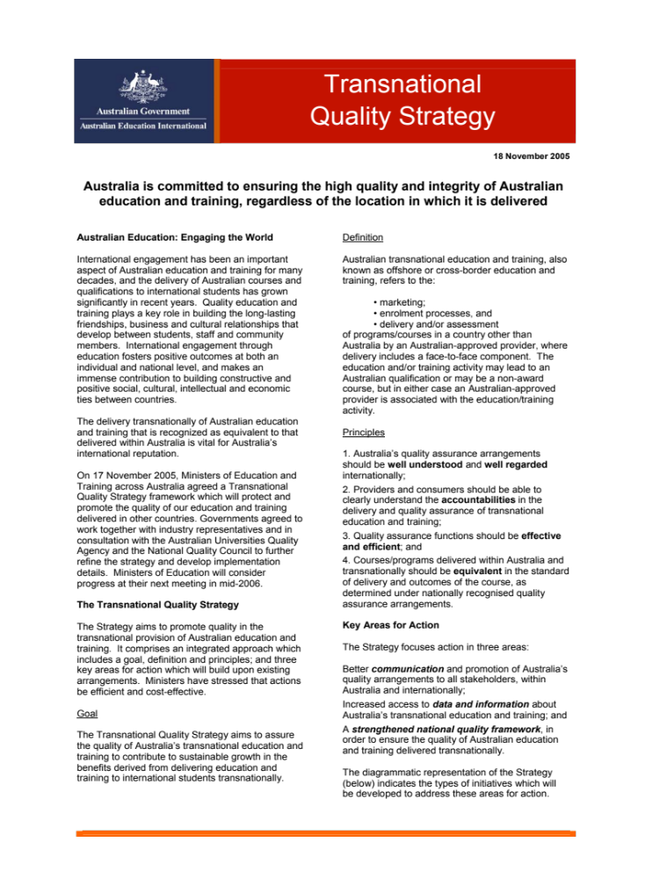
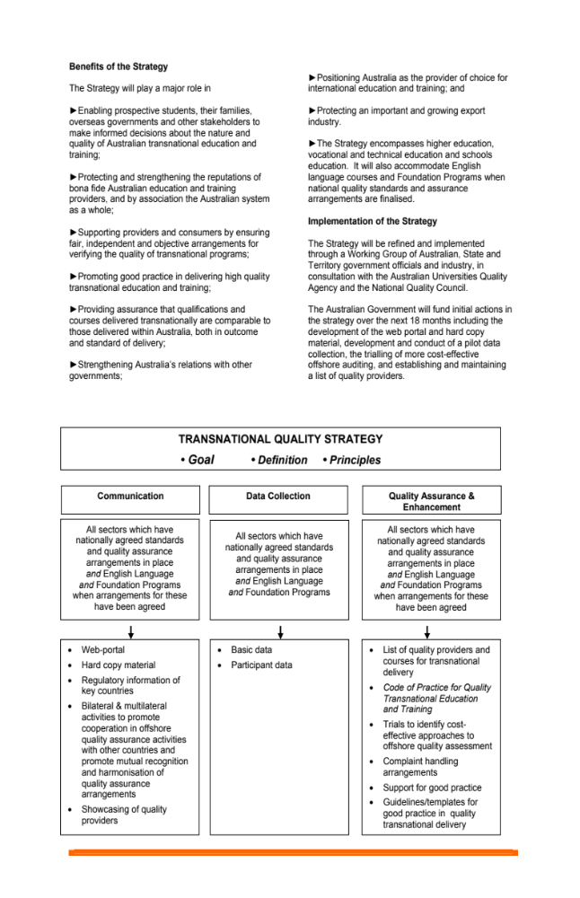

7.2.2.1 Transnational Education Checklist
Below is a checklist to be used as a general guide when considering establishing a transnational education program. This can be used with other resources available to Australian Education Providers in establishing, managing and monitoring TNE programmes.

Market Research
- What are the education trends in Thailand?
- What region of the Thailand are you targetting?
- Who are the main stakeholders: government, educational, private, peak bodies and industry?
- Who are your main competitors: local and international?
- What are the main labour trends in market?
The Partner
- Who is the potential partner and how are they categorised in Thailand: private higher educational provider, public higher education provider, university, private enterprise, vocational college?
- What government accreditations does the partner hold?
- What private accreditations does the partner hold?
- What is the partner’s experience in international collaborations? Are all government approvals in place for those internal collaborations?
- Is the Rector, President, Vice President, or CEO directly involved in the negotiation of the collaboration?
Partnership
- What is the main partnership objective for the Australian provider and the Thai partner? Do they align?
- Has sufficient due diligence been conducted and necessary documents been recorded, exchanged and analysed?
- Have exit strategies been clearly articulated in the partnership agreement
The Model
- Which TNE model will be used?
- What accreditation, registration, approvals and commercial licences are required to operate the model in the Thailand?
- What accreditation, registration, approvals are required to operate the model from Australia?

The Program
- Which programme or suite of programmes will be offered?
- What are the Thai partners’ responsibilities in delivering the programme?
- What is the Australian partner’s responsibilities in delivering the programme?
The Financials
- Who will set the programme fees?
- Has financial modelling been completed based on three scenarios (optimistic, targeted and pessimistic student targets)?
- How will income and expenses be split?
- How will the money be remitted to Australia?
- Are there any Thai tax implications? What are the Australian tax implications for operating offshore?
Approvals and Accreditation
- What government approvals are required? (Thailand/Australian)
- What are the timelines for accreditation and approvals?
- What if approval is not gained?
Implementation
- Has a TNE Steering Committee been established?
- Have responsibilities been allocated?
- Has a policies and procedures document been written?
Monitoring and Review
- How often will the program be reviewed internally?
- Are there sufficient quality assurance systems in place?
- Are there systems in place for continuing improvement?

Other Cooperative Activities and Models

Credit Transfer Provisions
Provision is made in regulations for transfer of credits between schools and institutions in general basic and vocational education. A strong policy commitment to lifelong learning has led to encouragement of adults to enter the education system and for recognition to be given to various forms of informal and non-formal education. Detailed procedures are set out in regulations.

It is possible for credit to be granted at senior secondary level for studies undertaken at overseas schools. Applications for credit for studies at an Australian school may require verification by the Australian Embassy which can advise on the standing of the school where studies were undertaken. In higher education, credit can be obtained for studies undertaken at other institutions. Approval of credit is determined by institutions subject to regulations established by the Commission on Higher Education. These regulations provide for up to 75 percent of requirements for an award to be satisfied by credits for studies elsewhere. Institutions may establish a minimum grade for studies to be given credit.

Management Contracts
Management contracts refer to arrangements where an overseas institution is involved in a contractual agreement with a local institution to provide assistance in the form of managing human, financial, information or physical resources, and/or consultancy services. This form of cooperation aims to improve the efficiency of education management through a range of initiatives such as institutional development, improvement of management information systems, operational development of monitoring and evaluation, integrated quality management, and other management activities. Australian institutions can enter into management contracts with educational institutions in Thailand, but must be aware of a number of specific requirements for Thai nationality in certain situations and that these requirements can vary for different sectors of the education system and for public and private institutions. It would be important if any such arrangement is contemplated, and there is any doubt about requirements to consult with the Commission or Office to which the Thai institution is administratively responsible.

Teacher/Lecturer Exchanges
Teacher and lecturer exchanges or short term appointments are encouraged, and there is particular interest in having native speakers of English who can work in English language classes. Qualifications requirements are comparable to those in Australia and include both relevant academic or vocational requirements and, for appointments in schools, qualifications in teaching. It is necessary for teachers or academic staff wishing to work in Thailand education institutions to obtain the relevant work permits as for foreign workers as indicated below.

Partnerships and Joint Ventures
Education institutions in Thailand can be involved in a wide variety of partnerships and joint ventures. These can deal with management and administrative arrangements subject to the constraints indicated above under Management Contracts or with provision of educational programmes. As noted above, it is possible for the councils of public universities to approve arrangements under which there is a joint venture for the provision of programmes or other activities in partnership with an overseas university. Under recently changed regulations, such an arrangement for provision of programmes with a private university must first be approved by the council of the private university and then approved by the Commission on Higher Education. Depending on the nature of the joint venture, it may also be necessary under Thailand’s regulations for international cooperation to obtain permission from the Ministry of Commerce.

Consequently, if a proposed joint venture is for anything other than the provision of educational programmes, this should be checked in advance and permission sought if required.

Twinning Programmes
Twinning programmes can be conducted through a Thai institution, and an overseas institution can organise joint teaching or research, with credit for completed work being recognised at either institution. The agreement establishing such an arrangement should make clear which institution (or either institution) is to grant the award or whether it can be granted jointly with the name of both institutions appearing on a certificate. Such an agreement with a public university can be approved by the council of the university but as for other joint ventures, such an arrangement with a private university must be approved by the Commission on Higher Education as well as the council of the university.

If an award is to be granted by a Thai institution with teaching organised through a twinning arrangement, the programme must comply with Thailand’s regulations for the kind of award concerned. It should comply with Thailand’s National Qualifications Framework and with relevant Standard Criteria specified by the Ministry of Education for the level of programme concerned. Details of these Standards (for Diploma Programmes, for Undergraduate Programmes, and for Graduate Programmes) can be obtained from the Commission on Higher Education. Arrangements must also comply with a requirement that a minimum proportion of studies must be undertaken at the institution granting the award.

Under current arrangements, it would be very difficult to gain approval for a collaborative programme developed between a TAFE institute and a Thai higher education institution leading to a higher education award. Although there is a strong commitment to lifelong learning and flexible processes for recognition of prior learning and credit recognition, Thai higher education authorities would be reluctant to accept equivalency of studies which is a prerequisite for approval of overseas programmes that vary from normal Thai requirements.

Establishing a Campus
Details of procedures and requirements for establishing a campus have been included in previous sections dealing with higher education and with schools and vocational education institutions under the headings of Licensing, Approval/Accreditation and Registration Processes

Level of English Language Proficiency
English has been widely taught in schools for a number of years and is increasingly regarded as an important skill in business. Most senior staff in industry and academics in post secondary institutions have a good command of English. Following recent curriculum reforms, English is now taught as a core subject at all levels in schools. Despite these considerations, many adults (particularly in rural locations) have little or no English language ability. A majority of students graduating from secondary schools can converse in English, but a high proportion require additional English language instruction before undertaking tertiary studies in an English speaking country offshore or in programmes taught in English within Thailand.

Business and Financial Requirements

Australia / Thailand Free Trade Agreement
The Thailand-Australia Free Trade Agreement (TAFTA) was established in January 2005 and was Australia’s third free trade agreement. Since the agreement came into effect, the total two-way trade between Australia and Thailand has more than doubled.

The agreement has eliminated the majority of Thai tariffs on goods imported from Australia. The reduction of Thailand's previously high tariff barriers (for some goods, up to 200 percent) is a significant win for Australian businesses, opening up a range of export opportunities. TAFTA also improves the environment for bilateral services trade and investment.

Whilst educational trade between the two countries has not been subject to tariffs or other barriers, the Free Trade agreement has made it possible for an Australian tertiary institution to be established in Thailand with up to 60 percent share ownership by Australian investors. However, there are some constraints relating to location and programme provision. Under the terms of the TAFTA, the institution must be located outside Bangkok and must be in Science and Technology, fields classified as high priority for economic development. The legal structures for approval and regulation of tertiary institutions under this arrangement have not yet been established; however, it is anticipated that licensing and accreditation requirements will be comparable to those for other private institutions.

Foreign Investment
The country's well-defined investment policies focus on liberalisation and encourage free trade. Foreign investments, especially those that contribute to the development of skills, technology and innovation are actively promoted by the government. Thailand consistently ranks among the most attractive investment locations in international surveys, and the World Bank’s 2012 Ease of Doing Business report places Thailand as the 17th easiest country in the world (and second-ranked country in Southeast Asia) in which to do business.

The Board of Investment also coordinates the activity of the One-Stop Service Centre for Visas and Work Permits, which enables foreign staff of BOI-promoted companies to obtain work permits and long-term visas within three hours or less. The BOI also administers the One Start One Stop Investment Centre which opened in November 2009 to facilitate a full range of services and streamline investment procedures by bringing representatives from more than 20 government agencies under one roof.

Foreigners in Thailand are subject to the laws of Thailand and, in general terms, have the same rights and responsibilities as Thai citizens. There are restrictions on foreign ownership in a range of service and primary and secondary industry fields and are defined in a number of different laws relating to those industries.

The definition of an “alien” under the Foreign Business Act includes a natural person who is not a Thai, a juristic entity that is not registered in Thailand, a juristic entity with foreign ownership of more than half the total number of shares, and a partnership whose manager is a foreigner. The Act includes three lists of industries in which alien ownership is not permitted or is subject to special approval or regulatory requirements. The lists do not include the establishment of educational institutions, but could affect spin off activities in certain fields. The Act is currently being amended and relevant details should be checked before entering into an arrangement that could be affected.

Licensing requirements for educational institutions under the Private University Act and the Private Schools Act require either Thai ownership or a majority of Thai shareholders so they are not foreign for the purposes of the Foreign Business Act. On the other hand, it is anticipated that a tertiary education institution established with 60 percent foreign ownership as specified under TAFTA would be “foreign” for the purposes of these requirements except where modified by the TAFTA itself.

There are a number of requirements that apply to the establishment of companies or partnerships, taxation, local employment, the employment of foreign nationals, repatriation of funds and related matters that have to be considered. Details of these requirements can be obtained from the Thailand Board of Investment (http://www.boi.go.th) or from major international accounting firms operating in Thailand.

Visa Requirements
Australians wishing to enter Thailand for employment purposes must apply for a non-immigrant “B” visa before entering. The non–immigrant “B” visa has 2 categories:
- Single entry visa will allow you to stay up to 90 days in Thailand and is valid for 3 months.
- Multiple entries visa will allow you to stay up to 90 days in Thailand on each visit and is valid for multiple entries within 12 months. Upon entry into Thailand, an applicant must apply for a work permit at the Office of Foreign Workers Administration, Department of Employment, Ministry of Labour and the applicant will be obligated to pay income tax accordingly. If the applicant’s associated company is located in the provinces, a work permit may be applied at the Employment Office of that province.

An extension of stay can be requested at the Office of the Immigration in Bangkok. Accompanying family members can obtain a non-immigration category O visa for the same period.

Business Registration Process
Business organisations could be sole proprietorships, partnerships or limited companies. The most common form is a limited company. As noted above, licensing requirements for educational institutions (other than under TAFTA) require either Thai ownership or majority Thai shareholding.

Related Business Legislation

Taxation
Thailand has a very attractive taxation system. The 2012 reduction in corporate income tax rates will place Thailand as the second most tax-competitive country in the region in 2013, behind Singapore. It is strongly recommended that individuals or institutions considering establishment of an educational institution obtain detailed advice on applicable provisions. This could be obtained from several sources including major international accounting firms operating in Thailand, from the Thailand Board of Investment, or from the Austrade office in Thailand.

Thailand has a number of taxation requirements and some exemptions or concessions are available for education institutions. Some of the major provisions are:
- Corporate income tax is imposed on an entity’s net taxable profits which normally consist of business/trading income, passive income and capital gains/losses. Expenses that relate specifically to generating profits for the business or the business itself may be deducted in determining net taxable profits.
- A registered foreign branch or partnership is taxed the same as a limited company, but only on Thailand-source income.
- As from 1 January 2012, the corporate tax rate is 23 percent; the rate further reduces to 20 percent for the two accounting periods beginning on or after 1 January 2013. Certain public limited companies and small and medium-size limited companies are subject to lower progressive rates up to a certain amount of net taxable profits (23 percent for the accounting period that begins on or after 1 January 2012, and 20 percent for the next 2 accounting periods).
- Remittance tax for a foreign company disposing of profits out of Thailand of 10 percent must be paid within seven days of remittance. This tax applies to profits transferred from a branch in Thailand to a head office overseas. It does not apply to expenditure for purchases, most business expenses, and repayment of loans or returns on investment. Taxes on dividends are taxed at the time of payment.
- Thailand residents and non-residents are taxed on their Thailand-source income. Employment income, including most employment-related benefits, is subject to personal income tax. Profits derived by individuals from the carrying on of a trade or profession generally are taxed under the personal income tax regime.
- Subject to certain restrictions, deductions are granted for first time purchase of a personal residence, insurance, mortgage interest, retirement or long-term equity plans, charitable contributions, etc. Personal allowances are available for the taxpayer, his/her spouse and children/parents under certain conditions.
- Rates are progressive between 5 percent and up to 37 percent. For expatriates qualifying as employees of a regional operating headquarters, a flat income tax rate of 15 percent can apply from four to eight years, depending on the status of the regional operating headquarters.
- A value added tax of seven percent is applicable to most goods and services over 1.8 million Baht, but education services are exempt.

Quality Assurance for Businesses
Businesses operating in Thailand are subject to regulations relating to employment conditions, minimum wages, leave requirements and related matters. Dispute resolution arrangements are available under the Labour Court Procedure Act of 1979.

Proper financial records that meet accounting standards are required with annual submission of audited accounts and financial reports. Auditing standards are based on international auditing guidelines with some local modifications. Books and records must be retained for at least five years. Financial penalties are imposed for breaches of requirements.
A branch office established by a foreign company to carry our business in Thailand is regarded as the same legal entity as its head office, which will be held responsible for all liabilities of the branch. Representative offices or regional offices to provide services for a foreign company can only be established with the permission of the Director-General of the Business Development Department in the Ministry of Commerce, with the approval of Foreign Business Committee.

Repatriation of Funds
Profits earned by activities in Thailand are subject to taxation as indicated above. Dividend payments by a foreign individual or corporate investor are not subject to withholding tax.

Remittances of foreign currency may be made at any time; however, there are some requirements for reporting to or obtaining permission from the Bank of Thailand.

Remittances for amounts exceeding US$50,000 or equivalent must be reported to the Bank of Thailand through an authorised commercial bank.

Cultural Considerations and Resources

Doing Business Tips
- Normal office hours are 8.00 a.m. to 5.00 p.m. or 6.00 p.m. with lunch between 12.00 p.m. and 1.00 p.m.
- April and early May are the main holiday periods, and business trips to Bangkok should be avoided during this time as many staff will be on leave and institutions are closed.
- English is commonly used in business, especially in large companies in Bangkok, and presentations, proposals and contracts are acceptable in English.
- Thai business reflects a society in which hierarchy and respect for seniors are very important.
- Traditionally, women were under-represented in the business world and especially in managerial positions. However, this has changed and now women have equal rights and protection, although some inequalities remain in the law.
- Building good relationships is an important part of business and the negotiation process. Thais place great importance in “liking” their business partners.
- Invitations to social activities from your Thai counterparts should always be accepted as these are used as a means of getting to know each other before doing business together.
- Thais are generally not confident decision makers and often need to consult with several people before making a decision, leading to a lengthy process. However, impatience should be avoided as it will be seen as a sign of weakness.
- In Thai business, first names are generally used, preceded by the honorific title “Khun”, used both for men and women. Note that Thais will tend to use first name as opposed to last names even when using Mr and Miss.
- A high quality business card is an important asset in Thailand and should be exchanged when initiated by the host. Cards should be offered to the most senior person first, and it is imperative that cards are given and received with the right hand.

Business Etiquette (Do’s and Don’ts)

- DO wear business suits for meetings with a long-sleeved shirt and tie. Women should normally wear skirt and blouses, covering the shoulders and upper legs.
- DO take off your shoes when invited into your Thai business colleague’s home.
- DON’T joke about or criticise the Thai King or Queen as these are to be treated with respect and it is illegal to say or write anything offensive to royalty.
- DON’T touch your Thai colleague’s head as it is considered sacred according to Buddhist tradition.

Additional References
Title | Source | URL
Doing Business in Thailand | Austrade | http://www.austrade.gov.au/Doing-business-in-Thailand/default.aspx
Doing Business in Thailand | World Bank | http://www.doingbusiness.org/data/exploreeconomies/thailand/
Smart Travellers | DFAT | http://www.smartraveller.gov.au/zw-cgi/view/Advice/Thailand
Doing Business in Thailand | Thai Social and Business Culture | Communicaid | http://www.communicaid.com/access/pdf/library/culture/doing-business-in/Doing percent20Business percent20in percent20Thailand.pdf
Thailand | Business Culture | http://businessculture.com/thailand.html
Thailand | e-diplomat | http://www.ediplomat.com/np/cultural_etiquette/ce_th.htm
Living In Thailand | Thailand Board Of Investment | http://www.boi.go.th/index.php?page=living_in_thailand

Key Contacts/ Agencies
Agency | URL
Australian
Austrade | http://www.austrade.gov.au/
Australian Education International | http://www.aei.gov.au
Australian Education International (AEI) | http://www.aei.gov.au
Australian Universities Quality Agency (AUQA) | http://auqa.edu.au
Department of Education, Employment and Workplace Relations | http://www.deewr.gov.au
Department of Foreign Affairs and Trade | http://www.dfat.gov.au
Dept. of Immigration | http://www.immi.gov.au/
Thailand
Office for the National Education Standards and Quality Assessment | http://www.onesqa.or.th/
Office of the Basic Education Commission | http://www.obec.go.th
Office of the Higher Education Commission | http://www.mua.go.th
Office of the National Education Commission | http://www.edthai.com/about/index.htm
Office of the Non-Formal and Informal Education | http://www.nfe.go.th
Office of the Private Education Commission | http://www.opec.go.th
Office of the Vocational Education Commission | http://www.vec.go.th
Thailand Board of Investment | http://www.boi.go.th
Thai Embassy in Australia | http://www.thailand.embassy.gov.au/bkok/home.html

Bibliography
Ahuja, Ambika. “Analysis: As Thais Vote, A Struggle with Education.” Reuters, May 30, 2011.
http://www.reuters.com/article/2011/05/30/us-thailandeducationidUSTRE74T0NV20110530.

Austrade website. http://www.austrade.gov.au/

Austrade. “Doing Business.”
http://www.austrade.gov.au/Doing-business-in-Thailand/default.aspx.

Australian Government (Australian Education International). “AEI International Education Briefing: South and South East Asia Session.”
https://www.aei.gov.au/News/LatestNews/Documents/IEBpapersSouthSouthEast Asiasession4.pdf.

Australian Government (Australian Education International) wbsite. http://www.aei.gov.au

Australian Government (Australian Education International). “International Student Data 2011.” https://aei.gov.au/research/International-Student-Data/Pages/InternationalStudentData2011.aspx.

Australian Government (Australian Education International). “AEI International Education Briefing: South and South East Asia Session.”
https://www.aei.gov.au/News/LatestNews/Documents/IEBpapersSouthSouthEast Asiasession4.pdf.

Australian Government (Australian Education International) website. http://www.aei.gov.au

Australian Government (Australian Education International). “International Student Data 2011.” https://aei.gov.au/research/International-Student-Data/Pages/InternationalStudentData2011.aspx.

Australian Government Department of Education, Employment and Workplace Relations website. http://www.deewr.gov.au

Australian Government Department of Foreign Affairs and Trade. “Thailand Country Brief.”
http://www.dfat.gov.au/geo/thailand/thailand_brief.html.

Australian Government Department of Foreign Affairs and Trade website.
http://www.dfat.gov.au

Australian Government; Department of Foreign Affairs and Trade. “Thailand Country Brief.”
http://www.dfat.gov.au/geo/thailand/thailand_brief.html.

Australian Government Department of Foreign Affairs and Trade. “Thailand.”
http://www.smartraveller.gov.au/zw-cgi/view/Advice/Thailand

Australian Government Department of Immigration and Citizenship. “Student Visa Statistics.”
http://www.immi.gov.au/media/statistics/study/.

Australian Government Department of Immigration and Citizenship website.
http://www.immi.gov.au/

Australian Government Tertiary Education Quality and Standards Agency website. http://www.teqsa.gov.au

Australian Industry Group. “A Guide to Doing Business with Thailand.”
http://pdf.aigroup.asn.au/trade/TAFTA%20Guide%20FINAL.pdf.

Bank of Thailand. “Exchange Control Regulations in Thailand: A Guide for the General Public.” http://www.bot.or.th/English/ForeignExchangeRegulations/FXRegulation/Pages/ExchangeControlLaw.aspx

British Council. “Internationalising Higher Education.”
http://ihe.britishcouncil.org/educationintelligence/partnership-access-thailand

Business Culture in Thailand. http://businessculture.com/thailand.html

Chang, Chinda Tejavanija. “ Internationalisation Development of Thailand’s Higher Education:
Positioning Thailand as An International Education Center for The ASEAN Region.”
http://www.spu.ac.th/intl/files/2011/02/Article-3.pdf

C.I.A. “World Fact Book.” https://www.cia.gov/library/publications/the-world-factbook/geos/th.html.

Deloitte. “International Tax: Thailand Highlights 2012.” http://www.deloitte.com/assets/Dcom- Global/Local%20Assets/Documents/Tax/Taxation%20and%20Investment%20Gu ides/2012/dttl_tax_highlight_2012_Thailand.pdf

eDiplomat. “Thailand.” http://www.ediplomat.com/np/cultural_etiquette/ce_th.htm

International Council for Open and Distance Learning. “Country Profile: Thailand.” http://www.icde.org/projects/regulatory_frameworks_for_distance_education/cou ntry_profiles/thailand/

Ministry of Education, Thailand. http://www.moe.go.th/English/#.

Ministry of Education, Thailand. “Educational Statistics.”
http://www.moe.go.th/English/nu/stat.htm

Ministry of Education, Thailand. “Towards a Learning Society in Thailand.” http://www.bic.moe.go.th/fileadmin/BIC_Document/book/intro-ed08.pdf

New Zealand Trade and Enterprise. “Doing Business in Thailand.”
http://www.nzte.govt.nz/explore-export-markets/south-and-southeast- asia/doing-business-in-thailand/Pages/Doing-business-in-Thailand.aspx

New Zealand Trade and Enterprise. “Finance and Legal Solutions.” .
http://www.nzte.govt.nz/explore-export-markets/South-and-Southeast- Asia/Doing-business-in-Thailand/finance-legal/Pages/Finance-legal.aspx

New Zealand Trade and Enterprise. “Culture and Language Solutions.”
http://www.nzte.govt.nz/explore-export-markets/South-and-Southeast-Asia/Doing-business-in-Thailand/culture-language/Pages/Culture-language.aspx.

Office of the Education Council, Thailand website. http://www.edthai.com/#

Office of the Higher Education Commission, Thailand. “Foreign Students in Thai Higher Education Institutions.” http://www.inter.mua.go.th/main2/article.php?id=5
B.E.2542 (199

Office of the Higher Education Commission, Thailand. “Collaborative Degree Programmes between Thai and Foreign Higher Education Institutions.”
http://www.ba.cmu.ac.th/mis/information/upload/5/52832

Office of the Higher Education Commission, Thailand. “Announcement of the Ministry of Education on Guidelines for Academic Cooperation between Thai Higher Education Institution and Foreign Higher Education Institution.”
http://www.britishcouncil.org/guidelines_for_academic_cooperation_between_thai_he_instututions_and_foreign_he_institutions.pdf
“Overview of Current Thai Higher Education Development.”
http://www.thailand.embassy.gov.au/bkok/home.html

Oxford Business Group. “Thailand: Earmarking Education Reform.”
http://www.oxfordbusinessgroup.com/economic_updates/thailand-earmarking-education-reform.

Thailand Board of Investment. “New Investment Policy.” http://www.boi.go.th/index.php?page=index.

Thailand Board of Investment. “Work Permits.”
http://www.boi.go.th/index.php?page=legal_issues_for_investors_02_workpermits.

Thailand Board of Investment website. http://www.boi.go.th

Thailand Board of Investment. “Living in Thailand.”
http://www.boi.go.th/index.php?page=living_in_thailand

Thai Embassy in Australia website. http://www.thailand.embassy.gov.au/bkok/home.html

Thailand Government Office for the National Education Standards and Quality Assessment website. http://www.onesqa.or.th/

Thailand Government Office of the Basic Education Commission website.
http://www.obec.go.th

Thailand Government Office of the Higher Education Commission website.
http://www.mua.go.th

Thailand Government Office of the National Education Commission website.
http://www.edthai.com/about/index.htm

Thailand Government Office of the Non-Formal and Informal Education website. http://www.nfe.go.th

Thailand Government Office of the Private Education Commission website.
http://www.opec.go.th

Thailand Government Office of the Vocational Education Commission website. http://www.vec.go.th

Thailand. National Education Act of B.E. 2542(1999).
http://www.edthai.com/act/index.htm

Pricewaterhouse Coopers Legal and Tax Consultants Ltd. “Thai Tax 2012 Booklet.”
http://www.pwc.com/en_TH/th/tax/assets/2012/thai-tax-2012-booklet.pdf

“Special Report: Thailand to become a hub for international education.”Pattaya Mail, September 28, 2011. http://www.pattayamail.com/news/special-report-thailand- to-become-a-hub-for-international-education-6529

Sripatum University. “Internationalization Development of Thailand’s Higher Education: Positioning Thailand as An International Education Center for The ASEAN Region.” http://web.spu.ac.th/intl/files/2011/02/Article-3.pdf

The World Bank. “Thailand – Towards a Competitive Higher Education System in a Global Economy.” http://documents.worldbank.org/curated/en/2009/01/11377079/thailand-towards- competitive-higher-education-system-global-economy

The World Bank. “Ease of Doing Business in Thailand.”
http://www.doingbusiness.org/data/exploreeconomies/thailand

United Nations; Division for Public Administration and Development Management & Department of Economic and Social Affairs. “The Kingdom of Thailand Public Administration Country Profile.” http://unpan1.un.org/intradoc/groups/public/documents/un/unpan023244.pdf.

UNESCO. “Education Financial Planning in Asia: Implementing Medium-Term Expenditure Frameworks.” http://unesdoc.unesco.org/images/0018/001848/184850e.pdf

UNESCO. “Education Systems Profile.”
http://www.unescobkk.org/education/resources/education-system-profiles/thailand/references.

UNESCO. “Education Financial Planning in Asia: Implementing Medium-Term Expenditure Frameworks.” http://unesdoc.unesco.org/images/0018/001848/184850e.pdf

UNESCO International Bureau of Eduction. “National Education Agencies.”

UNESCO Institute for Statistics. “UIS Statistics in Brief.”
http://stats.uis.unesco.org/unesco/TableViewer/document.aspx?ReportId=124&I F_Language=eng&BR_Country=7640&BR_Region=40515

World Population Review. Thailand Population 2012.”
http://worldpopulationreview.com/thailand-population-2012/

“UIS Statistics in Brief,” UNESCO Institute for Statistics, http://stats.uis.unesco.org/unesco/TableViewer/document.aspx?ReportId=124&IF_Language=eng&BR_Country=7640&BR_Region=40515
“Thailand Population 2012,” World Population Review, http://worldpopulationreview.com/thailand-population-2012/
UNESCO, Education Financial Planning in Asia: Implementing Medium-Term Expenditure Frameworks: Thailand (Bangkok: UNESCO, 2009) http://unesdoc.unesco.org/images/0018/001848/184850e.pdf
“Education Systems Profile,” UNESCO, http://www.unescobkk.org/education/resources/education-system-profiles/ thailand/references/
UNESCO, Education Financial Planning in Asia: Implementing Medium-Term Expenditure Frameworks: Thailand (Bangkok: UNESCO, 2009) http://unesdoc.unesco.org/images/0018/001848/184850e.pdf
UNESCO, Education Financial Planning in Asia: Implementing Medium-Term Expenditure Frameworks: Thailand (Bangkok: UNESCO, 2009) http://unesdoc.unesco.org/images/0018/001848/184850e.pdf
“Overview of Current Thai Higher Education Development,” http://inter.mua.go.th/main2/files/file/Plicy&Issue/Overview%20of%20Current%20Thai%20Higher%20Education%20Development.pdf
“Special report: Thailand to become a hub for international education,” Pattaya Mail, September 28, 2011,http://www.pattayamail.com/news/special-report-thailand-to-become-a-hub-for-international-education-6529
“Exchange Control Regulations in Thailand: A Guide for the General Public,” The World Bank. http://www.bot.or.th/English/ForeignExchangeRegulations/FXRegulation/Pages/ExchangeControlLaw.aspx
“ Doing Business in Thailand: Thai Social and Business Culture”, Communicaid, http://www.communicaid.com/access/pdf/library/culture/doing-business-in/Doing%20Business%20in%20Thailand.pdf

