PERSPECTIVES ON STUDENT/RESEARCHERS MOBILITY FROM CATANDUANES STATE UNIVERSITY: AN ISLAND UNIVERSITY IN THE PHILIPPINES

DR. MINERVA Isorena MORALES Philippine Participant, APEC University Associations Cross-Border Cooperation Workshop Member, Philippine Association of State Universities and Colleges SUC President III, Catanduanes State University, Philippines

INTRODUCTION
The Philippine Association of State Universities and Colleges (PASUC), composed of 110 state universities and colleges (SUC), strategically scattered in the more than 7,100 islands of the Philippine Archipelago, supports the Philippine Higher Education Agenda.

The Agenda, among others, is moving towards comparability with ASEAN countries. Philippine state universities and colleges in its transformation embraces reforms and drivers of innovations contained in the ASEAN Socio-Cultural Community Blueprint working on the “strategic goal of integration of education priorities into ASEAN’s development agenda and creating a knowledge-based society; enhancing awareness of ASEAN to youths through education and activities to build an ASEAN identity based on friendship and cooperation.” Its realization, among others, comes in the form of increasing student mobility.

During the recently concluded 7th ASEAN International Mobility for Students (AIMS) Programme Review Meeting hosted by the University of the Philippines and the Philippines’ Commission on Higher Education (CHED) last MAY 4, 2014, President Alfredo E. Pascual of the University of the Philippines pronounced, “for academics and education planners like us, the need to intensify our internationalization program has never been more urgent.” The declaration is a recognition of the educational demands for globalization which cannot be ignored, capped with international student mobility.
In the same ASEAN International Mobility for Students (AIMS) Programme Review Meeting, it was disclosed that data on international students in Philippine universities remains low compared to other countries in the region. CHED data shows that there are 7,785 foreign students enrolled in 2012-2013 coming from Iran (1,712), South Korea (1424), China (1122), United States (501), Vietnam (164) and Indonesia (123). These students are mostly enrolled in leading universities in the Philippines.
On the other hand, other state universities and colleges geographical dispersed all over the Philippine archipelago while working on the same framework, have myriad of priority issues and concerns unique in the dynamics of governance of respective institutions that need urgent resolve. These institutions meet rough seas toward the seaport of educational excellence, more so, for a comparable cross-border education, and the grounding for international student mobility.

ROADBLOCKS AND WINDOWS TO CROSS-BORDER EDUCATION INTERNATIONAL STUDENT MOBILITY
Majority of the Philippine state universities and colleges, if not all, vigorously pursue the Philippine Higher Education Reform Agenda (PHERA) geared towards transnational education standard and global competitiveness, among others. In this paper, I am briefly presenting four factors affecting international mobility experience from the perspective of a typical SUC from the Philippine archipelagic landscape. Two are presented as roadblocks, and the other two are presented as windows, to wit:
First is Access. In 2005, the Organisation for Economic Co-operation and Development (OECD) and the UNESCO Institute for Statistics reported that there were 2,725,996 foreign students enrolled worldwide. Out of this figure, only 0.27 percent or 7,430 were from the Philippines. This figure is possibly affected by limited access to opportunities to cross-border education student mobility which only the affluent can afford. Scholarship programs and sponsorships are scarce for international mobility of students.
The access concern of the majority of Filipino youth is just to have college education. They leave their home and move to the capital towns or cities where tertiary schools are available. They are lucky enough if their parents can afford their education. They are heavily dependent on scholarship and financial support from the government.
Presently, the Commission on Higher Education (CHED) offers full and half merit scholarship under Student Financial Assistance Program (StudFAPs), grant-in-aid programs and student loan program under Study Now.
Still to address access, the Catanduanes State University launched the University Mobile Admission Examination (U-MAdE) to reach out for the OSY to take admission exam. Grounding for cross border education takes the back seat.
Second—and strongly related to the number one key point for action—is Poverty. Inherent to the cyclical nature of poverty is its debilitating effect of hampering access to cross-border education among poor and marginalized Filipino students.
In Follari’s (2004) Comparative Cost of Higher Education for International Students on major programs in selected countries, the cost of tertiary education in countries like the US, UK, New Zealand, Australia, Canada, Singapore, Hongkong and China ranges from $16,000.00--$119,000.00. The cost of cross-border education has not decreased but rather increased since this 2004 data.
As a result, an average Filipino student whose family is among the 18.5 million poor families based on the first semester of 2013 data by the Philippine National Statistical Coordination Board will be unable to avail of a cross-border education without a scholarship or other forms of financial grant. The tuition fee, transportation costs, and living costs in the country where the cross-border education is to be pursued is beyond their financial capacity. Distance learning options with access to technology provisions that will literally and figuratively bring the university at the doors of Filipino students will support cross-border education.
Third, is English. In 2012, the Philippines was rated as the world’s best country in English proficiency based on the annual Business English Index by the Global English Corporation, a leading provider of on-demand technology for improving Business English proficiency.
This is not surprising considering that from basic to tertiary level education; the English language has been the major language of instruction and the major language for communication within and outside the four walls of the classroom in the Philippines.
This supposedly positions the Philippines for international student mobility had the other hard and soft structures for cross-border education and student mobility are in place.
Last but not the least on my list of key points for action, is collaboration. Echoing the words of Helen Keller and applying these to our purpose of enhancing student mobility for cross-border education, “Alone we can do so little; together we can do so much.” As highly esteemed institutions in the Asia Pacific Region, we need to work together in order to transform the challenges we face into opportunities. I believe, we each have our own strengths and resources that if when pooled together can really make a difference.
The first and second are roadblocks (Access and Poverty); and the second and fourth (English language and Collaboration are the windows). These are the APEC factors to be crossed for cross border education and student mobility.

BRACING FOR CROSS-BORDER EDUCATION AND STUDENT MOBILITY FROM A TYPICAL ISLAND UNIVERSITY IN THE PHILIPPINES: CATANDUANES STATE UNIVERSITY

At this point, may I present international student mobility from the perspective of an island university located in Catanduanes, historically along the track of typhoon in the east-border of Luzon, Philippines, shown in Figure 1.

Figure 1. Location of Catanduanes State University
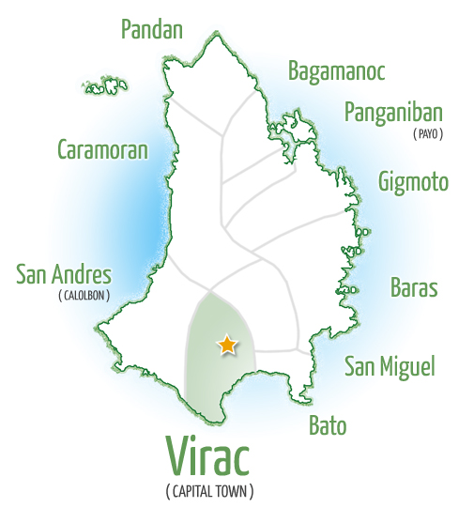

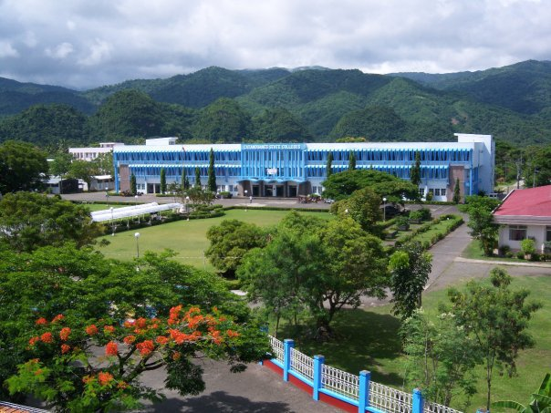

[Type a quote from the document or the summary of an interesting point. You can position the text box anywhere in the document. Use the Text Box Tools tab to change the formatting of the pull quote text box.]

The university will find a niche for cross-border education and mobility for researchers along climate change, disaster, survival, and resiliency and associated coping amidst displacements, damages resulting to poverty of peoples and the societies. This a phenomenon which the rest of the world can relate and participate, Figure 2.

Figure 2. Framework for Engagement with Cross-Border Education Mobility of Researchers along Thematic Pillars of Island Research on Climate Change, Disaster, Survival and Resiliency

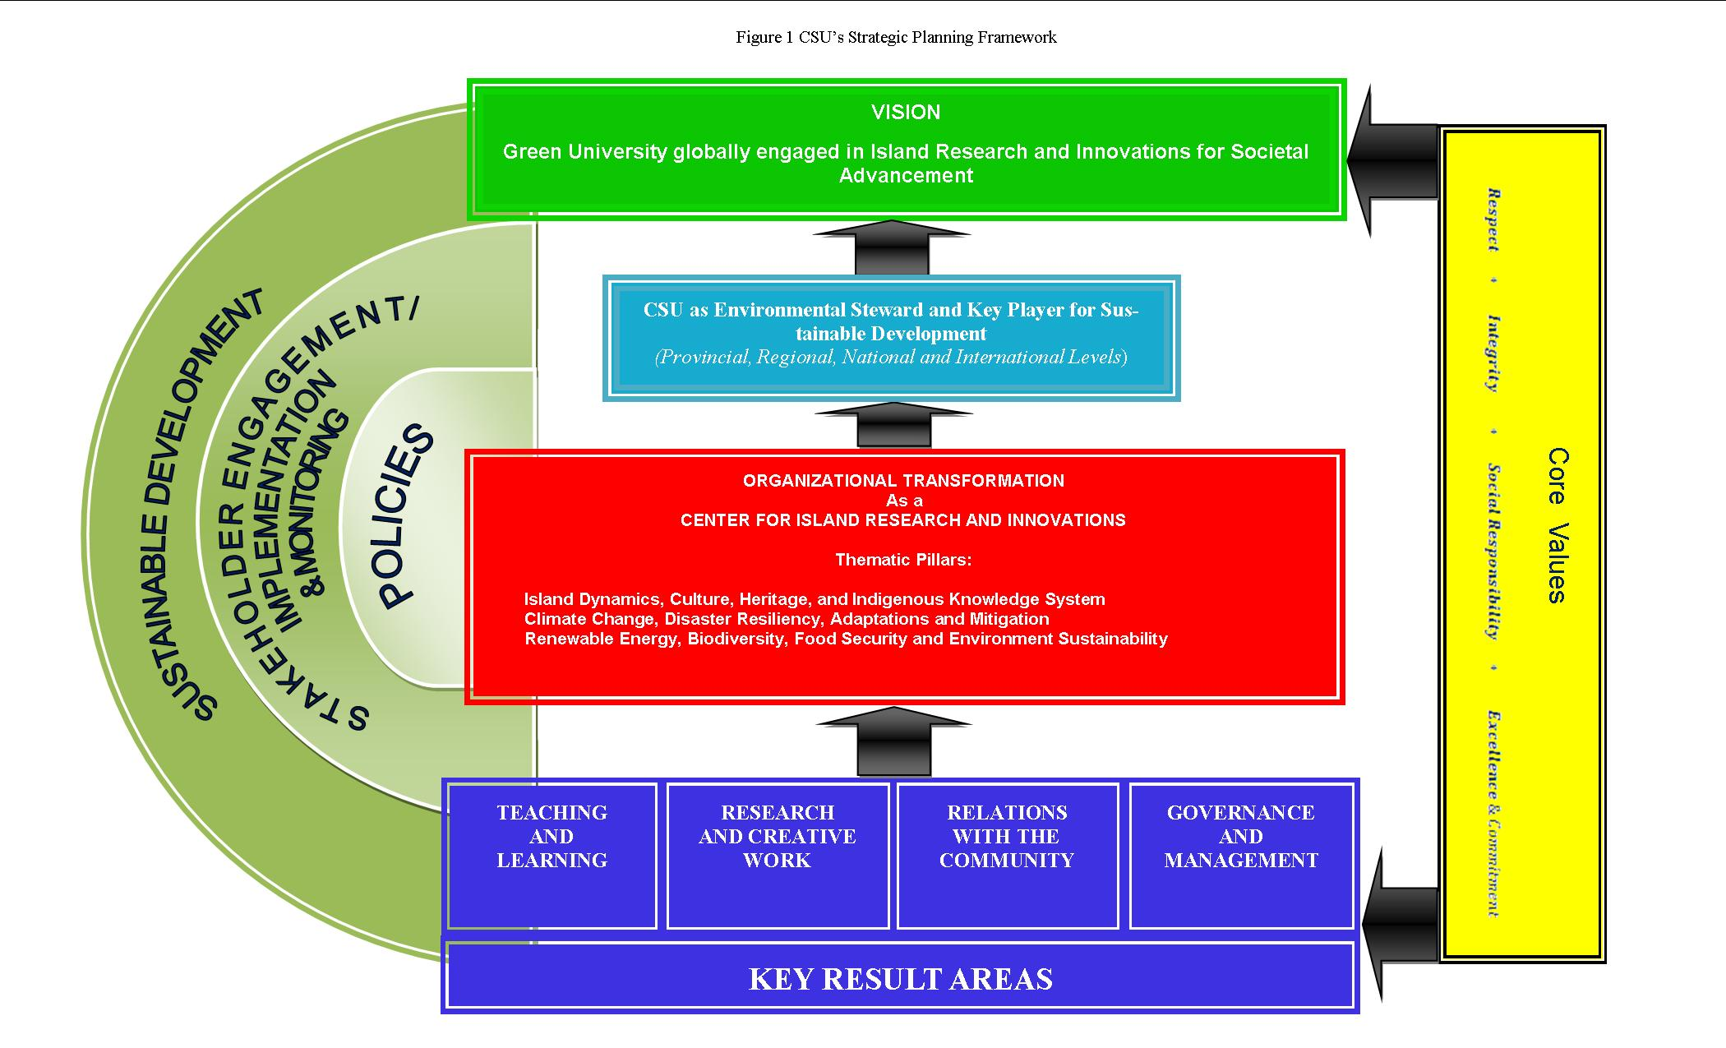

With the wrath of nature, human beings share the same fate, coping and survival depends on synergy for sustainable development. It being the great levelling factor among peoples and societies, it is everyone’s concern. This is defining the university’s stature of being “glocal”, that is an educational system that is both locally and globally relevant and responsive.

The University’s presence in the province, region and beyond shall be a hub for collaborative mobility among researchers, scientists and innovators, along the thematic pillars of:
  - Island Dynamics, Culture, Heritage, and Indigenous Knowledge System
  - Climate Change, Disaster Resiliency, Adaptations and Mitigation
  - Renewable Energy, Biodiversity, Food Security and Environment Sustainability
It is hoped and prayed that Catanduanes State University, and the Philippines’ State Universities and Colleges will be in the radar and destination of APEC cross-border education and developmental undertakings in the near future.

MARAMING SALAMAT PO AT MUBUHAY!

