HIGHER EDUCATION

QUALIFICATIONS



Chinese International Students in Australia: 2015



STUDENT NUMBERS

136,097

Chinese students in Australia in 2015



Female

53%



Male

47%

57%

of all enrolments were in higher education



41% were Bachelor

degrees



41% were Masters (Coursework) degrees



7% were Doctorates and other qualifications

Chinese students make up the largest share of all the international students in Australia



11% were Diplomas





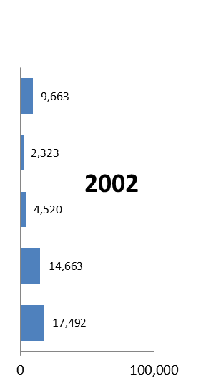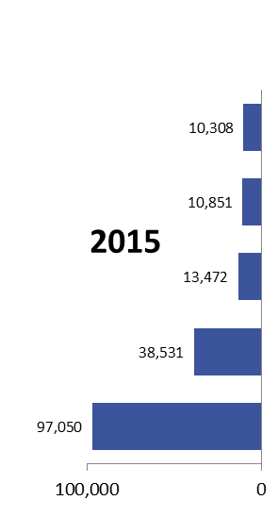

Schools



Non-Award



VET



ELICOS



Higher

Education

EDUCATION SECTORS

STATES AND TERRITORIES

HIGHER EDUCATION

COURSES



73%

study an ELICOS   
 course first

C:\Users\AP3143\AppData\Local\Microsoft\Windows\Temporary Internet Files\Content.IE5\M3GCEED3\learn[1].png



Management and Commerce

59%



Engineering

12%

Information Technology

5%



All data in this snapshot is from the Department of Education and Training at: [https://internationaleducation.gov.au/research/international-student-data/pages/default.aspx](https://internationaleducation.gov.au/research/international-student-data/Pages/defaultOLD.aspx)