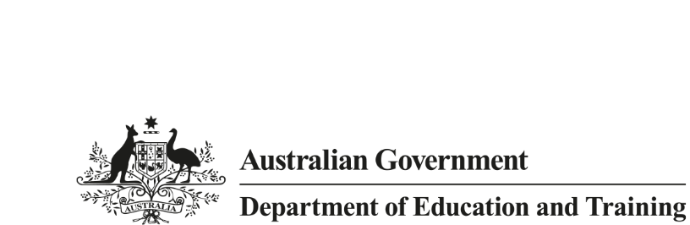

Research  
Snapshot

October 2018

# **Offshore delivery of Australian higher education courses in 2017**

Many students around the world study Australian higher education courses without coming to Australia. For example, an Australian university may have campuses in one or more countries outside Australia or deliver courses fully or partially through a stand-alone arrangement or a partnership arrangement with foreign institutions, or offer courses online. This snapshot outlines these different modes of offshore education in the higher education sector. The data is sourced from the Australian Higher Education Statistics Collection and is largely limited to students studying courses recognised in the Australian Qualifications Framework.

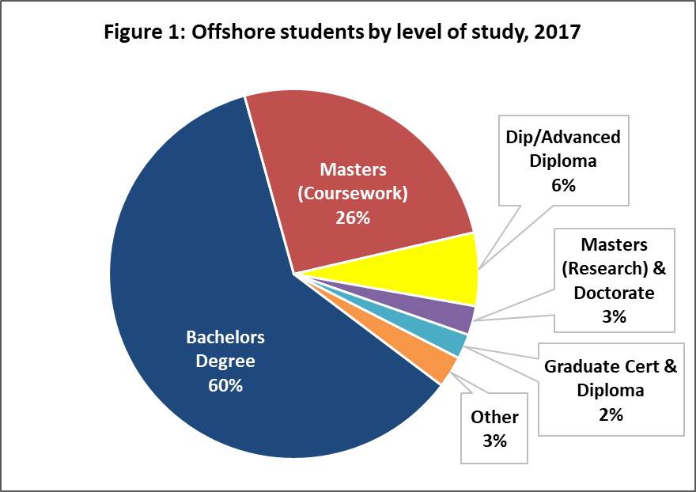In 2017, there were 431,438 overseas students studying Australian higher education courses. Almost 28% of those students were studying offshore. Of these, 39,262 students were enrolled in programs provided at offshore Australian university campuses1, 72,697 were enrolled in programs delivered through partnerships between Australian and foreign institutions or other programs and a further 7,392 were enrolled in online (distance) education (Table 1)2.

**Level of study and field of education**

The most popular qualifications for offshore students in 2017 were Bachelor (60%) and Masters by coursework (26%) degrees

(Figure 1). The top broad fields of education were Management & Commerce (55%), Engineering & Related Technologies (11%), Information Technology (8%) and Society & Culture (8%).

**Age and Gender**

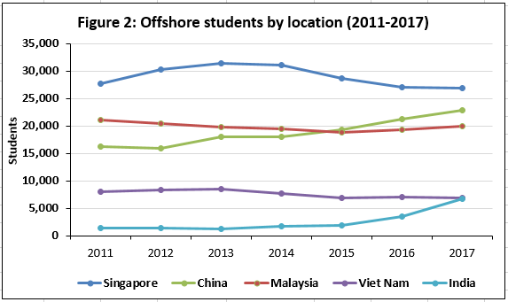There was little difference in age and gender between offshore students and international students studying in Australia. In both cases, most were between 20 to 24 years of age in 2017. There were slightly more male (51%) than female students studying offshore, while 52 per cent of international students studying in Australia were male.

**Location**

Figure 2 shows the top five countries with the most number of students enrolled in Australian offshore programs over the last six years from 2011 up to 2017. These top countries represent the location of institutions where students studied and not necessarily the nationalities of those students. For example, around 20 per cent of students undertaking Australian university programs in Singapore were not permanent residents of Singapore.

**Type of attendance**

While onshore international students are primarily full time students, only 76% of offshore students studied full time in 2017.