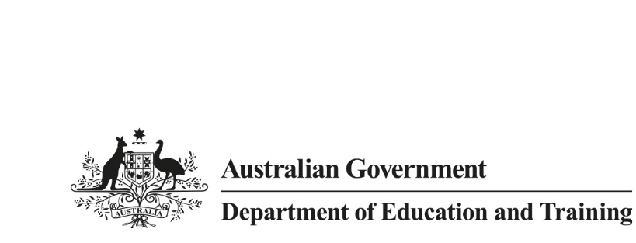

Research
Snapshot
  - September 2018
The global context of tertiary student mobility
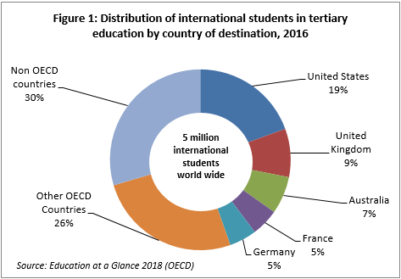
The OECD's Education at a Glance 2018 provides a picture of where international students around the world choose to study. The OECD report only counts tertiary students, including undergraduate and postgraduate higher education programs, up to PhD level and vocational diploma programs of at least two years duration. Hence, the OECD data is largely reflective of students studying towards full qualifications in other countries and excludes the substantial number of internationally-mobile students who may be studying for course credit in other countries through study abroad and student exchange programs.
Major destination countries
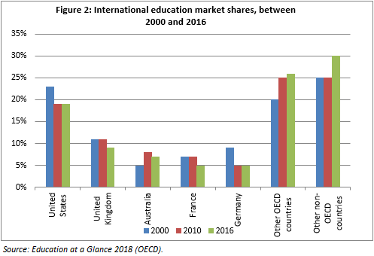
The OECD reported that five million international students were studying outside their home country in 2016 with 3.5 million in OECD countries. The United States hosted the largest number of international students (19%) enrolled at the tertiary levels with over 971,000 international students followed by the United Kingdom (8%) with 432,000 international students. Australia’s global share was third (7%) with 336,000 international students in 2016. The top five destination countries, including France (5%) and Germany (5%), hosted 45 per cent of all international tertiary students in 2016 (Figure 1).

The share of international tertiary students who chose the United States as their choice of study destination has declined since 2000 due to the growing prominence of other study destinations, including Australia (Figure 2). The global share of the United Kingdom, Australia and France declined slightly since 2010 while the share of other OECD and non-OECD countries increased.
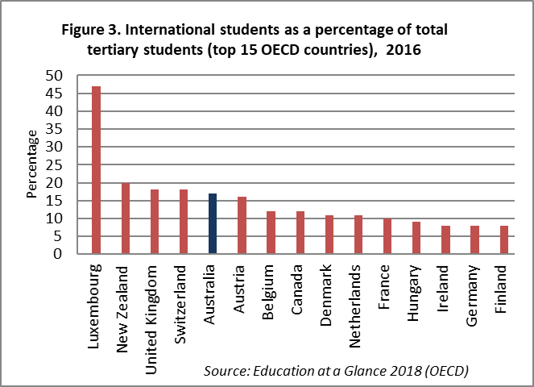
The OECD reported Australia as having the fifth highest proportion (17%) of international students in its total student population in 2016, behind Luxembourg (47%), New Zealand (20%), United Kingdom (18%) and Switzerland (18%) (Figure 3). The same figure for the United States was just 5 per cent in 2016. International students in OECD countries accounted for 6 per cent of all students in OECD countries.
Major source regions/countries
Asia (55%) was largest regional source of international tertiary students for OECD countries, followed by Europe (24%), the Americas and Africa (8% each). The top source countries were China (22%), India (7%) and Germany (3%).
Broad fields of Education
Education at a Glance 2018 reports that about one third of internationally mobile students were studying in Science, Technology, Engineering and Mathematics (STEM) fields. This can be further broken down into engineering, manufacturing and construction (17%); natural sciences, mathematics and statistics (10%); and information and communication technologies (6%).

The OECD report ‘Education at a Glance 2018’ is available at: < insert link>. The OECD term 'international student' refers to those students who have left their country of origin for the purpose of study and ‘foreign student' refers to students who are not citizens of the countries in which they are enrolled, but may be long-term residents or were born in that country. The ‘international students’ in this research snapshot also include ‘foreign students’. The data do not include students enrolled in countries that did not report international or foreign students to the OECD or to the UNESCO Institute for Statistics.

