2014 sample stocktake of international student accommodation in Australia
Purpose: This document provides a sample stocktake of international student accommodation usage in 2014, being sample data from a national survey of international students, further supplemented by findings of a 2014 national census of university student accommodation providers.
2014 International Student Survey – Student accommodation findings
The 2014 International Student Survey overview report released by the Hon Christopher Pyne MP, Minister for Education and Training in April 2015, collated national survey responses from over 50,000 tertiary students across higher education, vocational education and training (VET) and English language intensive courses for overseas students (ELICOS), as below.
International tertiary student accommodation choices
Accommodation | Higher  education | VET | ELICOS | Total tertiary
Friends or relative | 20% | 33% | 18% | 21%
Private halls or student hostel | 4% | 1% | 3% | 3%
Private rented house/flat/room | 55% | 47% | 51% | 53%
Staying with host family | 4% | 10% | 21% | 8%
Student house or flat controlled by university | 1% | 1% | 2% | 1%
University or College Halls of Residence | 11% | 4% | 4% | 9%
Other | 6% | 5% | 2% | 5%
(Base: 54,397 respondents)
A different survey instrument (and question) was used to survey the accommodation options chosen by over 1,000 international students in Australian public and private schools.
International secondary school student accommodation choices
Accommodation | Total
Relative/other family member | 32%
Boarding school or equivalent | 17%
Staying with host family | 39%
Other | 12%
(Base: 1,225 respondents)
The most popular options used by international students, being private rental accommodation for tertiary students and ‘homestay’ boarding for school students, indicate that international students in Australia are comfortable with accommodation options in the wider community, ahead of purpose-built student accommodation, either on campus or otherwise. For comparison, the United Kingdom is estimated to have 7 times as many on‐campus places as Australia, while it only hosts 2.3 times as many inbound international students.
2014 national census of university student accommodation providers
In 2014, the Australian Government also supported a national census of providers of purpose-built accommodation for university students in Australia in 2014. Key findings which may be of interest to international education stakeholders are outlined below.
Size of the purpose built student accommodation sector
The 2014 census involved 315 accommodation sites with more than 100 beds around Australia, which were primarily available to university students. The sites contributed a total of 74,482 places that were primarily available for Australian university students in 2014. Of these places:
- 67 per cent were on campus;
- 81 per cent were in metropolitan areas; and
- NSW had the largest share (30 per cent), although Melbourne had the largest number (16,393) of any capital city.
Although out of scope for this project, it was estimated that other purpose-built student accommodation sites, with less than 100 beds, may contribute a further 15,000 places nationally.
Usage by international students
The census identified approximately 40 per cent of the 74,482 places (or approximately 30,000) were taken by international students in 2014. This suggests the sector as a whole provided places for around 13 per cent of all international higher education students in 2014 (236,249).
The remaining places taken by Australian domestic students were estimated to represent about 33 per cent of Australian ‘mobile’ domestic students, studying at a location that was more than 60 kilometres from their permanent home address.
Although international students have a lower statistical propensity for using purpose-built student accommodation than domestic students (who are living away from home), it is unknown whether this represents individual preference or a difference in access by either group.
Growth in the sector
This is the first national census of this type undertaken since 1999, when 39,561 places were identified. This indicates an average annual growth in places of 4.3 per cent from 1999 to 2014.
Survey respondents were asked to anticipate the number of additional places they would establish by 2018, which was a total of 15,119 additional places (giving a total of 89,601 places in 2018), which represents an average annual growth of 4.7 per cent. On this basis, the report authors have claimed that the number of available places is likely to exceed 100,000 by 2020.

Appendix: Figures and charts from the university student accommodation census report.

1. Location of student places by state and territory in 2014

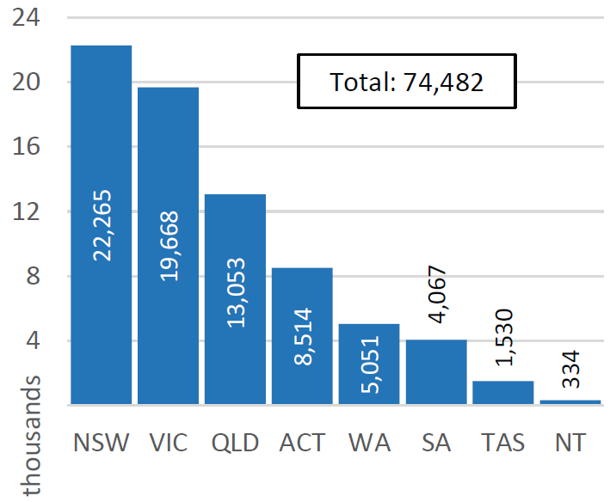
2. Locations of student places by capital city in 2014

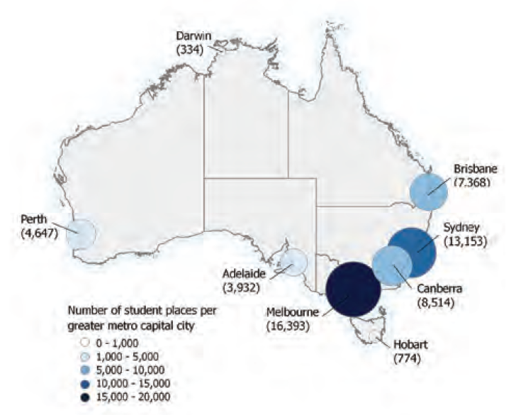

3. Breakdown of places between regional and metropolitan, by state and territory

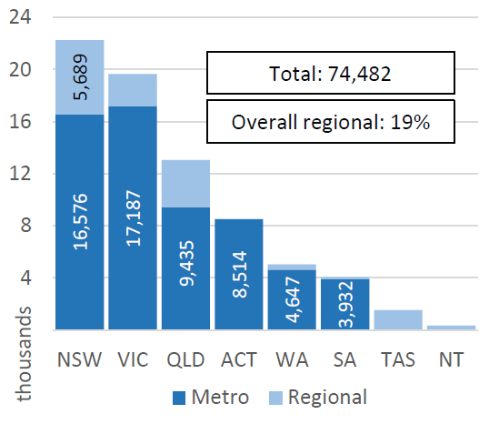

4. Available places as a proportion of the estimated number of mobile university students*
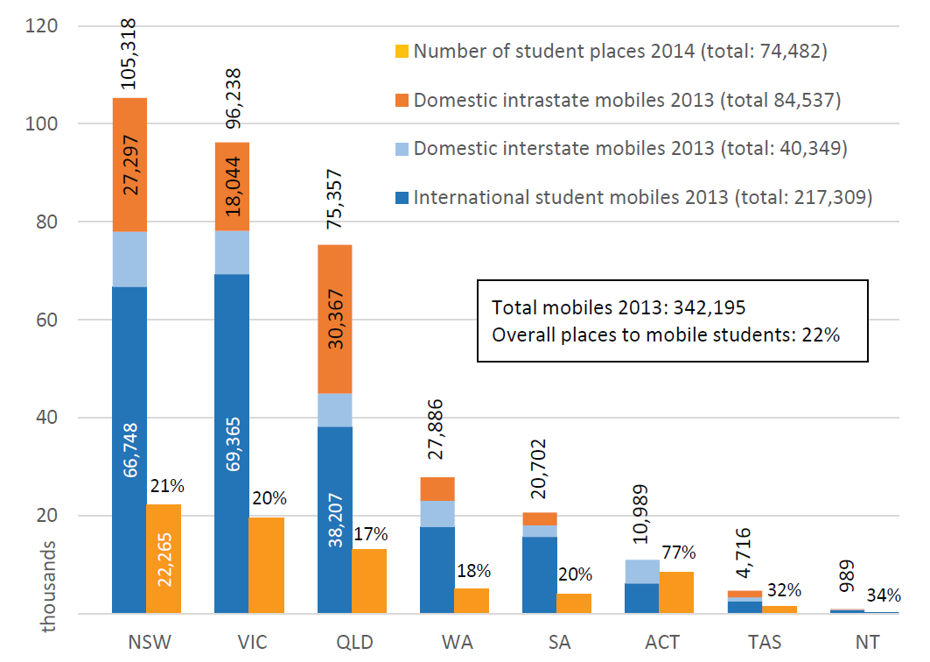
*Mobile university students include international students and domestic students with a term address more than 60 kilometres of their home address where the latest available domestic student data is for 2013.
5. Places associated with a member of one of the major university groups*
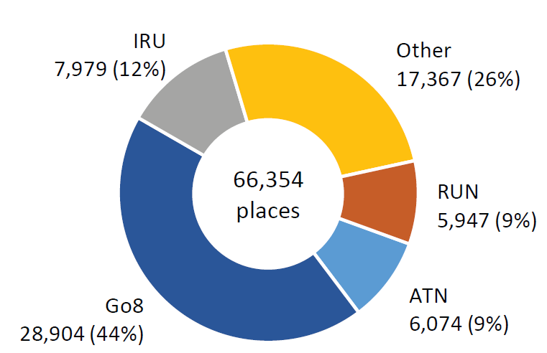
*Go8 = Group of Eight; IRU = Innovative Research Universities; RUN = Regional Universities Network; ATN = Australian Technology Network. Other = other universities not in the aforementioned groups. The remaining 8,124 places belonged to providers of university accommodation which did not report being associated with any particular university.

6. Past growth - number of places in 1999 compared to 2014, by state and territory
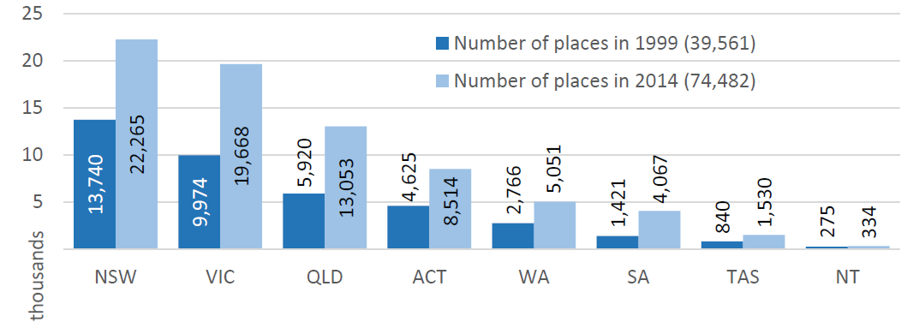

7. Past growth - number of places in 1999 compared to 2014, by capital city
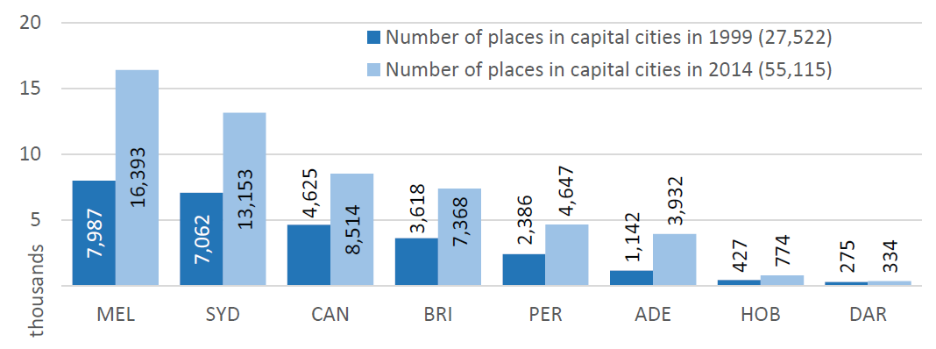

8: Future growth - actual places in 2014 versus projected places in 2018, by state and territory
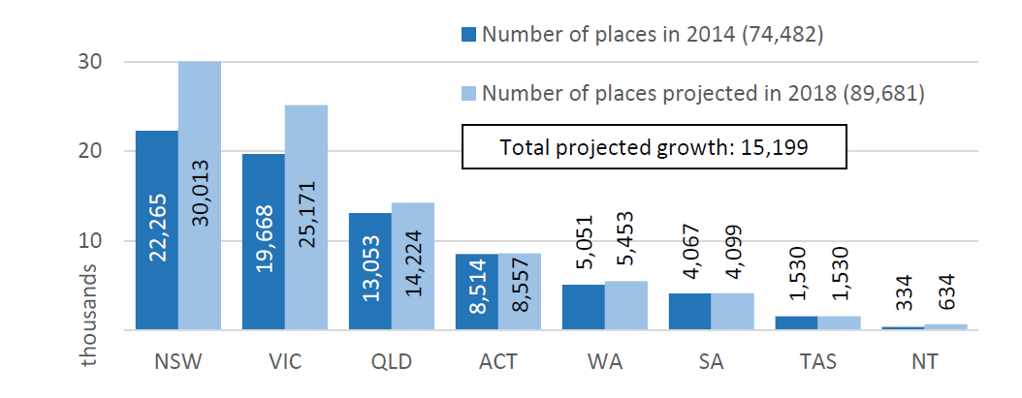
9: Future growth - actual places in 2014 versus projected places in 2018, by capital city
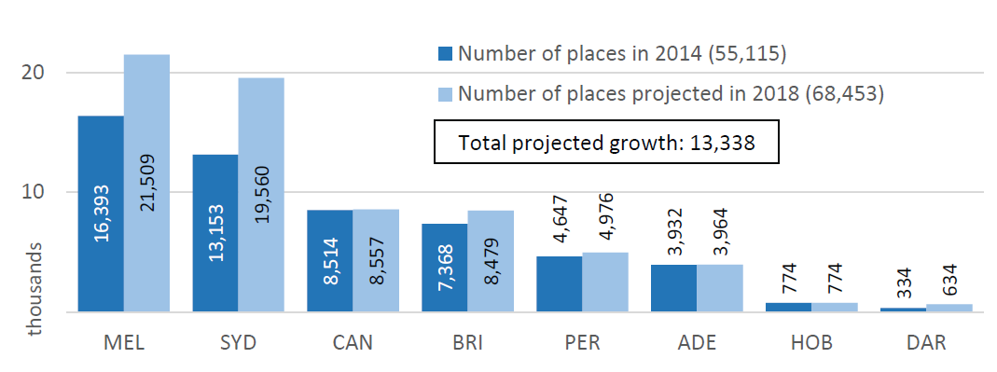

National Census of University Student Accommodation Providers 2014.
Purpose-built accommodation for non-university students was not in scope for this research project. The accommodation bodies involved in this project suggested that such establishments were relatively rare.
The providers prefer the term places, which, in all important respects, is equivalent to the term beds.
The estimate of Australian mobile students was derived through analysis of Australian Government Higher Education Statistics where the latest full-year data available is for 2013.

