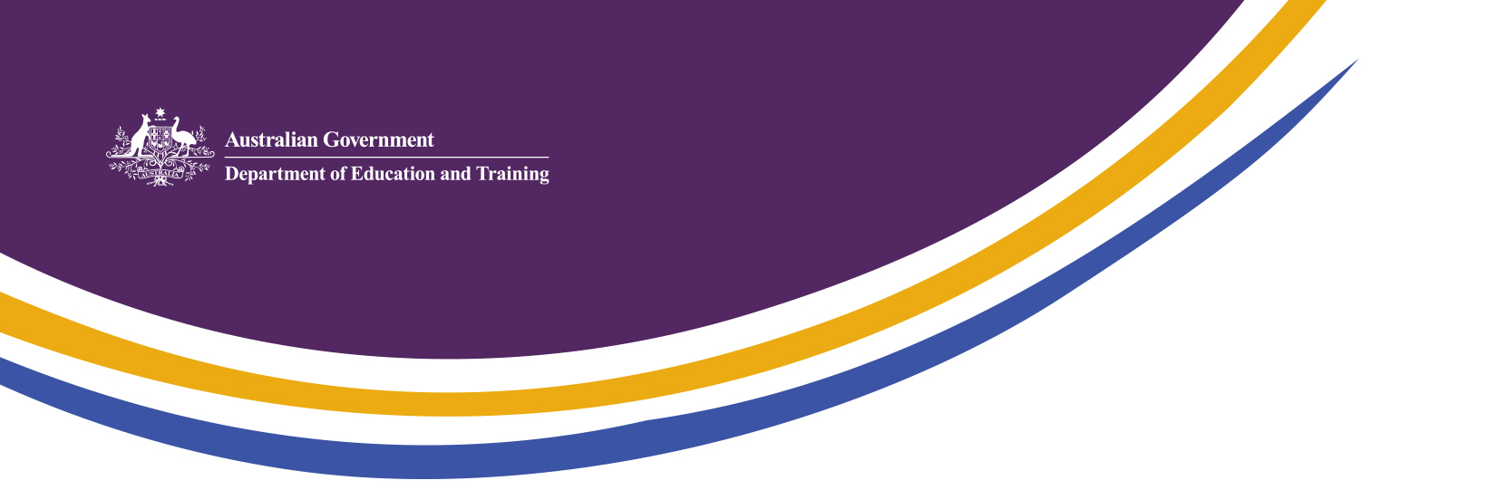

Strengthening English Language Education Outcomes for International Students

English Language Intensive Courses for Overseas Students Standards 2018

Overview

The ELICOS Standards 2018 (the Standards) set nationally consistent levels of quality, governing courses of English language instruction delivered by providers registered on the Commonwealth Register of Institutions and Courses for Overseas Students (CRICOS).

The Standards, which were revised in 2017, will apply from 1 January 2018 to existing ELICOS courses, and to ELICOS courses newly registered on CRICOS (these course types are defined below).

International education providers must comply with the Standards to maintain their registration to provide English language courses to international students.

Amendments to the ELICOS Standards

Amendments to the Standards will apply to all registered courses which are solely or predominantly of English language instruction and are delivered to student visa holders in Australia. This includes courses previously not covered by the Standards, such as vocational education and training (VET) English language courses.
- The Australian Government believes it is reasonable to expect all English language providers to meet the same standards of delivery and student support as other English language colleges delivering to international students.

All providers delivering courses defined as ELICOS will have to meet minimum requirements relating to course contact hours and staff-student ratios, with a mandatory 20 contact study hours a week and a maximum student teacher ratio of 18 to 1.

Where there is an arrangement in place for an international student to enter a tertiary course directly following successful completion of the ELICOS course, the new ELICOS Standards require ELICOS providers to implement additional formal assessment measures.
- Providers will need to demonstrate that assessment outcomes for international students are comparable to other English language criteria used for admission to that tertiary course (Standard P4.1 C[ii]).
- This amendment adds transparency to assessment processes for these students.

The changes allow the national regulators, the Tertiary Education Quality and Standards Agency (TEQSA) and the Australian Skills Quality Authority (ASQA), greater scrutiny and oversight and will ensure all students meet the requisite English language requirements for their course, whether they enter university directly or through an ELICOS direct entry arrangement.

Implementation

The ELICOS Standards will apply from 1 January 2018 to existing and new providers.
- Existing provider means a registered provider regulated under the previous ELICOS Standards before 1 January 2018.
- New provider means a provider that becomes newly registered on CRICOS to deliver an ELICOS course on or after 1 January 2018, irrespective of the date of their application for registration.

The Standards will apply from 1 March 2018 to transitioning providers.
- Transitioning provider means a provider registered on CRICOS, to which the ELICOS Standards did not apply prior to 1 January 2018, and is subsequently assessed by an ESOS Agency to be delivering an ELICOS course.
If an ESOS Agency assesses a course as being solely or predominantly English language instruction, the ESOS Agency will assess it as being an ELICOS course under the new Standards. The ESOS Agency will inform the provider as to how it needs to proceed to transition its courses to the new Standards.
To read the ELICOS Standards 2018 in more detail, please visit:
https://www.legislation.gov.au/Details/F2017L01349

