August 2016
China – Outbound and inbound international students
This snapshot provides an overview of available data on outbound students from mainland China as well as inbound students, including Australians, for whom mainland China is becoming one of the world’s most popular study destinations. The data used in this snapshot are from various sources including the Chinese Ministry of Education (MoE), UNESCO Institute for Statistics (UIS) and the Institute for International Education (IIE).
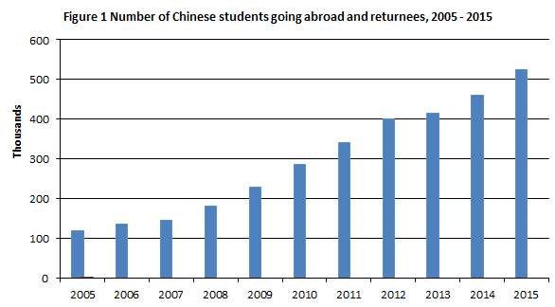
Outbound students
The MoE reported that over 523,700 Chinese students went abroad to study in 2015, representing a new record in outgoing student numbers. It is important for Australia, as a major education destination for Chinese students, to understand the employment outcomes of students who have studied here and then returned home. A recent survey of graduates returning to China with overseas qualifications found nearly a third (30%) seek employment in finance-related fields, followed by education (9.9%), culture (7.8%), and software and IT services (6.7%). Management & Commerce is the most popular field of higher education for Chinese students in Australia, with Society & Culture and IT also in the top five fields.
Source: MoE
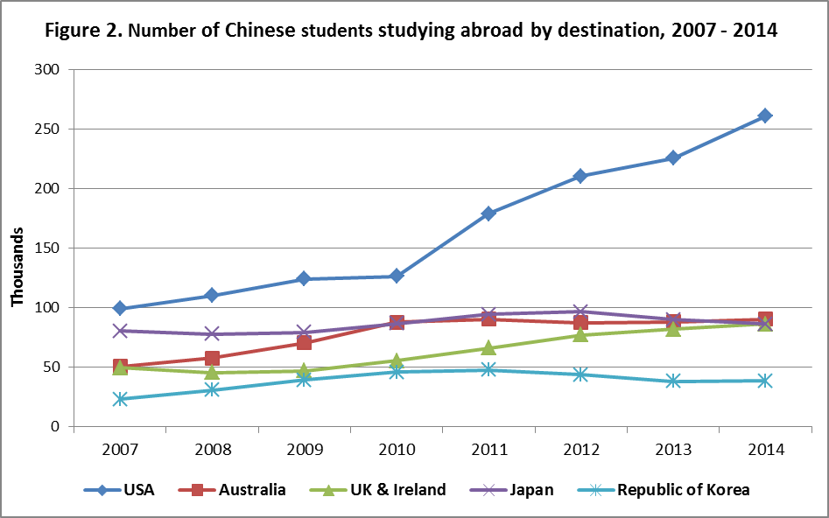
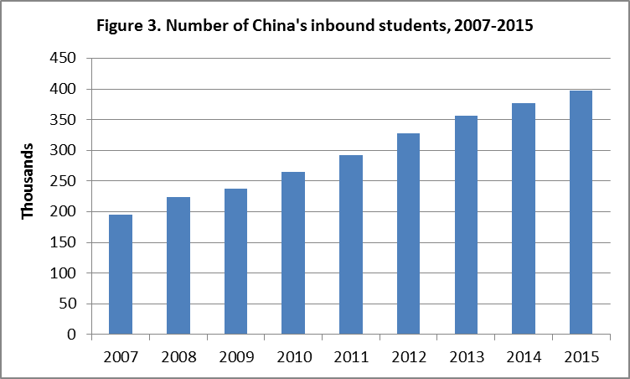
According to MoE statistics, the three most popular destinations for outgoing Chinese students were the USA, the UK, and Australia. Chinese students made up 31 per cent of international students in the USA in 2014–15, 20 per cent in the UK in 2014-15 and 27 per cent in Australia in 2015. Since 2002, the number of Chinese students coming to study in Australia has been growing at an average annual growth rate of 11 per cent per year. The latest UIS report indicates that over 700,000 Chinese students were studying abroad in 2014. The apparent discrepancy between this and China’s data (459,800 student in 2014) arises from the MoE reporting the number of students departing China each year, while the UIS reports the total number of Chinese students in other countries, including many who may have departed China in previous years.
Source: UIS
Inbound students
A total of 397,635 international students studied in China's educational institutions in 2015, an almost 6% increase from the 2014 total of 377,054. The top 3 source countries were the Republic of Korea (16.8% of total), the USA (5.5%) and Thailand (5.0%). Australia was China's 21st source country with 4,411 students in 2015. Over 1,400 Australian undergraduate students were being supported to study in China in 2015 and 2016 through the New Colombo Plan, in addition to other existing Australian scholarship and mobility programs.
Source: MoE

China attracts a much larger proportion of non-award students than other popular international study destinations. In 2015, the MoE reported 212,836 (53.5%) of all inbound students were studying non-award courses, most of which would not have exceeded one year in duration. Of the remainder 131,227 (33.0%) were studying undergraduate degrees and 53,572 (13.5%) were studying postgraduate degrees.

1UIS: http://data.uis.unesco.org/
MoE: http://thepienews.com/news/chinese-outbound-growth-slows-returnee-numbers-rise/
Australian Government Department of Education and Training: https://internationaleducation.gov.au/research/international-student-data/pages/default.aspx
Open Doors (IIE): http://www.iie.org/Research-and-Publications/Open-Doors#.V6P_nv5f2Uk
UK Higher Education Statistics Agency: https://www.hesa.ac.uk/stats
Australian Government Department of Education and Training: https://internationaleducation.gov.au/research/international-student-data/pages/default.aspx
Minor differences in the MoE and UIS data also arise from different data definitions employed by each agency.
Australian Government Department of Foreign Affairs and Trade: http://goo.gl/VAedNI
Chinese Ministry of Education News: http://en.moe.gov.cn/News/Top_News/201604/t20160420_239196.htm

